


ENVIRONMENTAL & SOCIAL IMPACT ASSESSMENT REPORT

Mano River Union Road Development and Transport Facilitation
Programme (MRU/RDTFP) Phase-IV

of Lot 3 (Paving of John Davies Town to Zwedru (48.5Km) Road in Grand Gedeh County) of the
Ganta – Harper Road (510Km) Project

Project ID No.: P-Z1-DB0-259

Grant No.: ____________

Loan No.: _____________

MINISTRY OF PUBLIC WORKS

THE GOVERNMENT OF LIBERIA

May 2023



ROYAL ENVIRONMENTAL GROUP, RE-GROUP

Contents
LIST OF TABLES vi
LIST OF FIGURES vi
EXECUTIVE SUMARY 1
1.0 INTRODUCTION 15
1.1 Background 15
1.2 Objectives of the ESIA Study 16
1.2.1 Objectives of the Proposed Road Project 17
1.3 Scope of the ESIA 17
1.4 Approach and Methodology of the ESIA Studies 18
1.5 Environmental Screening 18
1.5.1 Environmental Scoping 18
1.5.2 Desktop Study 19
1.5.3 Site Assessment 19
1.5.4 Data Analysis, Reporting, and Documentation 19
2.0 PROJECT DESCRIPTION 20
2.1 Existing Road Conditions 20
2.2 Project Location and Area 21
2.3 Project Justification 23
2.3.1 Need for a Primary Road in Rural Liberia 23
2.3.2 Feeder Road Connections 23
2.3.3 Augmentation of Economic Activities 24
3.0 ANALYSIS OF PROJECT ALTERNATIVES 25
3.1 Alternative Mode of Transportation 25
3.2 Alternatives Considered 25
3.2.1 Do Nothing Option 26
3.2.2 Engineering Intervention Option 26
3.2.3 The Preferred Alternative 27
4.0 INSTITUTIONAL AND LEGAL FRAMEWORK IMPLEMENTATION OF THE PROJECT 28
4.1 Policy Framework 28
4.1.1 Land Rights Policy of Liberia (2013) 28
4.1.2 National Policies for Reconstruction and Development 28
4.1.3 National Environmental Policy (2003) 29
4.1.4 The National Transport Policy and Strategy (NTPS) 29
4.1.5 Integrated Water Resources Management Plan (IWRMP), 2009 30
4.1.6 National Forestry Policy, 2006 30
4.1.7 National Biodiversity Strategy and Action Plan, 2004 31
4.2 Legal Framework 31
4.2.1 Liberian Constitution 1986 31
4.2.2 Environmental Protection Agency Act (2002) 31
4.2.3 The Environmental Protection and Management Law of Liberia (EPML), Act 2002 32
4.2.4 The ESIA Process of the EPA of Liberia 32
4.3 International and Regional Requirements 33
4.4 Institutional Framework 35
4.4.1 Environmental Protection Agency (EPA) 35
4.4.2 Ministry of Public Works 35
4.4. 3 Liberia Land Authority 36
4.4.4 Ministry of Mines and Energy 36
4.4.5 Ministry of Agriculture 36
4.4.6 Forestry Development Authority 36
4.4.7 Ministry of Health and Social Welfare 37
4.4.8 Ministry of Finance, Development and Planning 37
4.5 The African Development Bank’s(AfDB) Safeguards Requirements 37
4.5.1 Differences Between the Borrower’s Existing Environmental and Social Framework Requirements and the Af DB's ISS 39
5.0 DESCRIPTION OF THE PROJECT ENVIRONMENT 41
5.1 Physical Environment 41
5.2 Biological Environment 43
5.3 Human Environment-Socio-Economic Baseline 44
6.0 POTENTIAL IMPACTS OF THE PROPOSED PROJECT 48
6.1 Introduction 48
6.2 Methodology for Impact Identification 48
6.3 Environmental and Social Risks and Impacts 50
6.3.1 Beneficial Environmental and Social Impacts 50
6.3.2 Adverse Environmental and Social Risks and Impacts 52
7.0 MITIGATION/ENHANCEMENT MEASURES AND COMPLIMENTARY INITIATIVES 58
7.1 Introduction 58
7.2 Mitigation Measures during the Reconstruction of the Proposed John Davies Town to Zwedru (48.5Km) Reconstruction Project 58
7.2.1 Mitigation Measures against The Effects of Land Loss 58
7.2.2 Mitigation Measures Against the Effects of Noise Pollution and Excessive Vibrations 59
7.2.3 Mitigation Measures Against the Effects of Air Pollution Due to Dust Generation and Air Emissions 59
7.2.4 Mitigation Measures Against the Effects of Solid Waste Generation 60
7.2.5 Mitigation Measures Against The Effects Of Discharge of Wastewater, Sewage and Degradation of Water Quality 61
7.2.6 Mitigation Measures Against the Effects of Water Abstraction and Consumption 61
7.2.7 Mitigation Measures Against the Effects of Storm Water and Impact on Drainage 62
7.2.8 Mitigation Measures Against the Effects of Modification of Hydrological Regime of Project Area 62
7.2.9 Mitigation Measures Against the Effects of Increased Soil Erosion Risk and Soil Quality Degradation 62
7.2.10 Mitigation Measures Against the Effects of Loss of Vegetation Covered and Biodiversity 63
7.2.11 Mitigation Measures Against the Spread of STD, HIV and AIDS 63
7.2.12 Mitigation Measures Against Gender Inequality 63
7.2.13 Mitigation Measures Against Labor Influx 64
7.2.14 Mitigation Measures Against Socio-cultural Conflicts 64
7.2.15 Mitigation Measures Against Disturbance to Wildlife 65
7.2.16 Mitigation Measures Against Occupational Safety and Health Impacts 66
7.2.17 Mitigation Measures Against Negative Impacts to Community Health and Safety 67
7.2.18 Mitigation Measures Against Increased Loss of Human and Animal Life due to Road Accidents 68
7.2.19 Rural Economy Enhancement Measures 68
7.3 Environmental Risks to the Project 68
7.3.1 Flush Floods Along the Road Corridor 68
7.3.2 Fire 69
7.3.3 Environmental Risk Management 69
7.4 Bidding Phase: Procurement of Contractor 70
7.5 Summary of Mitigation Measures---Construction Phase 72
8.0 Environmental Social Management Plan (ESMP) 79
8.1 Introduction 79
8.2 Objectives of the ESMP 79
8.3 Environmental Social Monitoring Program 80
8.4 Capacity Building and Training Needs 96
9.0 STAKEHOLDERS AND PUBLIC CONSULTATIONS 101
9.1 Introduction 101
9.2 The Consultation Process 101
9.3 Public Meetings 107
9.4 Public Disclosure 108
9.5 Grievance Redress Mechanism 108
9.5.1 GRM Overview 108
9.6 Object of the GRM 109
9.6.1 Main Principles of this GRM 110
9.6.2 Grievances Procedure 111
9.6.3 Estimated Budget and Workplan for Effective GRM Implementation 113
9.6.4 Work Plan for the Implementation of the GRM 114
10.0 CONCLUSION, RECOMMENDATION, AND AGREED ACTIONS 116
10.1 Conclusion 116
10.2 Recommendations/Agreed Actions 116
11.0 REFERENCES 117
12.0 ANNEXURES 118

LIST OF TABLES
Table 1: Summary of Potential Impacts and Mitigation Measures 9
Table 2: Estimated Overall Budget for Implementation of all Environmental and Social Measures 14
Table 3: Technical Alternatives Considered and Reasons for Rejection 27
Table 4: International and Regional Requirements Relevant to the Project 34
Table 5: Comparison of EPA ‘s Policy (ESIA/SEA, 2022) Procedural Guidelines and Policy of AfDB’s ISS (OSs, 2023) and Gap Assessment and Gap Filling Measures 39
Table 6: Population Distribution of Districts within the Project Area 44
Table 7: Levels of Scale Used in the Impacts Analysis 48
Table 8: ESHS Management in the Bidding Documents 70
Table 9: Social Risks, and Mitigation Measures 72
Table 10: Detailed Environmental and Social Management Plan Including Responsibility and Cost Estimate 82
Table 11: Summary of Capacity Building Program 97
Table 12: Detailed Itemized Cost for Implementing ESMP 98
Table 13: List of key informants interviewed during the ESIA study 102
Table 14: Comments from the key stakeholders 102
Table 15: Venue of Public Meetings 107
Table 16: Grievance Resolution Process 111
Table 17: Grievance Implementation Work Plan 114
Table 18: Estimated Budget and Work Plan for GRM Implementation 114
Table 19: References 117
Table 20: Annexure 118
Table 21: Public Consultation Meetings ‘Minutes in John Davies Town, Karlorwleh Town, Gbargbo Town and Zwedru, Grand Gedeh County 121
Table 22: Questions and Answers from Consultation Meetings 125
Table 23: Annex “E-2”: MPW Valuation Rates for Structures 139

LIST OF FIGURES
Figure 1: Map showing Project Road: John Davies Town to Zwedru (48.5Km) in Grand Gedeh County 3
Figure 2: Segment of the Existing Road near Jarwleh Village 20
Figure 3: Project Road: John Davies Town to Zwedru (48.5Km) in Grand Gedeh County 21
Figure 4: Sapo National Park Junction at the project corridor. 22
Figure 5: ESIA Process Stages of the EPA 33
Figure 6: Grievnace Handling Process 109
Figure 7: GRM escalation matrix 113

EXECUTIVE SUMARY
OVERVIEW OF THE PROJECT

Goal of the Project
The goal of this project is to support the Government of Liberia’s Pro-Poor Agenda for Prosperity and Development (PAPD)-a 5-year (2018-2023) National Development Plan (NDP) anticipated under the Liberia Vision 2030 Framework, and by extension facilitate long-term national development agenda that contributes to its post-conflict through sustainable economic growth and development of the transportation infrastructure of the country.

Specific Objectives of the Project
The project is part of a road development program which aims to contribute to the opening up of the interior of Liberia to the strengthening of sub-regional integration and trade. Specifically, the project will (i) improve the level of service of Fish Town – Zwedru (48.5km) corridor; (ii) improve accessibility and living conditions of the populations in the Programme's Zone of Direct Influence (PDIA); and (iii) help build the portfolio of future road Programmes (new pipeline) by carrying out road studies.

Project Components and Main Activities
The project has four main components including the following:
- Component 1: Upgrading Climate Resilient Road: This component aims to expand and improve the road segment from Fish Town-Zwedru (48.5km). This will include control and monitoring of civil works, civil works supervision, ESMP and RAP implementation and other related activities including HIV/AIDs and road safety awareness.
- Component 2: Integrated Support: This component will include construction of market and boreholes facilities in Liberia, support to 2 health centers, and implementation of Empowerment and capacity building of farmers and SMEs (including SME's) to better engage in commercial activities, assess climate risks and opportunities and deploy climate-smart agricultural practices in Liberia.
- Component 3: Transport and Trade Facilitation: This component will support study on needs assessment of trade facilitation, including streamlining of border and corridor procedures and processes of this Programme and development of transit zones; inter-agency coordination platform, sensitisation, and training of customs officials, and Technical Assistant support to Mano River Union Secretariat in project Management.
- Component 4 : Programme Management: This component will support socio-economic impact monitoring/evaluation; monitoring the implementation of the Environmental and Social Management Plan (ESMP) including Annual E&S performance and Programme compliance audit; technical and road safety audit; accounting and financial audit; institutional support and professional training Course for sector engineers and PIU; equipment of the implementing agency (vehicles, computer equipment and furniture); functioning of the Implementing Agencies; and Functioning of the Joint Technical Committee (JTC).

Alternatives to the Project
Three (3) pavement alternatives were considered and analyzed in the feasibility study including Asphalt Concrete, Concrete, and Interlocking Blocks. The alternatives were assessed based on cost, environmental impact, and maintenance. Interlocking blocks was the cheapest in terms of construction cost but require a higher maintenance over its lifespan, also due to the undulating terrain it was not considered a suitable option, while the construction cost of concrete doubles that of asphalt and the maintenance cost of asphalt is higher compared to that of concrete. Asphalt Concrete was considered the most suitable option due to construction cost and maintenance because of the undulating terrain.
DESCRIPTION OF THE PROJECT SITES AND THE MAJOR ENVIRONMENTAL AND SOCIAL STAKES AND CHALLENGES

Project location
The project road lies entirely in Grand Gedeh County, in southeastern Liberia. Grand Gedeh is bounded on the Northwest through the North by Nimba, on the Northwest through the East by the Cavalla River forming the boundary with Cote d’Ivoire, on the South by River Gee County, and on the Southwest by Sinoe County. The total land area of Grand Gedeh County is 10,276 km", which is about 9.22% of the total land area of Liberia.

The project road lies entirely in Grand Gedeh County, in southeastern Liberia. Grand Gedeh is bounded on the Northwest through the North by Nimba, on the Northwest through the East by the Cavalla River forming the boundary with Cote d’Ivoire, on the South by River Gee County, and on the Southwest by Sinoe County. The total land area of Grand Gedeh County is 10,276 km", which is about 9.22% of the total land area of Liberia.

The elevation at the site varies between 35 and 300 m asl (meters above sea level). Approximately 32 towns and villages along the proposed corridor and about 16 streams/creeks would require culverts installation in line with the design specification. The project road section has a lane configuration from a single lane to two lanes. The design speed is 60Km/h-100Km/h, the carriageway is 7.30 m wide and the shoulders are 2.00 m wide.
The Condition of the road is poor (70% of the section is average or poor) to very deplorable condition. About 4 major/minor feeder roads (CVI Junction, Putu Iron Ore Mining Company Junction, Sapo National Park Junction, and Gbargbo Town Junction) meet the project road at various locations.

The land along the project road is mostly agricultural land, except in built-up areas, where there is nominal barren land. There is an additional land requirement for the project especially for quarry and borrow pits. The project road traverses about thirty-four (34) communities of which 18 communities were found within the RoW of the proposed project corridor.

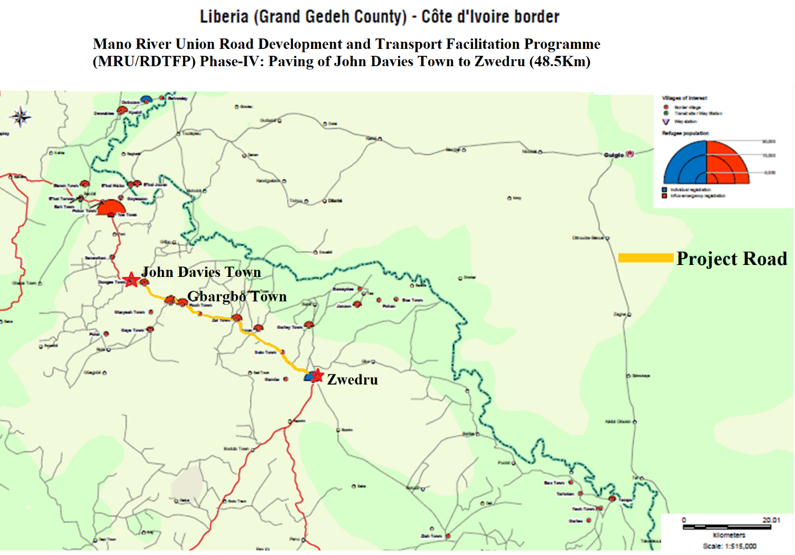

Figure 1: Map showing Project Road: John Davies Town to Zwedru (48.5Km) in Grand Gedeh County

Baseline Environmental Conditions
Topography: Grand Gedeh County is a much hillier region, as compared to River Gee County. This region is a portion of the highlands of the country. Nearing River Gee County, there are generally gently rolling with wide and shallow valleys with the following identified geographical belts. The vegetation of Grand Gedeh County is typical of the tropical rainforest, characterized by evergreen and semi-deciduous forests. Most of the forests along the road are open, with only insolated huge trees such as Antaris toxicaria, Pentaclethra macrophylla, Piptadenias-trum africanum, Sacoglottis. Terminaliasuperba and Triplochiton, scleroxclon, which were giving abundant forest regrowth. They are 260 species of trees, including Mahogany, African Walnut, Mahere, Teak, Ebony, Ironwood, Makore, Sikon, and Camwood within the project area of influence. The road runs through a range of luscious secondary forests, with few rubber and palm farms along the road. The coastal vegetation consists of mangrove swamps, savannah woodland, and patches of forest scattered in fields of grassland.

Geology: Geological investigations in Liberia have shown that nearly all the terrain is underlain by Precambrian crystalline rocks which form part of the West Africa Shield. The country can be divided into three (3) geological regions, namely the Liberian Age Province, the Eburnean Age Province, and the Pan African Age Province. The Liberian Age province is underlain by rocks aged between 2.5 and 3.0 billion years, Eburnean Age Province aged between 2.0 and 2.5 billion years and the Pan African Age Province aged less than 500 million years.

Water Resources and Drainages: The project area is endowed with abundant water resources. Data from the rural water supply program indicate that the depth of the water table in wells can be less than 10 meters, especially during the rainy season. Drilled boreholes can be as deep as 100 or more meters. Grand Gedeh County has several large rivers, inclduing the Jay River, located in the East, the Neemi River, Feeley River, Gbornee River, and the Dugbeh River run across the project road. The project road crosses major rivers and streams as well as small tributary creeks. The major rivers and streams are perennial whilst most of the tributary creeks are ephemeral. These ephemeral creeks often run completely dry during the dry season, except for a few localized depressions in the creek bed.

Rainfall, Humidity, Temperature, Wind, and Sunshine: Located at an elevation of 230.64 meters (756.69 feet) above sea level, Grand Gedeh has a Tropical monsoon climate. The city’s yearly temperature is 26.31ºC (79.36ºF) and it is -0.55% lower than Liberia’s averages. Grand Gedeh typically receives about 302.42 millimeters (11.91 inches) of precipitation and has 275.73 rainy days (75.54% of the time) annually.
The mean monthly relative humidity varies between 70 and 90%. The mean daily bright sunshine hours vary over 4.0 hours. The mean monthly temperatures of the project catchment vary from 24.5⁰C and 27.5⁰C. Wind speeds are generally light being of the order of 6 knots.

Flora and Fauna: The vegetation of Grand Gedeh County is typical of the tropical rainforest, characterized by evergreen and semi-deciduous forests. Most of the forests along the road are open, with only insolated huge trees such as Antaris toxicaria, Pentaclethra macrophylla, Piptadenias-trum africanum, Sacoglottis. Terminaliasuperba and Triplochiton, scleroxclon, which were giving abundant forest regrowth. They are 260 species of trees, including Mahogany, African Walnut, Mahere, Teak, Ebony, Ironwood, Makore, Sikon, and Camwood within the project area of influence. The road runs through a range of luscious secondary forests, with few rubber and palm farms along the road. The coastal vegetation consists of mangrove swamps, savannah woodland, and patches of forest scattered in fields of grassland. The Liberian Forest serves as a habitat for large amounts of endemic flora and fauna and is a unique ecological niche for some of the rarest species in the world.
Human Environment-Socio-Economic Baseline
Population Size: The population of Grand Gedeh County is estimated at 125,258 with male and female populations at 51.9% and 48.1% respectively (LISGIS, 2011). In Grand Gedeh County, the road under Lot 3 traverses the Tchien and Putu Districts. The total population of Tchien and Putu Districts is 48,402, representing 38.6% of the Grand Gedeh County population, with male to female population ratio estimated at 51.9% to 48.1%.

Communities Along the Road
Within Grand Gedeh County, the Lot 3 (John Davies Town to Zwedru (48.5Km)) road traverses 34 communities including Zwedru within the Tchien and Putu Districts, and two campsites (Liberia Logging Company’s Camp, an unknown campsite) along the corridor in Grand Gedeh County.

Ethnicity and religion: The main ethnic group in Grand Gedeh County is Krahn. Most of the respondents in Grand Gedeh County (96.6%) were Christians, 1.4% Muslims, 0.5% practitioners of African Traditional Religion and 1.5% professed no religious affiliation.

Institutional and Legal Framework for Implementation of the Project

The Environmental Protection Agency
The Environmental Protection Agency of Liberia (EPAL) is the statutory institution that regulates, manages, and protects the environment and by extension guides the Environmental and Social Impacts Assessment Process (ESIA) and authorizes the issuance of environmental permits in close collaboration and partnership with relevant line ministries, and agencies. The EPA will be responsible for compliance monitoring during the project implementation.
This ESIA considers applicable existing policy, legal, regulatory, and institutional frameworks within the context of Liberian Law. The ESIA study is conducted in adherence to relevant legal policy and administrative framework of the Republic of Liberia including the Environmental Protection and Management Law of Liberia (EPML, 2003), the Revised Environmental and Social Impact Assessment/Strategic Environmental Assessment (ESIA/SEA) Procedural Guidelines (March 30, 2022), the African Development Bank’s Integrated Safeguards System (ISS, updated 2023), Environmental and Social Guidelines and Policies, and other Good International Industry Practice (GIIP).

The five (05) Environmental and Social (E&S) Operational Safeguards establish the standards that Borrowers will meet, as appropriate, in projects, activities, and initiatives supported through Bank financing throughout the life cycle of operations, as follows:

- E&S Operational Safeguard 1 (OS1): Assessment and Management of Environmental and Social Risks and Impacts.
- E&S Operational Safeguard 2 (OS2): Involuntary resettlement land acquisition, population
displacement and compensation
- E&S Operational Safeguard 3 (OS3): Biodiversity and Ecosystem Services
- E&S Operational Safeguard 4 (OS4): Pollution prevention and control, hazardous materials and resource efficiency
- E&S Operational Safeguard 5 (OS5): Labour conditions, health and safety
Role and Responsibilities of the Project Implementation Entity (PIE)

The Government of Liberia through the Ministry of Public Works (MPW) is the project proponent responsible for the implementation of the proposed John Davies Town-Zwedru (48.5 km) road. The Ministry through its Project Implementation Unit (PIU) will be responsible for implementing the project ESMP including the RAP in line with relevant national environmental standards and AfDB’s environmental and social standards. Specific responsibilities and roles will include supervision of road works contracts to ensure adherence to environmental permit conditions and AfDB’s ISS requirements, preparation of monthly E&S and annual E&S performance audit reports, and stakeholder consultations and awareness throughout the life of the project.

MAJOR AND MODERATE ENVIRONMENTAL AND SOCIAL RISKS AND IMPACTS
The following provides a summary of the potential impacts associated with the roads during design/preconstruction, construction, and operational phases:

- Air Pollution: The project site's impact on ambient air quality within the project site and nearby settlements may be significant during the project construction phase. The particulate matter will be the main pollutant due to the excavations, quarry blasting and concrete mixing, handling and transport of earth and construction materials, etc. at the site. Lack of foresight in the siting of construction camps, rock-crushing plants, and concrete batching plants in the pre-construction phase could lead to significant air quality impacts in the construction phase, especially to sensitive receptors.

- The risk of pollution of Surface Water Bodies: Impacts on surface water and groundwater could occur through improper operation of construction camps, asphalt plants, etc. Poor construction management around bridges and close to surface watercourses could also lead to pollution incidents. Without due care temporary drainage structures may also fail, or get obstructed with construction debris, leading to flooding of property and access roads. Construction of minor bridges (about 6 bridges) on rivers, and 16 culverts on streams/creeks and road embankments will have a potential impact on the quality of surface water bodies.
- Involuntary resettlement, land acquisition, and loss of livelihood: The project will lead to land acquisition, resettlement and loss of livelihood which will impact a total of 18 communities, about 294 families, 20 farmlands, 113 businesses, and 134 residential structures.
- Loss of vegetation cover: The road works will involve creation of new alignments, establishment of borrow areas, camp sites and access roads. An estimated area of 137.627ha of vegetation cover will be lost
- Cultural resources and community services: 08 graves will be affected/relocated, 01 market building, and 01 hand pump.

- Increased risk of disease transimission including sexually transimitted diseases due to labor influx:. The project will experience an influx of workers thus posing an increased risk transmission of sexually transmitted diseases including HIV/AIDS in surrounding towns and villages.

- Loss of utilities and disruption of services High, Medium, and low voltage power lines from the neighboring Country of Côte d'Ivoire; and water supply lines are located within the project corridor. These utilities may need to be relocated or temporarily removed during construction.

- Waste: The road construction will inevitably generate solid and liquid waste products including inert waste (e.g., concrete, wood, plastics, etc.) and hazardous waste (e.g., bitumen drums, fuel, waste oils, used tires, scraps, batteries, etc.). In addition, uncontrolled discharges of sewage and ‘grey water’ (e.g., from washrooms and canteens, kitchens, etc.) from construction sites and worker’s camps may also cause odors and pollute local water resources.

- Risks to Community Health and Safety: Construction activities may increase road traffic accidents between vehicles, pedestrians and vehicles, and livestock and vehicles. There will also be short-term impacts on vibration, noise, and air quality, which may impact health.
- Occupational Health and Safety: Workers’ rights including occupational health and safety need to be considered to avoid accidents and injuries, loss of man-hours, labor abuses, unavailability of necessary PPEs, and to ensure fair treatment, remuneration, and working and living conditions of workers.

Mitigation Actions: The summary mitigation measures for the potential impacts identified above for Project Road are presented in Table 1 below:

Table 1: Summary of Potential Impacts and Mitigation Measures
No | Potential Environmental and Social Risks and Impacts | Mitigation Measures | Responsible Party | Monitoring frequency
1 | Involuntary Resettlement and Displacement of Local Communities, Loss of Properties and Businesses  - 294 structures, inclduing 8 graves, 113 commercial facilities, 133 resendential structures, 2 hand pumps, 3 churches, 1 clinic, and 2 market buildings; 246 PAPs have been recorded and 147  - 20 farmlands or tree crops will be affected | - Payment of timely and adequate compensation at replacement cost.  - The MPW will ensure that the final designs of the highway shall be realigned to minimize displacements minimized as much as possible.  - A Resettlement Action Plan is implemented appropriately and professionally | GoL/MPW | Prior to the commencement of civil works for assets & crops and during Implementation for quarry, borrow pits and camp sites
2. | Loss of Vegetation Cover: An estimated area of 20 ha arable/farmland will be cleared including land for widening of right-of-way, borrow areas, and quarry sites | - Revegetation of designated areas, particularly areas prone to erosion  - Separate ESMPs to be prepared for borrow areas and quarry sites management | MPW/Contractor | Weekly/Monthly
3. | Increased risk of the spread of STDs including HIV and AIDS | - STDs and HIV and AIDS awareness program and community/workers sensitization throughout project implementation period. | MPW/Contractor | Monthly
4 | Water pollution | - Modify embankment slopes leading to water bodies avoid / minimize the missing of contaminants with water bodies.  - Control excessive abstraction of water from rivers and wetlands.  - Avoid complete blockage of river channels during construction of bridges and culverts.  - Re-open all blocked river channels after construction of bridges | Contractor | Daily / Monthly
2 | Air Pollution | - Sprinkling of water on dry and dusty surfaces regularly including the access roads.  - Use of wastewater to sprinkle at the construction site so as to reduce excessive dust.  - Adherence to personal protective clothing such as dust masks.  - Enforce onsite speed limit regulations.  - Ensure machines and vehicles are properly and regularly maintained. | Contractor | Daily / Monthly
3 | Soil Pollution | - Vehicle, machinery, and equipment maintenance and refueling will be carried out so that spilled materials do not seep into the soil.  - Vehicle maintenance and fuel areas shall be pave to avoid or minimize soil contamination.  - Fuel storage and refilling areas will be located at least 300m from drainage structures and water bodies.  - Oil traps will be provided for service and parking areas, the camp site.  - All spoils and wastes will be disposed of as per the contractor’s approved waste disposal plans at designated waste site (excluding wasteland areas), after consultation with local communities. | Contractor | Daily/weekly/monthly
Social Component
5 | Occupational Hazards | - Development of a traffic management plan for road construction.  - Use protective barriers to shield workers from traffic vehicles, regulation of traffic flow by warning lights/ signs.  - Eliminate or decrease blind spots and ensure reduction of maximum vehicle speeds in work zones.  - Training of workers in occupational safety.  - Installation and maintenance of all signs, signals, markings, and other devices used to regulate traffic, specifically those related to pedestrian facilities or bikeways.  - Prepare an emergency preparedness and response plan in coordination with the local community and emergency responders. | MPW/Contractor | Daily / weekly/ monthly
6 | Road Accidents | - Create parking areas for trucks or vehicles.  - Create speed humps in towns.  - Provide signage and markings such as zebra, stop signs etc.  - Provide and enforce speed limit along the project road.  - Conduct community awareness raising programs. | Contractor | Developed prior to the commencement of work and implemented throughout the life of the project.

The ESMP, its mitigation and monitoring programs, contained herewith will be included within the Project Bidding documents for project works. This ensures that all potential bidders are aware of the environmental requirements of the Project and its associated environmental costs.The Bid documents state that the Contractor will be responsible for the implementation of the requirements of the ESMP through his Specific Environmental Management Plan (SEMP) which will adopt all the conditions of the ESMP and add site-specific elements that are not currently known, such as the Contractors campsite.The ESMP and all its requirements will also be added to the Contractors Contract, thereby implementing the ESMP a legal requirement according to the Contract.
Consultation with Key Stakeholders
For the proposed project road, the following major groups of stakeholders have been identified for consultations:
- Primary stakeholders: Individuals, groups, or local communities that may be affected by the project, positively or negatively and directly or indirectly especially those who are directly affected, including those who are disadvantaged or vulnerable. Consultation meetings were held between May 29, 2023, to June 1, 2023, in four communities (John Davies Town, Karlorwleh Town, Gbargbo Town, and Zwedru).

- Secondary stakeholders are institutional stakeholders such as concerned government ministries and agencies. Meetings were first held with some officials of government that include Ministry of Public Works, Ministry of Labor, Liberia Land Authority, Liberia Electricity Corporation (LEC), Liberia Water & Sewer Corporation (LWSC), Ministry of Internal Affairs (MOI), Ministry of Mines & Energy (MME), Ministry of Justice (MOJ), Ministry of Finance Development and Planning (MFDP), Ministry of Agriculture (MOA), and the Environmental Protection Agency (EPA) Liberia.

Consultations were carried out in two phases namely general in-depth interviews followed by phase two which consisted of consultative stakeholder and public participation meetings. Phase one involved in-depth consultations with key informants including the Local Authorities (County authorities that include district officials, paramount and clan chiefs, etc.) and focus group discussions with residents along the project corridor (farmers, miners, landowners, traders, etc.). Consultations with residents were undertaken in several major towns and the City of Zwedru that fall directly in the project area. Consultation meetings were held at John Davies Town, Karlorwleh Town, Gbargbo Town, and Zwedru City in Grand Gedeh County.

During the consultations, several issues were raised, such as:
- Spoil material, tree cutting, and replanting;
- Access to properties during construction and identification of sites of cultural heritage;
- Employment opportunities for youths along the project road;
- Transfer of skills and technology;
- Compensation, RoW Encroachment, and Property/Asset Valuation;
- Road Safety and accidents emanating from speeding vehicles and construction machines;
- Public Utilities: Restoration of public utilities (water and electricity) disrupted during the construction;
- Grievances arising from the project;

Grievance Redress Mechanism (GRM)
A Grievance Redress Mechanism (GRM) for the project has been developed to address all project-related complaints including those that may arise from RAP implementation. It follows customary norms and fits into the statutory administrative process of the Government of Liberia. The GRM also satisfies the AfDB Integrated Safeguards System (ISS) requirements. These requirements are consistent with the Liberian laws which recognize the need for a mechanism for the PAPs to air their grievances, mainly land-related grievances in local government structures, customary authorities, and courts of law. The grievance mechanism will be another form of promoting participation and consultations.

Non-resettlement issues may include, but not be limited to, labour disputes, safety issues, and environmental issues reported will be referred to appropriate authorities for resolution. Timely response to the grievances will be ensured and records will be kept and updated for project reporting purposes. Basically, the GRM shall adhere to the following set of principles:
- Ensure social and gender equity
- Availability of key messages and documents
- Accessibility at no cost to the affected party
- Proportionality to the scale of the impact anticipated.
- Non-discrimination and equity on any grounds (gender, religious affiliation, language, economic status, etc.)
- Assurance of confidentiality where required
- Assurance against victimization for raising complaints
- Timely, efficient, relevant and transparent handling of grievance and complaints on matter within the remit of the RAP
- Cultural appropriateness in handling community concerns

Complaints will be handled in two stages as follows:
• 1- At the Community level: Use of traditional grievance resolution system in place with town Chiefs, Elders along with the Community Liaison Officer (CLO) for contractors and the E&S team of the PIU will at that level, start grievance resolution process following investigation and exchanges with the complainants;
- 2- At the Grievance Redress Committee (GRC) level: Implication of the Grievance redress committees that will be set up in Counties crossed by the project. The GRC is the second level of complaints and disputes resolution. It will start its action mainly when the arbitration through the traditional grievance resolution system in place failed. The GRC will also work on complex issues and complaints.
When the resolution of the grievance at the community level and the grievance redress committee failed the complainant has the right to refer to court.

The overall estimated cost for the project ESMP Management is two million nine hundred eighty-four thousand five hundred twenty eighty-two cent United States Dollars ($2,984,520.82). This includes the RAP budget, GRM implementation cost, cost of capacity building initiatives, and cost of implementing and monitoring mitigation measures.
Table 2: Estimated Overall Budget for Implementation of all Environmental and Social Measures
No. | Activity | Timeframe | Estimated Cost (USD) | Source of Funding/Responsibility
1 | Contractor’s ESMP Preparation and EPA License Acquisition
 | Preparation of contractor’s ESMP | First quarter in the pre-  construction phase | $50,000.00 | Contractor
2 | GRM implementation Cost
 | Operationalization, implementation and monitoring of GRM throughout the project life cyle | Throughout project implementation | $100,000.00 | AfDB Loan/Grant
3 | Involuntary Displace/Resettlement Cost and Associated Cost
 | RAP cost including compensation for PAPs, relocation of graves, replacement of affected community resources, administrative cost and monitoring of RAP | Throughout project implementation | $1,544,520.82 | AfDB Loan/Grant
4 | ESMP Implementation and Monitoring
 | Implementation of of other mitigation measures and Regular supervision of environmental and social issues including health and safety and reporting | Throughout the project implementation | $810,000.00  detailed | AfDB Loan/Grant  GoL/Contractor
5 | Capacity Building of  Technical Officers Environmental Matters | Throughout project implementation | $240,000.00  (detailed breakdown in the capacity building section) | AfDB Loan/Grand  GoL/MPW
6 | Annual E&S audit | Annually  throughout the  life of the project | $140,000.00  (35,000 per audit at 3 man-months for 4 years) | AfDB Loan/Grant
7 | Environmental Permit/License Acquisition | Prior to the start of construction works and  annually | $100,000.00  ($25,000/yr. for 4 yrs.) | AfDB Loan/Grant
 | Total Cost |  | $2,984,520.82.00

1.0 INTRODUCTION

1.1 Background

The Government of Liberia (GOL) has identified road infrastructure development as one of the key areas of its development agenda. The country’s road network is in deplorable condition and needs urgent attention to drive economic activities around the country. It is believed that of the estimated 10,538Km of public roads in Liberia, only a minute portion about 7% (734 Km) are paved. In this regard, the Government of Liberia is in talks with the African Development Bank (AfDB) to construct a portion of the 510Km of Ganta to Harper Road that linked three (3) south-eastern counties (Grand Gedeh, River Gee, and Maryland counties) with an estimated population of one (1) million (25% of Liberia's population). Also, the three (3) counties by extension link Liberia to Ivory Coast via the Cavalla Customs in Maryland County which forms part of the Mano River Union Road Development and Transport Facilitation Programme as well as the Trans-African Highway. The proposed road project (John Davis Town to Zwedru City (48.5Km)) which is a remaining portion of LOT-3 (Zwedru to Fish Town in Grand Gedeh and River Gee counties) is a continuation of the 510Km road development from Ganta/Nimba County to Harper/Maryland County. The entire 510 km road corridor was portioned into two (2) Sections. Section 1 is the road from Ganta, Nimba County to Zwedru, Grand Gedeh County, while Section 2 is the road from Zwedru, Grand Gedeh County to Harper and Harper Junction to Cavalla Custom in Mary Land County.
Section 2 under which this report covered, was further phased into three (3) LOTS:
- Lot 1, for which construction work has been constructed to the asphalt pavement, consists of the reconstruction of the laterite road from Harper to Karloken (50km) and Harper Junction to Cavalla Custom (16km) in Maryland County.;
- LOT-2, which is currently under construction, consists of the section of road from Karloken, Maryland County to Fish Town (80 Km) in River Gee County and is about 89% complete; and
- LOT-3 is (134.2Km) and consists of the following sections of road: (Fish Town to Kilepo (20Km); Kilepo to Putuken (11.5Km); Putuken to John Davis Town (50Km) and John Davis Town to Zwedru (48.5Km) in Grand Gedeh County. Currently under consideration by the GOL and the AfDB for paving is the section between John Davis Town to Zwedru City (48.5 km) for which these ESIA studies have been conducted.

It is proposed that the above-mentioned section of the road will be upgraded to improve the living condition of the people, ensure traffic safety and accommodate evident increases in traffic flow.

In addition to the construction and pavement of the road, the project will also deliver new bridges of varying sizes, culverts, etc. There will also be a realignment of the road in several places.

The project aims at ensuring suitable operating conditions for safe driving on the selected routes during the entire year by providing adequate running surface and drainage systems.

Against this background, the services of Royal Environmental Group (RE-GROUP), Inc. were hired to conduct an environmental and social impact assessment of the project area, to provide for the reconstruction and paving of the road between John Davies Town to Zwedru City (48.5Km) in Grand Gedeh County. Hence, the environmental and social impact study is intended to assess the setting along the road, identifies social and economic impacts, which may evolve from the proposed activity, and determines the feasibility of the project. Finally, taking into consideration internationally acceptable standards, it proposes measures aimed at the mitigation or prevention of adverse outcomes.

1.2 Objectives of the ESIA Study

The objective of this ESIA study is to predict, assess, and analyze the possible positive and negative environmental and social risks and impacts that are expected during the construction, operation, and decommissioning phases of the project. This study also enhances the beneficial impacts and proposes possible mitigation measures for all the highlighted adverse impacts. This will make sure that the development does not negatively impact the environment, especially concerning the social, health, economic, and biophysical (soil, water, plant, and animals) states of the proposed project site.

The exercise has been carried out per the Environmental Protection Agency Act (2003), National Environmental Policy, and the Environment Protection and Management Law (EPML, 2003). Section 6 of the EPML places a mandatory requirement for environmental screening and/or Environmental Impact Assessment of all investment works or projects that are likely to have significant adverse environmental impacts with subsequent issuance of licensing or permitting from the EPA as stipulated in the legislation and the Environmental and Social Safeguards requirement of the African Development Bank.

The specific objectives are:
- Prediction and evaluation of potential environmental impacts of the project, and propose workable and sustainable mitigation measures for the significant negative impacts of the project on the environment.
- Propose measures to enhance the beneficial impacts of the project.
- Facilitation of consultative public participation and the incorporation of expressed views into the study report.
- Preparation of a detailed Environmental and Social Management Plan (ESMP) for the proposed road project.
- Ensure compliance with the relevant local environmental laws and regulations and the E&S standards of the funding agency

1.2.1 Objectives of the Proposed Road Project

The primary objective is to support Liberia’s economic growth through the development of transportation infrastructure that contributes to its post-conflict agenda for transformation. The proposed road project is expected to meet the following objectives and service needs both during the construction and operation phases of the project.
- Improve the region’s road network;
- Reduce travel time and cost along and across the roads;
- Enhance the operational efficiency of the road;
- Promote economic growth within the region;
- Improve safety and reliability for all road users;
- Attract diverted traffic that will foster regional growth;
- Provide employment opportunities to local inhabitants, among other benefits;

1.3 Scope of the ESIA

The scope of this ESIA is to meet national regulatory requirements and the Integrated Safeguards System (ISS, 2023 of the AfDB. This will involve:

- Collecting primary and secondary environmental baseline data within the project boundary and surrounding areas;
- Assessing potential adverse environmental impacts that might arise during the design, construction, and operation phases concerning the design proposal of the project and using the environmental baseline study;
- Suggesting appropriate mitigation measures, monitoring, and management plans, and soliciting public view and opinions relevant to the project development and implementation;
- Analyze the alternatives in terms of alternative of upgradation of the alignment, technology, design, and operation, including the "without and with project" situation. A detailed analysis for each of the alternatives was carried out to analyze the feasibility in terms of capital and recurrent costs; their suitability under local conditions and quantify the environmental impacts to the extent possible, attach economic values where feasible, and explain the rationale behind the preferred/chosen option
- Consultation with the Public/key Stakeholders and incorporate their concerns into the project design;
- Developing an Environmental Management Plan (EMP) including environmental monitoring plan to implement suggested mitigation measures and management plans to minimize adverse impacts through effective management systems including formulation of monitoring and reporting requirements;

1.4 Approach and Methodology of the ESIA Studies

The methodology for this ESIA study employs a traditional approach of identifying the environmental sensitivities along the project corridor and analyzing the environmental issues identified. The EIA process simultaneously informs the design of the project road about these issues so that necessary modifications can be carried out to minimize these environmental concerns. Thereafter the impact assessment that is carried out would identify the impacts which are still likely and identify mitigation measures that need to be adopted during the construction and operational phases of the project road.

The data collection has been carried out through key stakeholders’ interviews, focused group discussions (FGD), use of checklists, observations and photography, site visits and desktop environmental studies/review, review of past ESIAs reports prepared for similar projects in the manner specified in the EPA’s Act, 2003 and the African Development Bank’s Safeguards (ISS, 2023).
The general steps followed during the assessment were as follows:
- Environment screening, which the project has identified as required by EPA and AfDB;
- Environmental scoping that provided the key environmental issues
- Desktop review;
- Physical inspection of the area and surrounding communities;
- Public participation through interviews, meetings, focused group discussion, etc.;
- Data analysis; and Report preparation.

1.5 Environmental Screening

The environmental screening has been conducted through legal review and desktop studies to assess whether there will be a need for an environmental and social impact assessment, and what level of assessment is necessary. This was done using a screening checklist about the requirements of the EPA and the AfDB’s Integrated Safeguards System. Section 6 of the EPML places a mandatory requirement for environmental screening and/or Environmental Impact Assessment of all investment works or projects that are likely to have significant adverse environmental impacts. The project is classified as Category “1”: Bank’s Operation likely to cause significant environmental and social impact according to the AfDB’s E&S requirement. Therefore, a full environmental and social impact assessment is required to be undertaken by the borrower.

1.5.1 Environmental Scoping

The scoping (in other words, consultation) process, through an ESIA scoping checklist, has also been conducted to help streamline issues down to the most critical requiring attention during the assessment. Environmental issues are categorized into physical, natural/ecological, social, economic, and cultural aspects. It also included discussions with key stakeholders, managers, and design Resident Engineers as well as interviews with local communities.

1.5.2 Desktop Study

The desktop study undertaken included a document review on the nature of the proposed activities, project documents, designs, policy, and legislative framework as well as the environmental setting of the area among others.

1.5.3 Site Assessment

Field visits have been conducted to the proposed project site for physical inspections of the areas around the project site and the environmental status of the surrounding areas to determine the anticipated impacts.

1.5.4 Data Analysis, Reporting, and Documentation

Data has been quantitatively and qualitatively analyzed thematically. The Environmental Social Impact Assessment Study Report was compiled from the findings under the guidelines issued by EPA for such works and prepared and will be submitted for consideration and approval.

2.0 PROJECT DESCRIPTION

2.1 Existing Road Conditions

The project road lies entirely in Grand Gedeh County, in southeastern Liberia. Grand Gedeh is bounded on the Northwest through the North by Nimba, on the Northwest through the East by the Cavalla River forming the boundary with Cote d’Ivoire, on the South by River Gee County, and on the Southwest by Sinoe County. The total land area of Grand Gedeh County is 10,276 km², which is about 9.22% of the total land area of Liberia.

The elevation at the site varies between 35 and 300 m asl (meters above sea level). Approximately 32 towns and villages along the proposed corridor and about 16 streams/creeks would require culverts installation in line with the design specification. The project road section has a lane configuration from a single lane to two lanes.The proposed road comprised 6 existing bridges which shall be kept in place or rehabilitated.

The Condition of the road is poor (70% of the section is average or poor) to very deplorable condition. Many locations along the road alignment require geometric improvements to maintain the riding quality and hindrance-free movements of the vehicles to avoid accidents and other road hazards. Geometric Improvement of the highway is proposed for the entire John Davies-Zwedru (48.5 km) stretch. All the geometrically deficient curves are proposed for realignment and curve improvements. About 4 major/minor feeder roads (CVI Junction, Putu Iron Ore Mining Company Junction, Sapo National Park Junction, and Gbargbo Town Junction) meet the project road at various locations. A segment of the existing road is shown in Figure 2.
.
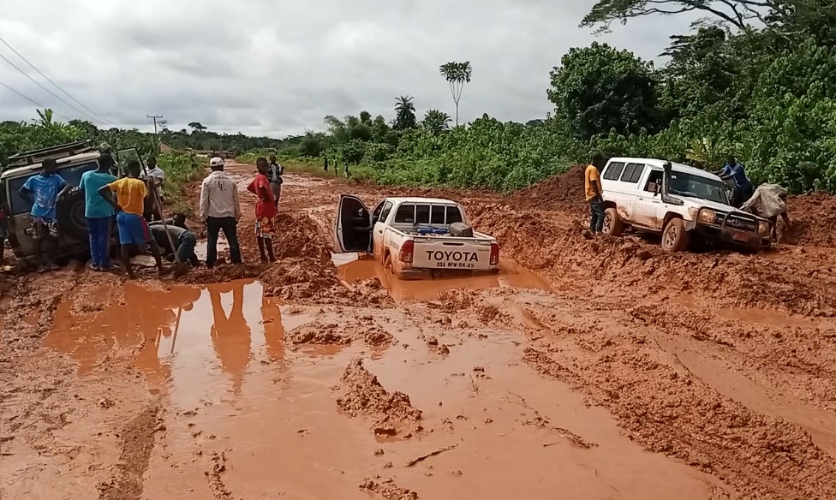

Figure 2: Segment of the Existing Road near Jarwleh Village

Generally, the vertical and horizontal alignments require improvement to meet minimum curve radii and sight distances. Most crest curves have steep grades and poor sight distances. Some of the horizontal curves also have small radii and require improvement to meet minimum standards for a primary road. Due to the sharp horizontal curves and poor sight distances of crest curves, drivers in opposing directions tend to scuffle for the use of the center of the carriageway, as if it were just one lane.
The unpaved road surface is in good condition in many areas. It is well compacted and all cross drains (culverts) have been well constructed to carry streams without affecting the road. However, heavy rains are creating shallow longitudinal gullies, especially, at sections with very steep grades. Road surface becomes very slippery when wet, making it difficult to maintain control while driving, even for motorcycles and 4-wheel drive vehicles in the rainy season.
There are no lighting along the route, but there are some signs to identify bridges, towns, villages, and junctions along the route.

2.2 Project Location and Area
The Ganta – Harper Road network runs from Northeastern Liberia to Southeastern Liberia. Section 2 – Zwedru – Harper runs entirely in the southeastern part of Liberia. This section has been divided into three (3) lots. This ESIA covers the final portion of Lot 3 (Zwedru-Fish Town).
The project areas comprise approximately 34 towns and villages, 3 churches, 1 clinic, 2 market buildings, a Rock Deposits/Quarry area; two campsites (Liberia Logging Company’s Camp, and unknown campsite); six (6) bridges (Neemi River Bridge, Feeley River Bridge, Jay River Bridge, Gbornee River Bridge, Dugbeh River Bridge, and unknown bridge before the City of Zwedru) along the corridor in Grand Gedeh County.

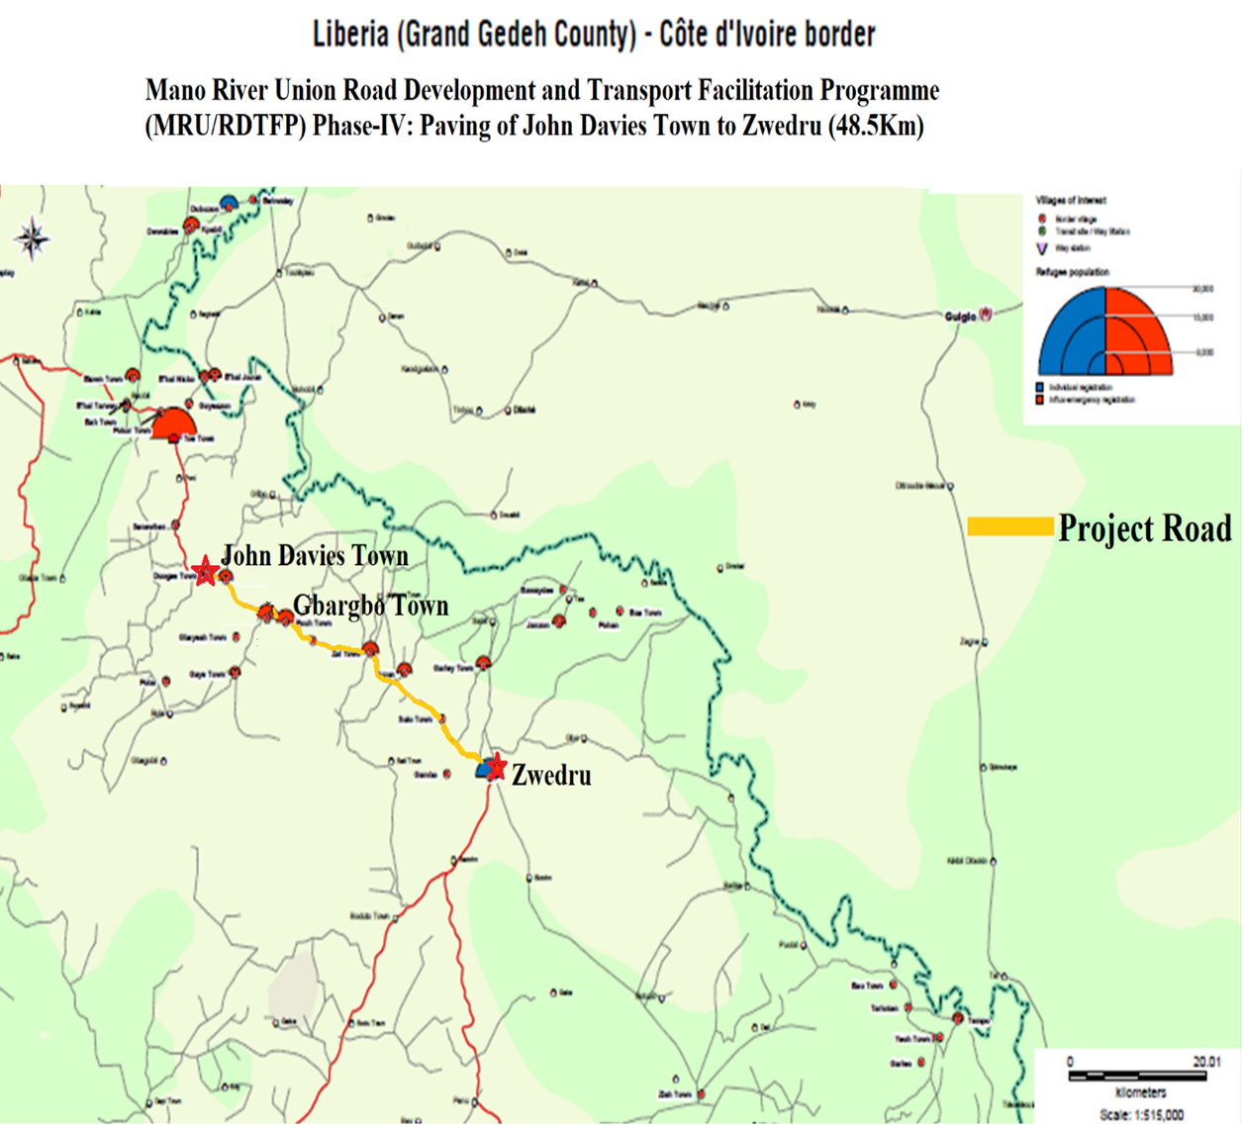
Figure 3: Project Road: John Davies Town to Zwedru (48.5Km) in Grand Gedeh County
The road traverses thirty-four (34) communities including the City of Zwedru, a Rock Deposits/Quarry area; two campsites (Liberia Logging Company’s Camp, and unknown campsite); six (6) bridges (Neemi River Bridge, Feeley River Bridge, Jay River Bridge, Gbornee River Bridge, Dugbeh River Bridge, and unknown bridge before the City of Zwedru) along the corridor in Grand Gedeh County. The communities include (1) John Davies Town, (2) Ma Jersey Village, (3) Duo Town, (4) Karlorwleh Town, (5) Putu Waterside Town, (6) Wroto Village, (7) Pahng Village, (8) Royal Village, (9) Robert Quiah Village, (10) Kamnyee Village, (11) Monge Village, (12) Jarwleh Village, (13) Saryon Town, (14) Jackie Village, (15) Wilson Taye Village, (16) George Quiah Village, (17) Emmanuel David Village, (18) Zulu Village, (19) A. G. Village, (20) Jaygbo Village, (21) Tolbert Village, (22) Chaiye Village, (23) Nyanue Village, (24) Sayeetan Village, (25) Gaye Village, (26) Garden of Eden Village, (27) Gbargbo Town, (28) Pellezon Village, (29) Polah Village, (30) Jabbah Town, (31) Kula Town, (32) Boleyville Village, (33) Ellen Estate, and (34) Zwedru.

The road that traversed the counties of Grand Gedeh and River Gee remained largely neglected until the African Development Bank provided grant support to the GOL in 2008 to rehabilitate the road infrastructure between Fish Town and Harper to an all-weather gravel standard as part of the Labour-Based Public Works Project. The Government of Liberia through the Ministry of Public Works officially dedicated the Fish Town-Harper Road project in 2012. Portions of the road between the Sapo National Park’s Checkpoint which is about 106 km away from the park and Gbargbo Town in Grand Gedeh County have been rehabilitated by the Putu Iron Ore Mining Company (PIOM). The remaining sections between Kilepo to the Sapo National Park’s Checkpoint and Gbargbo Town to Zwedru remain in a serious deplorable condition although the road sections between Kilepo to Putuken (11.5Km) and Putuken to John Davies Town (50Km) have been earmarked rehabilitation and construction under the Mano River Union Road Development and Transport Facilitation Programme (MRU/RDTFP) Phase-III with funding from the African Development Bank.

The challenges posed by these roads are enormous and as a result, these may cause a serious economic breakdown, and the people of this region lived in underdeveloped conditions, especially in predominantly rural communities.
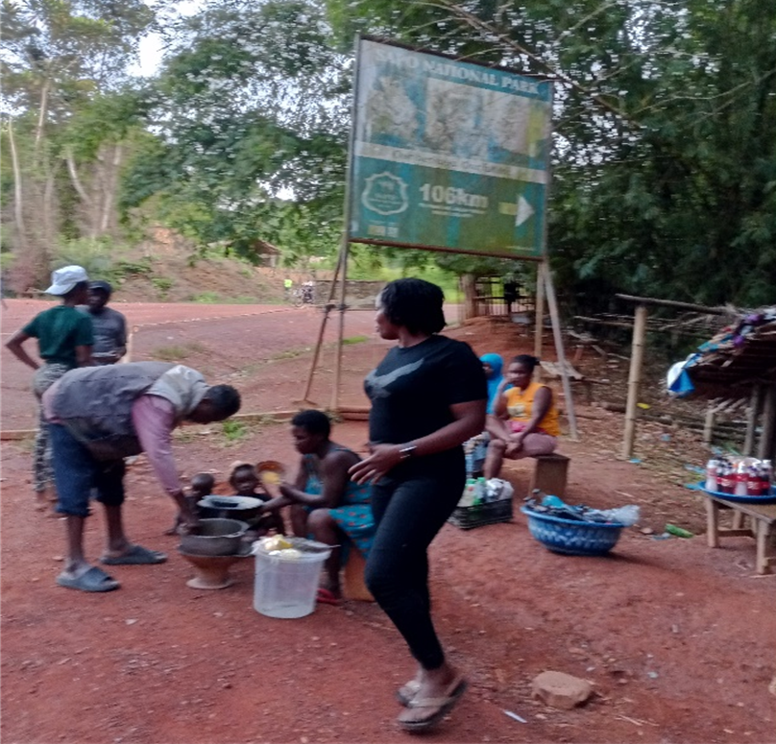
Figure 4: Sapo National Park Junction at the project corridor.

2.3 Project Justification

Notwithstanding, the functionality of the current design, the intense wet climatic conditions in Liberia present major challenges in the maintenance of unpaved roads which often come with high life cycle costs. In the absence of a suitable maintenance funding framework, such as a Road Fund, Liberia would increasingly find it difficult to maintain unpaved roads that require consistent technical and cost attention. Paving the John Davies Town-Zwedru (48.5 km) corridor road would ensure that the design of the roads is robust, fully responsive to the terrain and climatic conditions, and have low life-cycle costs.

The project would improve access to transport services for the rural population in Grand Gedeh, River Gee, and Maryland Counties with the rest of the country; improve farm-to-market linkages as well as uplift the quality of life of the people of the project area. The road corridor is situated in an area heavily endowed with mineral and agricultural resources such as rubber that could take the populace to greater socio-economic development.

2.3.1 Need for a Primary Road in Rural Liberia

During the fourteen (14) years of civil unrest, almost all the roads, including the project road were left in very poor condition, leaving Grand Gedeh one of the priority counties for road development. Despite the deplorable road conditions, demand for transportation continued to increase resulting from the increased exploitation of economic opportunities in the region. Traffic between Zwedru in Grand Gedeh County and Fish Town in River Gee County to the Cavalla Custom in Harper, Maryland County is on the increase as the border region continues to gain prominence in terms of national security, trade, and economic activities. Yet the existing road link from John Davies Town to Zwedru (48.5 km) could at best be classified as an unpaved secondary road, with several inadequate drainage structures, poor road conditions, and inferior Resident Engineering standards.
It is apparent that in order to meet the transportation demand in the southeastern region, there is a need to provide a reliable road network that will effectively harness the enormous amount of agricultural, mining, and other economic potential. The development of this road will complement the investments that are being made as part of the country-wide rural and feeder road programs.

2.3.2 Feeder Road Connections

Although there are programs under the Ministry of Public Works that are tremendously contributing to the development of feeder roads in rural Liberia, the construction of the John Davies Town-Zwedru Road (48.5Km) will greatly facilitate the improvement and construction of secondary feeder roads culminating in establishing the badly needed road network in the southeastern region.

2.3.3 Augmentation of Economic Activities

The development of the John Davies Town-Zwedru (48.5 km) Road will specifically enhance the economic activities within the area of influence of the entire region. These activities include the production of main food crops such as rice, cassava, groundnuts, sweet potato, vegetables, and relatively large plantations of cocoa, coffee, rubber, plantain, and increase activities such as gold/diamond mining in the region.

3.0 ANALYSIS OF PROJECT ALTERNATIVES
Considering the national regulatory requirements and the AfDB Integrated Safeguards System (ISS, 2023), numerous project alternatives were taken into consideration. A comparative analysis of various alternatives considered to avoid, prevent, or minimize impacts that would be inevitable if technically (based on design speed and geometrics) best-fit alignment is followed. The consideration of alternatives to a proposal is a requirement of this ESIA Report. During the scoping process, alternatives to a proposal can be generated or refined, either directly or by reference to the key issues identified. A comparative analysis of the alternatives will help to determine the best method of achieving project objectives while minimizing environmental and social impacts.
The following options are considered to decide the final alignment:

- ALT0: Base Case – Do Nothing;

- Engineering Intervention Option.

3.1 Alternative Mode of Transportation

There are no alternatives to this road that fulfill the functions of providing relatively fast, cheap land transportation. Air, rail, and water transport are unlikely to either complement or substitute for roads or highways in this region. There is no railroad link in or near the project area. Hence, rail is not considered an option. There are no water bodies that can be used as a mode of transportation in the project area. Streams or rivers in and near the project area are neither connected nor navigable. The only possible means is air transport but, this is a rather expensive alternative and cannot be used as an alternative to the road.
The road is the most important link between Zwedru (Grand Gedeh County) and Harper (Maryland County) and serves as the best interconnection within that region of the country, which is a high rubber and soon-to-be iron ore-producing area. The proposed project road is an existing gravel road and its upgrading will not involve any major horizontal or vertical realignment except as has been discussed in detail in Chapter 4 and elsewhere in this ESIA
.

3.2 Alternatives Considered

The effect of road projects on the physical and human environment raises issues regarding alternative choices to the road projects considered. The analysis will assess the effects of these alternatives on the environment against expected benefits. Two main project alternatives have been considered and they are:

3.2.1 Do Nothing Option

This alternative implies that the selected road corridor within Grand Gedeh County will not be improved and that it would be left in its present state characterized by several defects and related impacts. The main defects include the following:

- Narrow road widths at several sections;
- Presence of sharp curves with poor visibility at some sections;
- Poor pavement conditions;
- Very slippery road conditions in the rainy season;
- Inadequate drainage and erosion control measures contribute to the gradually deteriorating condition of some segments of the road.

The combined effect of these problems affects the smooth transportation of people and goods to and from the areas in the road corridors. Speed travel on these roads will continue to be slow and vehicular breakdown rate will continue to increase. Some communities are cut off during the rainy season and will continue to suffer that fate with the no-option alternative. Social and economic activities in the communities will generally decline. Dust pollution and poor riding quality of the existing roads will continue to pose health and safety problems to the communities. Development opportunities may not be realized and several natural endowments will remain in the limelight. Potential negative environmental and social impacts (relocation of settlements, burial sites, etc.) during the construction and operation of the proposed scheme would not be avoided with this option, but the measures being put in place will offset the impacts. Project acceptance has been 100% because the long-term commercial and social development advantages offered to the region by the Option 2 proposal are what the whole region is anticipating.

3.2.2 Engineering Intervention Option

This option assumes that engineering measures will be provided to correct the problems for the improvement of the safety, health, and social conditions of the local communities. In considering the various alternative solutions to the present state of the roads, the project aims at opening the Southeast region of Liberia to increase productivity, reduce transportation costs for the agricultural target centers, and improve critical social services and road safety have been considered. The alternative technical solutions considered and the reasons for their rejection are summed up in Table 3 below:

Table 3: Technical Alternatives Considered and Reasons for Rejection
Section | Alternative | Description | Reasons for Rejection
John Davies Town, to Zwedru 48.5km and Voinjama Mendikoma (80km) (Liberia) | Alternative 1: Development of a dual lane 2x3.5 road surface on the two road sections: 50mm+200mm+200mm+150mm | - Double-layer surface course, base course in crushed granite (200mm), and sub-base course in natural lateritic gravel (200mm). | Stabilization is incompatible with the level of rainfall observed in the Programme area.
 | Alternative 2: Development of a dual lane 2x3.65 rigid road surface on the road segments: 50mm+150mm | - Surface course in rigid concrete: 50mm-  - Sub-base course: 150mm of lateritic | Difficult implementation, high Cost of construction, twice the amount for a flexible pavement
Kailahun – Beudu, 39km (Sierra Leone) | Alternative 1: Concrete (Rigid) pavement | Surface course of 5cm constructed using Portland cement concrete (PCC) with transverse joints spaced at 4.6m. Pavement structure includes a sub-base constructed 10cm of engineered fill laterite material. | High investment cost of concrete compared to asphalt >60% higher.
 | Alternative 2: Interlocking concrete block pavement | A block paved surface consisting of interlocking flat concrete blocks (75mm) on a coarse bedding sand with fine sand between the blocks. Pavement structure includes a sub-base (10cm) of engineered fill laterite material. | Not suitable for the intended purpose and provides low riding quality compared to asphalt.

3.2.3 The Preferred Alternative

The advantages to be derived from the road improvement alternative far outweigh the disadvantages of the “Do Nothing Option”. Although there are environmental implications associated with the improvement alternative, appropriate mitigation measures would be implemented to control them, thus justifying the case for implementing the project. Even though the initial cost of the paved road improvement program would be much higher, the accrued benefits to be derived from this option socially, environmentally, and economically, far supersede all other options. For reasons of life-cycle cost, safety, better, safer driving, environment, traffic volumes, and citizen interest, in the operational phase, option 2- paved surface standard is recommended for the selected route. Alternative 3, reconstruction to Asphaltic Concrete surfacing with Mechanical Stabilized Base yielded the optimal investment and performed best in all the Sensitivity tests and it is therefore recommended for implementation for the proposed project road (48.5Km).

4.0 INSTITUTIONAL AND LEGAL FRAMEWORK IMPLEMENTATION OF THE PROJECT

4.1 Policy Framework

4.1.1 Land Rights Policy of Liberia (2013)

The Land Right Policy of 2013 provides policy recommendations for land rights in Liberia, centered on four basic types of rights: Public Land, Government Land, Customary Land, and Private Land.

The Policy also fosters equal protection of all relative to land matters. The policy recognizes that since the founding of Liberia, the lands of customary communities have been less secure than private lands. This must end such that lands under customary practice and norms are given protection equal to that of private lands. This policy aims to give equal protection to the land rights of men and women.

4.1.2 National Policies for Reconstruction and Development

Liberia’s first Poverty Reduction Strategy (PRS-1) - Lift Liberia (2008 -2011) articulated the Government’s overall vision and major strategies for moving toward rapid, inclusive, and sustainable growth and development. The PRS consists of four pillars: Peace and Security, Economic Revitalization, Governance and Rule of Law, and Infrastructure and Basic Services. The growth strategy of PRS-1 had three prongs: “rebuilding roads and other critical infrastructure; reviving the traditional engines of growth in mining, minerals, forestry, and agriculture; and establishing a competitive environment to help diversify the economy over the medium term”.

Liberia RISING 2030 (PRS-2) is a development agenda to succeed Liberia’s short-medium term Poverty Reduction Strategy – Lift Liberia. Like PRS-1, Liberia Rising 2030 embraces a strategy of broad participation and will serve as a roadmap for addressing the social, political, and economic challenges that confront Liberia on its path toward economic growth and wealth creation.

The National Visioning Project implemented by the Ministry of Planning and Economic Affairs and the Governance Commission envisages a long–term dimension to Liberia’s development process. The National Vision exercise will serve as the foundation for all development planning during the visioning period 2012-2030. This foundation and platform will define the framework for ensuring economic growth, wealth creation, and socio-political transformation of Liberia over the next 18 years. The National Vision and the PRS2 are ongoing simultaneously.

The Ministry of Public Works (MPW) is guided by the government's policy of poverty reduction strategies and has been made responsible for rehabilitating infrastructure and delivering basic services in: Roads and Bridges; Transportation; Energy; Water and Sanitation; Post and Telecommunications; Public Buildings and Housing; Health and Education

4.1.3 National Environmental Policy (2003)
The National Environmental Policy aims at improving the physical environment, quality of life, and coordination between economic development, growth, and sustainable management of natural resources. Key objectives of the policy include:
- The systematic and logical framework with which to address environmental issues;
- Benchmarks for addressing environmental problems in the medium- to long-term;
- The context for financial/donor support to sectors and non-sectors;
- The means for generating information and awareness on environmental problems; and
- To demonstrate Liberia’s commitment to sustainable management of the environment.

The National Environmental Policy (NEP) provides a broad framework for the implementation of national objectives and plans. The policy aims at ensuring sound management of resources and the environment.

The policy provides for:
- Integration of environmental considerations in sectoral, structural, regional, and socioeconomic planning at all levels;
- Sound management of the environment and natural resources;
- Protection and maintenance of human habitats, ecosystems, and ecological processes essential for the functioning of the biosphere;
- Guidance for a national action plan and healthy environmental practices in the national development effort;
- Sustainable development; and
- A common approach to environmental issues.

The primary aim of this policy is pursued through harmonization and enforcement of relevant laws on environmental protection. The NEP identifies that the EPA will operate under the guidance of the National Environment Council.

4.1.4 The National Transport Policy and Strategy (NTPS)

In 1987, the Executive Law - Title 12 of the Liberian Code of Laws Revised was amended to create the Ministry of Transport. The act mandates the Ministry to establish and implement, (among others) an “overall transport policy and develop plans for the movement of goods and people within and outside the Republic of Liberia”.

In 2009, the cabinet adopted the National Transport Policy and Strategy document which was developed by the Ministries of Transport and Public Works. The National Transport Policy Document provides the general policy framework for the improvement of the transport sector.

This policy framework sets out medium- and long-term goals for the rehabilitation of the road sector which include:

- Innovative use of contracting techniques and partnerships with the private sector to facilitate long-term preservation of road assets.
- Establishment of effective maintenance strategy through the participation of local enterprises and communities as well as innovative contract methods.

4.1.5 Integrated Water Resources Management Plan (IWRMP), 2009

The Integrated Water Resources Management Plan (IWRMP) (2009) provides an overarching approach to managing water resources in Liberia that is sustainable and beneficial to most people.
This policy was designed to provide a broad-based charter that must be recognized by all concerned sector institutions and be considered by all public and private projects and programs.
Two broad areas are covered in this policy:
- Water Resources Management: this covers the management framework, including policy objectives, principles, and strategies for monitoring, assessment, allocation, and protection of resources; and
- Water Resources Use: this covers the policy objectives, principles, and strategies for the development and use of water for people, water for food security, water for industry and other water uses such as hydropower, recreation, non-revenue water, and water for maintenance of productive ecosystems.

4.1.6 National Forestry Policy, 2006

The National Forest Policy was published in 2006. The Forestry Policy of Liberia aims to conserve and sustainably manage all forest areas so that they will continue to produce a complete range of goods and services for the benefit of all Liberians and contribute to poverty alleviation in the nation while maintaining environmental stability and fulfilling Liberia’s commitments under international agreements and conventions. In order to achieve this aim, the following specific objectives will be pursued to ensure that commercial forestry, community forestry, and forest conservation activities are integrated and balanced to optimize the economic, social, and environmental benefits of the forest resource.

- To conserve a representative sample of forest ecosystems so that important environmental functions are maintained.
- To contribute to the national development goals of poverty alleviation and increased food security by increasing the opportunities for forest-based income-generating activities.
- To grant more equitable access to forest resources so that the potential for future conflict is reduced and the benefits from forestry development are shared throughout Liberian society.
- To ensure that all stakeholders participate in the formulation of forestry policies and the conservation and management of the forest resource.
- To maximize the contribution of the sector to income, employment, and trade through the development of appropriate processing activities.
- To ensure that forestry development contributes to national development goals and international commitments (including regional cooperation and transboundary issues) and is coordinated with other relevant branches of government.
- To ensure that activities in the forestry sector (including forest management, plantation development, harvesting, conservation, and industrial development) are based on sound scientific and technical principles.

4.1.7 National Biodiversity Strategy and Action Plan, 2004

The overall goal of the National Biodiversity Strategy and Action Plan (2004) is to sustainably use biodiversity on a long-term basis to meet the needs of both the present and future generations.

4.2 Legal Framework

The Liberian Constitution and other laws provide for the management of the environment and natural resources. This section provides a detailed description of the legal framework for the management of the environment of Liberia, considering the following applicable Liberian Laws.

4.2.1 Liberian Constitution 1986
The constitutional basis for Liberia’s environmental law is provided in Article 7 of the Constitution (1986). The Article provides for:

- environmental protection as a fundamental rule;
- public participation of all citizens in the protection and management of the environment and natural resources; and
- binds state organizations to adopt and activate environmental policy and formulate national development plans that are environmentally sustainable.

4.2.2 Environmental Protection Agency Act (2002)

This act establishes the EPA as the principal authority in Liberia for the management of the environment. The role of the authority is to coordinate, monitor, supervise, and consult with relevant stakeholders on all activities in the protection of the environment and sustainable use of natural resources.

If an EIA/ESIA is required the proponent will be requested to carry out a public consultation termed scoping. The scoping exercises will identify what possible impacts there may be from the project and the alternatives considered. This process will also lead to the identification of a Terms of Reference (ToR) for the preparation of the Environmental and Social Impact Statement of the proposed project. The EPA must approve the ToR prior to the commencement of the ESIA study. Consultants for the ESIA must also meet the qualification criteria set by the Agency, and be in its Registry.
This ESIA considers applicable existing policy, legal, regulatory, and institutional frameworks within the context of Liberian Law. The ESIA study is conducted in adherence to relevant legal policy and administrative framework of the Republic of Liberia including the Environmental Protection and Management Law of Liberia (EPML, 2003), the Revised Environmental and Social Impact Assessment/Strategic Environmental Assessment (ESIA/SEA) Procedural Guidelines (March 30, 2022), the African Development Bank’s Integrated Safeguards System (ISS), Environmental and Social Guidelines and Policies, and other Good International Industry Practice (GIIP).
Prior to this ESIA report, the proponent followed a set of procedural guidelines by submitting to EPA application that led to the development of the project brief, scoping, etc. for undertaking this ESIA study (see annexure proponent’s application) as stipulated in the ESIA/SEA Procedural Guidelines (March 30, 2022).

4.2.3 The Environmental Protection and Management Law of Liberia (EPML), Act 2002

An Act to establish a legal framework for sustainable development, management, and protection of the environment by the Environment Protection Authority in partnership with regulated Ministries, autonomous agencies, corporations, and organizations and close and responsive relationship with the people of Liberia; and to provide high-quality information and advice on the state of the environment and for matters connected therewith. It also establishes regulations for environmental quality standards, pollution control such as Air & atmosphere, Environment gen., Forestry, Land & soil, Water, Wild species & ecosystems, Waste & hazardous substances, etc., and licensing, among others. The EPML, approved in 2002, is the most important legal instrument for environmental protection and management in Liberia. The EPML further mandates the EPA to establish environmental regulation standards for the full implementation of the EMPL. The EPML-most importantly- provides rules, regulations, and procedures for the conduct of the Environmental Social Impact Assessment (ESIA).

4.2.4 The ESIA Process of the EPA of Liberia

Section 2, subsection 2.1 of the revised ESIA/SEA (2022) Procedural Guidelines required the project proponent to apply for a permit for ESIA undertaking; submission of a Project Brief before the commencement of project activities. The project proponent whose project or activity falls under the prescribed list of Annex 1 of the EMPL is required to apply for ESIA permit/along with a project brief. A specified fee for project brief review is required. If the EPA considers the project brief to be complete, a copy of the project brief may be transmitted to individual relevant line ministries/agencies ten days after its submission, for comments. Part III sec. 6-7 of the EPML also required the project proponent to submit an application for an Environmental Impact Assessment License which shall be required prior to the commencement of all projects and activities specified in Annex I to this Law; and following the submission of an application for an environmental impact assessment permit, the project proponent shall publish a notice of intent, which shall state in a concise or prescribed manner information that may be necessary to allow a stakeholder or interested party to identify its interest in the proposed project or activity. Considering these provisions, the proponent has considered every step of the ESIA process as the proposed project road is a Category “1” project. Figure 4 provides the ESIA process stages of the EPA. Application to EPA is attached in this report annexure.
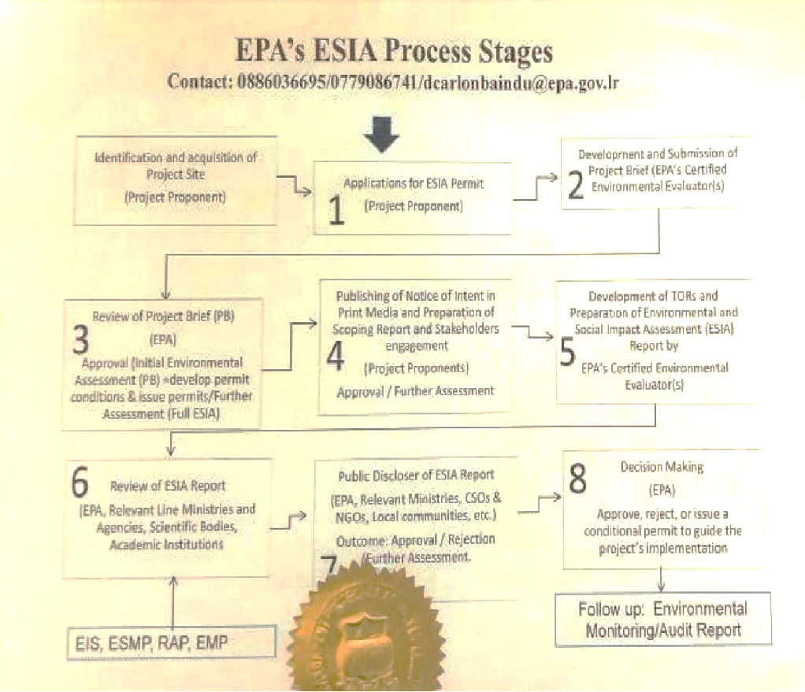

ESIA Process of the EPA of Liberia

Figure 5: ESIA Process Stages of the EPA

4.3 International and Regional Requirements
There are many Multi-Lateral Environmental Agreements (MEAs) that are relevant to the proposed project. Liberia is a signatory to several international conventions and agreements and legal obligations concerned with environmental and social issues. Table 4 provides International and Regional requirements relevant to the implementation of the project.

Table 4: International and Regional Requirements Relevant to the Project
Convention/Treaty | Ratification date | Objectives
1. OAU Convention on  Conservation of Nature and  Natural Resources | 21/09/1978 | Encourages action to conserve, use and develop soil, water, flora, and fauna sustainably.
2. Convention on International Trade in Endangered Species of  Wild Fauna and Flora (CITES) | 11/03/1981 | Ensures that international trade in specimens of wild animals and plants does not threaten their survival.
3. Convention on Biological  Diversity (CBD) | 08/11/2000 | - Promote Conservation of Biological Diversity  - Sustainable use of its components  - Fair and equitable sharing arising out of the utilization of genetic resources
4. The Cartagena Protocol on  Biosafety to the Convention on  Biological Diversity |  | To contribute to ensuring adequate protection in the field of living-modified organisms resulting from modern biotechnology
5. The United Nations Framework Convention  on Climate Change | 2003 | To achieve stabilization of greenhouse gas concentrations in the atmosphere at a level that would prevent dangerous anthropogenic interference with the climatic system
6. Ramsar Convention On  Wetlands of Importance | 02/11/2003 | - To manage wetland systems so that the human uses of these areas are undertaken in such a way as to retain their natural capital for future generations.  - To encourage and support countries to develop and implement national policy and legislative frameworks, education, and awareness-raising programs, as well as inventory, research, and training projects.
Other include
- Discrimination (Employment and Occupational) Convention, 1958
- Worst Forms of Child Labour Convention, 1999
- Equal Remuneration Convention, 1951
- Minimum Age Convention 1973
- Convention on the Conservation of Migratory Species of Wild Animals, 1988
- Convention Concerning the Protection of the World Cultural and Natural Heritage 1972
- Vienna Convention on the Protection of the Ozone Layer
- Convention on the Elimination of all forms of Discrimination against Women

4.4 Institutional Framework

Several institutions have statutory responsibility for the implementation of environmental and social management in Liberia, including the EPA and relevant ministries and agencies, and other governance structures at the level of the local government. The EPA is however the lead agency for the management of the environment in Liberia. Other agencies and ministries with environmental management responsibilities that the EPA coordinates with include the Ministry of Public Works, the Liberia Land Authority (LLA), the Ministry of Mines and Energy (MME), the Ministry of Agriculture (MoA), the Forestry Development Authority (FDA), and the Liberia Land Authority (LLA). Other institutions, including the Liberia Water and Sewer Corporation (LWSC), Liberia Electricity Corporation (LEC), Ministry of Gender, Ministry of Labour, Ministry of Health, etc. have various responsibilities and coordinate with the EPA as well.

4.4.1 Environmental Protection Agency (EPA)

The EPA is responsible for monitoring, coordinating, and supervising the sustainable management of Liberia’s environment. It is mandated to ensure the conduct of environmental impact assessments for all projects and activities that are likely to have significant adverse effects on the environment.
The Environment Protection Agency is established under Part-II sec. 4 of the Act creating the Environmental Protection Agency of Liberia (Nov. 26, 2002) as a body corporate. The Agency shall be a policy-coordinating body with specific functions as set out in section 6. The National Environment Policy Council shall be the supreme policy-making body in the field of environment in Liberia (sect. 7). The Agency shall be governed by a Board of Directors, the functions of which are set out in section 13, considering the gender perspective. The Agency shall establish a County Environment Committee and appoint a County Environment Officer for each county (sects. 24 and 25). District Environment Committees shall be established under section 26 and District Environmental Officers appointed under section 27. Sections 30 and 31 provide for environmental planning. Sections 32 to 44 provide for enforcement and control including Environmental Restoration Orders, Environment Easement Orders, monitoring, and auditing of environmental effects.

4.4.2 Ministry of Public Works

The Ministry of Public Works is the custodian, and the project road is under the supervision of the Ministry of Public Works (the project proponent), as the statutory governmental agency empowered to do so. The Ministry of Public Works has established an Infrastructure and Implementation Unit to supervise and monitor infrastructure projects, approve the design and construction of all civil works, and carry out urban and town planning, as well as provide architectural and engineering supervision of all infrastructure projects in the country. Therefore, the responsibility for ensuring that mitigation measures specified in this ESMP and the contract documents are implemented accordingly.

4.4. 3 Liberia Land Authority

The LLA, established by an Act of the National Legislature on October 6, 2016, as an autonomous agency of the Government with operational independence, subsumes land functions that were performed by several agencies of government, including the key land administration agencies. The primary mandate of the Authority is to develop policies continuously, undertake actions and implement programs in support of land governance, including land administration and management.
The project, in collaboration with the Liberia Land Authority, will support communities to self-identify, manage their land, and resolve land acquisition cases that may arise during the project lifecycle.

4.4.4 Ministry of Mines and Energy

The Ministry of Mines and Energy was established by an act of Legislature as part of the executive branch of government to administer all activities related to mineral, hydrocarbon, water, and energy resource exploration, coordination, and development in the Republic of Liberia. The new Minerals and Mining Law of Liberia was approved and became effective in April 2000.

The Ministry of Mines & Energy plays a major role in supporting the project in terms of geological site identification for suitable quarry or sand mind, identification of storage sites for the storage of blasting chemical explosive materials, granting of noncommercial blasting and quarry licenses, etc.

4.4.5 Ministry of Agriculture

Agriculture, including forestry, is the primary livelihood for more than 60 percent of Liberia’s population and accounted for 31 percent of Liberia’s 2021 real gross domestic product (GDP) with cassava and rice being the country’s primary staple food crops. The Ministry of Agriculture was established by an Act of the Liberia Legislature on May 11, 1972, to have oversight of agronomy, animal husbandry, and other agriculture industries, the economic organization of the agriculture and food industries, and national food security.

The Ministry of Agriculture assists the project in the resettlement action plan (RAP) evaluation specifically with affected tree crops (see annexure for the price listing/value of tree crops). The Ministry also guides the protection of wildlife, fish, etc.

4.4.6 Forestry Development Authority

The Forestry Development Authority is a state corporation established by an Act of the Legislature in 1976 with the mandate of ensuring the sustainable management and conservation of Liberia’s forest and related natural resources for the benefit of current and future generations. This mandate was further strengthened through the National Resource Law of 1979. The 2006 National Forestry Reform Law is the current legal instrument that guides the management of forest resources in Liberia.
The role of the FDA is to assist the project in the identification of the forest/wildlife reserved site either for quarry or sand mining and to guide the project against ecosystem services lost (e.g., medicinal plants, water sources, etc.).

4.4.7 Ministry of Health and Social Welfare

The Ministry has a Department of Environmental and Occupational Health that handles matters relating to water and sanitation and general environmental issues. It mandates require that sanitary and working environments are conducive for all workplaces, to ensure the health and safety of workers and nearby residents. The Ministry also provides capacity building and training of environmental health technicians. The Ministry also exists a project for awareness of STDs, HIV/AIDS, Teen Age Pregnancy, a campaign on Gender-Based Violence, awareness of disease outbreaks, etc.

4.4.8 Ministry of Finance, Development and Planning

The MFDP is responsible for inter-sectoral coordination for the development of policies, plans, and programs for the economic, financial, social, and physical development of Liberia.
In fulfilling its various duties, the MFDP serves as the direct link between implementing ministries/agencies, NGOs, PVOs, and the international community. The Ministry (MFDP), through its Project Financial Management Unit/Project Management Unit (PFMU/PMU), manages and disburses donors ‘project funding at the request of the implementing agency.

The ESIA requires the setting up of an environmental, health, and safety office by the contractor that will be responsible for the management of the EHS components during the implementation of the project.
The E&S officers of the Project Implementation Unit/MPW (as the project client) shall ensure the effective implementation of the environmental management plan. It is expected that the E&S officers will participate in the hiring of both the contractor and consultant’s environmental experts who shall master all environmental recommendations and the proposed action plans, timeframes, and expected targets. The environmental experts shall manage and handle all environmental issues arising during the implementation of the project.

4.5 The African Development Bank’s(AfDB) Safeguards Requirements

In 2013, the Bank adopted an Integrated Safeguards Systems (2013 ISS) which established the Bank Group’s commitment to promote the sustainability of project outcomes by protecting the environment and people from the potentially adverse impacts of projects. In April of this year (2023), the Bank updated the 5 Operational Safeguards (OS1-5) to 10 Environmental and Social Operational Safeguards (E&S OS1-10) for its program-based operations.
The five (05) Environmental and Social (E&S) Operational Safeguards establish the standards that Borrowers will meet, as appropriate, in projects, activities, and initiatives supported through Bank financing throughout the life cycle of operations, as follows:
- E&S Operational Safeguard 1 (OS1): Assessment and Management of Environmental and Social Risks and Impacts.
- Operational Safeguard 2 (OS2): Involuntary resettlement land acquisition, population displacement and compensation
- Operational Safeguard 3 (OS3): Biodiversity and ecosystem services
- Operational Safeguard 4 (OS4): Pollution prevention and control, hazardous materials and resource efficiency
- Operational Safeguard 5 (OS5): Labour conditions, health and safety
The E&S Operational Safeguard 1 (OS1) applies to all projects, activities, and other initiatives for which Bank financing is sought. OS1 establishes the importance of:
- The Borrower’s existing environmental and social framework in addressing the risks and impacts of the project;
- An integrated environmental and social assessment to identify the risks and impacts of a project, activity, or other initiative;
- Effective stakeholder engagement through disclosure of relevant information, consultation, and effective feedback; and
- Management of environmental and social risks and impacts, including climate risk and adaptation, by the Borrower throughout the life-cycle of operations. The Bank requires that all environmental, social risks and impacts, including climate vulnerability and adaptation, of the operations be addressed as part of the environmental and social assessment conducted per OS1.
The Bank’s Policy on Disclosure and Access to Information reflects the Bank’s commitment to transparency, accountability, and good governance, and applies to the entire ISS. It includes the disclosure obligations that relate to the Bank Group’s Operations.
The ISS includes provisions on grievance redress and accountability. Project-affected parties will have access, as appropriate, to project grievance mechanisms, local grievance mechanisms, and the Independent Recourse mechanism (IRM). Project-affected people will utilize the available project grievance redress mechanism (GRM), as the first step, in seeking a resolution for their grievances; they may also bring their concerns directly to the Bank’s attention. The Bank will engage with the borrower to address the concerns. Stakeholders may also submit their complaint to the IRM to request an independent review to determine whether harm has occurred as a direct result of the Bank’s non-compliance with its own policies and procedural requirements.

4.5.1 Differences Between the Borrower’s Existing Environmental and Social Framework Requirements and the Af DB's ISS

There are several policies, laws, and regulations specific to areas of environmental impact that affect the construction and rehabilitation of roads in the country. As a matter of policy, Part III Section 9 (1. a) and 10 (1); of the Environmental Protection and Management Law of Liberia (EPML) 2003, requires a project proponent/applicant to timely prepare the required documents in accordance with all procedures and guidelines prescribed by the Agency prior to the implementation of a proposed project; section 13, 14 and 15 of the EPML requires an Environmental & Social Impact Assessment (ESIA) and ESMP for Projects that would have a significant impact on the environment. The construction of the proposed John Davies Town-Zwedru (48.5 km) road is listed among those Projects requiring an Environmental Social Impact Assessment (ESIA). As such, there is a statutory requirement for conducting an environmental impact assessment for the proposed Project. In addition, other existing pieces of international and national legislation and regulations have relevance to the development and implementation of this project with regard to environmental and social concerns. The policies, regulations, and administrative frameworks expected to be met for this project include those of the AfDB (ISS-2023) and the EPA’s policy.

Table 5: Comparison of EPA ‘s Policy (ESIA/SEA, 2022) Procedural Guidelines and Policy of AfDB’s ISS (OSs, 2023) and Gap Assessment and Gap Filling Measures
GAP | YES | Suggest there is a gag
GAP | NO | Suggests no gap
No | AfDB’s Integrated Safeguards (E&S OSs, 2023)’s Requirements | EPA Liberia’s ESIA/SEA Procedures Guidelines (2022), & EMPL (2003) | Gap | Measures to Bridge the Gap
 | E&S OS1: Assessment and Management of Environmental and Social Risks and Impacts. | Sec. 2-2.5: Prior to the commencement of works, a proponent whose project /activity falls under the prescribed list of Annex 1 of the Environment Protection and Management Law of Liberia (EMPL) is required to obtain an application for EIA permit/ license | No gap | N/A
 | E&S OS2: Involuntary resettlement land acquisition, population displacement and compensation | Part II Sec. 87 of the EPML provides for Land Use. | Yes | Although the EPML provides for Land Use, it does not have a clear provision for Land Acquisition or Involuntary Resettlement. It is recommended therefore that the EPA link with Liberia Land Authority to include provisions for especially Land Acquisition or Involuntary Resettlement for development projects.
 | OS3: Biodiversity and Ecosystem Services | Part VII Sec.83-94 of the EPML provides provision for the protection of biodiversity, National Heritage, and the Ozone Layer | No Gap | The bridge of these provisions should be improved by strong enforcement measures in place both by the Bank and the EPA.
 | OS4: Pollution prevention and control, hazardous materials and resource efficiency | Part IV Sec. 51-73 of the EMPL provides for pollution prevention | No gap | Although the EMPL provides provisions for pollution prevention, no clause or provision for resource efficiency.  Recommendation: EPA must provide for resource efficiency.
 | OS5: Labour conditions, health and safety | Both ESIA/SEA procedural guidelines nor EPML does not have provisions for labor and working conditions although this is provided as an Act (2015) under the Ministry of Labor | Yes | The welfare of any project workers is essential hence, EPA should consider incorporating labor provisions for all road projects.

Based on the above analysis of the government provisions and AfDB’s OSs, the deficiencies identified in the national EIA framework are addressed through administrative, legislative, or regulatory change and/or institutional strengthening and capacity building.

5.0 DESCRIPTION OF THE PROJECT ENVIRONMENT

The collection of baseline information on physical, biological, and socio-economic aspects of the project area is the most important reference for carrying out environmental impact assessment studies. The description of environmental settings includes the characteristic of the area in which the activity of the project road would occur and the cover area likely to be impacted by anticipated environmental impacts. For environmental assessment along the project road, information and data have been obtained by intensive site visits, primary data collection by monitoring and analysis, secondary data from published sources, and various government agencies. Important ecosystem components have been systematically analyzed in this environmental assessment report.

5.1 Physical Environment

The physical environmental profile along the project road has been discussed in the following subsections:

Topography

Grand Gedeh County is a much hillier region, as compared to River Gee County. Particularly near the northwestern flank of the road, the Putu Range is seen. This region is a portion of the highlands of the country. Nearing River Gee County, there are generally gently rolling with wide and shallow valleys with the following identified geographical belts: mangrove swamps and beaches along the coast, wooded hills and semi-deciduous shrublands along the immediate interior, low mountains in the northeast, dense tropical forests, and plateaus in the interior.
Geology

Geological investigations in Liberia have shown that nearly all the terrain is underlain by Precambrian crystalline rocks which form part of the West Africa Shield. The country can be divided into three (3) geological regions, namely the Liberian Age Province, the Eburnean Age Province, and the Pan African Age Province. The Liberian Age province is underlain by rocks aged between 2.5 and 3.0 billion years, Eburnean Age Province aged between 2.0 and 2.5 billion years and the Pan African Age Province aged less than 500 million years.
Geography
Grand Gedeh has lower tropical forests which have mid-size hills composed of various valleys and water courses. These forests receive a very high rainfall ranging from 3,000mm (120in) to 4,100mm (160in) per year in two distinct seasons. It has evergreen forests while in the uplands it is conducive for rice cultivation, the low-lying areas are conducive for yam, cocoa, plantains, potatoes, vegetables, rubber, coffee, and sugarcane. Grand Gedeh County has two community forests, namely-Neezonnie, occupying an area of 42,424ha (104,830 acres), and Blouquia, occupying an area of 43,796ha (108,220 acres). There are three National plantation areas namely-the SIGA Reforestation Project (247.2ha(611acres)), EAC Reforestation Project (59.2ha(146acres)), and the WATRACE Reforestation Project (58.4ha(144acres)). It also shares the National proposed Reserve of Grebo Forest (97,136ha (240,030 acres)) with River Gee County.

Water Resources and Drainages

The project area is endowed with abundant water resources. Data from the rural water supply program indicate that the depth of the water table in wells can be less than 10 meters, especially during the rainy season. Drilled boreholes can be as deep as 100 or more meters. Grand Gedeh County has large rivers: the Jay River, located in the East, the Neemi River, Feeley River, Gbornee River, and the Dugbeh River run across the project road. The project road crosses major rivers and streams as well as small tributary creeks. The major rivers and streams are perennial whilst most of the tributary creeks are ephemeral. These ephemeral creeks often run completely dry during the dry season, except for a few localized depressions in the creek bed.
The project area lies in a predominantly undeveloped watershed and traverses largely through forest. The topography can best be described as undulating with few hilly and mountainous sections. The catchment is covered with a thick forest of equatorial type with high tree canopy except at the towns and villages along the corridor where there is virtually no grass cover.

Climate and Rainfall

Rainfall

Located at an elevation of 230.64 meters (756.69 feet) above sea level, Grand Gedeh has a Tropical monsoon climate (Classification: Am). The city’s yearly temperature is 26.31ºC (79.36ºF) and it is -0.55% lower than Liberia’s averages. Grand Gedeh typically receives about 302.42 millimeters (11.91 inches) of precipitation and has 275.73 rainy days (75.54% of the time) annually.

Liberia experiences more rainfall than other areas in West Africa. The continental and maritime air masses alternate their movements back and forth and from north to south. This brings some seasonal differences in rainfall intensity. The coastal region has the heaviest rainfall from between 3900mm to 4500mm annually in the west and about 2500mm of rainfall annually in the southeastern part of the country. Rainfall decreases going north and inland except highlands and the northernmost part of the country. The eastward of the country following the Cavalla River receive over 1700mm of rain annually.

Humidity, Temperature, Wind, and Sunshine

The mean monthly relative humidity varies between 70 and 90%. The mean daily bright sunshine hours vary more than 4.0 hours. The mean monthly temperatures of the project catchment vary from 24.5⁰C and 27.5⁰C. Wind speeds are generally light being of the order of 6 knots. Strong winds are usually associated with convective thunderstorm activity during the rainy season and are short. Temperature, humidity, and wind affect run-off. High temperatures, low relative humidity, and strong winds result in higher evaporation and subsequently reduce runoff. The highest temperature recorded in the project area is 32°C and the minimum is 22°C

5.2 Biological Environment

Biological resources represent one of Liberia’s most abundant raw material resources. Biodiversity contains ecological, economic, and socio-cultural values that justify the need for conservation and sustainable use. The range of biodiversity in Liberia includes forests, wildlife, mangroves, wetlands, and swamps. Liberia's biodiversity is under threat due to many factors such as ignorance, insufficient public education, and awareness, shifting agriculture, unregulated logging, unplanned roads in logging areas, unplanned human settlements, fuel wood gathering, charcoal production, population pressure, and establishment of rubber plantations.
Fauna

The Liberian Forest serves as a habitat for large amounts of endemic flora and fauna and is a unique ecological niche for some of the rarest species in the world. The Jentink’s duiker (the rarest in the world), white-breasted guinea fowl, pygmy hippopotamus, Diana monkey, Liberian mongoose, the giant forest hog, chimpanzees, red Colombus (a long-tailed monkey), bongo antelope, leopard, and the golden cat are amongst the animal population inhabiting Liberia’s forests. It is also home to hundreds of birds, nine of which are endangered; several dozens of reptiles, including three types of crocodiles and at least eight poisonous snakes; amphibians and at least a thousand different insects.

Flora

The vegetation found covering the project area consists of primary and secondary forests and savannah. Most of the forests along the road are open, with only insolated huge trees such as Antaris toxicaria, Pentaclethra macrophylla, Piptadenias-trum africanum, and Sacoglottis. Terminaliasuperba and Triplochiton, scleroxclon, which were giving abundant forest-regrowth. They are 260 species of trees, including the Mahogany, African Walnut, Mahere, Teak, Ebony, Ironwood, Makore, Sikon, and Camwood within the project area of influence.

Shifting cultivation practices are also destroying the forests in the area. The road runs through a range of luscious secondary forests, with few rubber and palm farms along the road. The coastal vegetation consists of mangrove swamps, savannah woodland, and patches of forest scattered in fields of grassland.

It was found out that along the John Davies Town to Zwedru corridor, about 20 farms will be affected. Few rubber and banana trees within the right-of-way at these farms will be cleared.

5.3 Human Environment-Socio-Economic Baseline

This data has been compiled using a secondary source from LISGIS and a primary source from the social survey conducted in the project area.

This section seeks to assess, evaluate, identify and the social and economic situation of the proposed project area of influence. It highlights key issues such as livelihood, economy, health, education, demography, income, food, jobs, market, waste, sanitation, hygiene, etc.

Livelihood

The communities in the project area of influence have social networks and support systems. Generally, social networks include associations along professional lines. For example, tailors, marketers; other associations are based on age, such as youth groups. On the other hand, some associations are on a gender basis such as the women's development groups. Such interactions are used to promote and protect personal relationships and welfare. Other social network in the project area of influence is called “Susu.” This social network is particularly a support group of small-scale businessmen and women, and investors coming together for saving and loan purposes. The Susu does not only provide financial security to its members but fosters solidarity and greater cohesion within the communities. In general, the main source of livelihood for people within the project area are farming, gold mining, fishing, etc.; hunting/poaching is scarce or minimized due to the presence or patrol of forest rangers from the FDA.

Demographic Characteristics

- Population Size

The population of Grand Gedeh County is estimated at 125,258 with male and female populations at 51.9% and 48.1% respectively (LISGIS, 2011). In Grand Gedeh County, the road under Lot 3 traverses the Tchien and Putu Districts. The total population of Tchien and Putu Districts is 48,402, representing 38.6% of the Grand Gedeh County population, with male to female population ratio estimated at 51.9% to 48.1%. The population distribution of Lot 3 project road is presented in Table 6 below:

Table 6: Population Distribution of Districts within the Project Area
Grand Gedeh Co. | MALE |  | FEMALE |  | TOTAL
District | No. | % | No. | % | No. | %
Tchien | 16,019 | 50.1 | 15,957 | 49.9 | 31,976 | 13.1
Putu | 9,044 | 55.1 | 7,382 | 44.9 | 16,426 | 25.5
Gd. Gedeh (Total) | 64,994 | 51.9 | 60,264 | 48.1 | 125,258 | 100

Age Distribution
During the socio-economic study of the project area, a sample size of the population was considered. A total of 139 persons were interviewed in Grand Gedeh County– 64 males and 75 females. Out of this sample population, 77.7% fell between the ages of 18 and 59, while 22.3% were 60 or above. This latter group of persons was seen to be non-active.

Ethnicity and Religion
Zwedru is in Tchien District of Grand Gedeh County, near the Cavalla River in the country’s south-eastern region and near the border with Cote d’Ivoire, and is located 350 miles away from the capital city of Monrovia. The main ethnic group in Grand Gedeh County is Krahn. The Krahn ethnic group constitutes 88.5% of the population in Grand Gedeh. Most of the inhabitants are Christian followed by a small population of Muslims and practioners of African Traditional Religion.

Transportation
The predominant mode of transport within the project influence area is road transport with motorbikes in large numbers although truck also travels the route for business and other agricultural or logging and mining activities. Some sections of the road remain in a very deplorable condition, especially with heavy passage of trucks.
Waste
There are no specialized waste disposal sites within the project area that include Zwedru City in Grand Gedeh. Locals practice open dumping. Municipal wastes and other commercial waste generated especially in Zwedru are usually buried, burnt, or dumped on road shoulders or in the open or wastelands or wetlands. Waste generation, collection, and management will be eminent during both the construction phase and the operational phase of the project development hence, it is advisable to begin arrangements with county authority, EPA’s County Inspector, NGOs involved with waste collection and disposal, youth groups, women groups, etc. for the disposal of project waste. Discussion can be reached for plans, development, and design of a future landfill site that would complement the road construction activities and the county at large.

Sanitation and Hygiene
On July 12, 2017, the World Health Organization (WHO) indicates that Liberia is one of the countries in Sub-Saharan Africa (SSA) where access to WASH services is persistently and critically low. The report estimated that 90% of the country’s population does not have access to safely managed drinking water and sanitation services. For instance, only 4% of the population has access to piped water, forcing 13% to depend on untreated surface water and another 40% to commute more than 30 minutes to get clean water. In addition, as much as 82% of the populace does not have access to safely managed sanitation facilities, causing 40% to engage in open defecation. The majority of the population along the project corridor in Grand Gedeh County practice open defecation, bushes, and others use water sources. Also, more people rely on creeks/streams and wells/handpumps for drinking and other household activities.
Health Care
The healthcare delivery system in Liberia is a daunting reality that continues to impede the fabric of the population. Poor and lack of primary health care system is unequivocally an urgent threat to a healthy society and by extension a great fraction of the poorer population. The governmental hospital as well as all other clinics in the County is supported by international non-governmental organizations, with the government playing a leading role through the Ministry of Health and Social Welfare (MoHSW). Grand Gedeh County has 2 hospitals including the Martha Tubman Memorial Hospital, Zwedru, and the Ziah Town Hospital, Ziah Town. One clinic exists along the project road.
Education
Literacy attainment among the population varies, and shows significant inequality, by gender, locality, and income (ES-B). People who are female, poor, and living in rural areas are less likely to be literate than their male, wealthy and urban counterparts. Education remains a challenge for local people along the project corridor although with people living in the City of Zwedru, mainly youth between the ages of 5-22 schooling compared to other parts of the County, the literacy rate is encouraging.
Energy
The electricity supply system in Liberia is operated by the Liberia Electricity Corporation (LEC). It is based on a Central Monrovia City System with radial lines extending into the country and independently isolated grids. Through the Government of Liberia, Grand Gedeh County relies on the neighboring Ivory Coast for power supply. Private generators are secondary sources of power supply to local people and they are available only to the few who can afford fueling and servicing costs. The main source of energy is charcoal made from the wood of local trees.

Water Supply
The Liberia Water and Sewer Corporation (LWSC) is in charge with the mandate of providing water supply for urban communities while the Department of Rural Development at the Ministry of Public Works and other NGOs are providing water supply through the installation of handpumps or boreholes to rural communities. Prior to the civil war precisely in 1990, there were 11 cities with piped water supply systems in Liberia. Four of these were based on groundwater sources. The destruction of most of these facilities means that today over 90% of the population has to rely on groundwater for water supply. The Monrovia urban area had the most sophisticated system with an impounding reservoir, water treatment plant, and distribution network although not stable.

Economy & Market
Nationwide, it is estimated that about 70 percent of the population lives on less than $1.90 per day, which is, on average, 20 percentage points higher than other developing countries in sub-Saharan Africa. The Liberia economy faces numerous, longstanding constraints to economic growth, including weak transportation infrastructure, unreliable utilities, and inefficient bureaucracy. However, the development of the proposed project road will to some extent improve the living condition of the people in the project area and Grand Gedeh as a whole. The project will create job opportunities, especially for people that fall directly within the project area.
Land Resources
Since the end of the civil unrest in Liberia, Land resources and associated conflicts have been a frequent and permanent social crisis nationwide. The Liberia Land Rights Act (LRA) was passed into law in 2018. The Act defines and delineates the different categories of land in Liberia into Private Land, Public Land, Government Land, and Customary Land. The Land Rights Act of 2018 regulates the form and manner of land acquisition, ownership, use, and management in Liberia. The Liberia Land Authority (LLA) is currently working in the County to confirm GoL land. This ESIA seeks to determine the status of the acclaimed property considering the potential for customary rights, private land rights, concession agreement overlaps, and potential resettlement requirements.

6.0 POTENTIAL IMPACTS OF THE PROPOSED PROJECT

6.1 Introduction

It is certain that the upgrading works will have adverse environmental and social impacts as well as several positive impacts. The following process was used for the impacts identification:

- Through an intensive and extensive field surveys, as well as key stakeholder consultation and public participation forums conducted on the proposed project area;

- Stakeholders were identified using a stakeholder identification matrix and were involved in the identification of the potential impacts

- Professional judgement from experts and other technocrats to provide a complete list of expected impacts on the road project with regards to the social, cultural, and environmental resources.

The potential environmental and social risks and impacts likely to arise were identified by matching the project activities with the surrounding environmental and socio-cultural resources.

The impacts have been categorized according to construction, operation, and decommissioning phases of the project. The magnitude and the extent of the impacts were also quantified in this report.

The negative and positive impacts likely to result from the project are generally associated to the social and biophysical environment and the economic aspects along the area that the road will traverse.

6.2 Methodology for Impact Identification

The road is being classified as Category “1” project based on the EPA and the AfDB’s ISS implying that the project is likely to have significant environmental and social impacts. The scale that was applied in the analysis of impacts is shown in Table 7 below. In making the observations in Table 7, expert knowledge based on the magnitude of the predicted impacts was relied upon. Positive impacts are designated by (+) and negative impacts by (-).
Table 7: Levels of Scale Used in the Impacts Analysis
Value | Description | Scale Description
0 | No impact | This means that to the best knowledge of the expert, the
 |  | particular activity/action will not have any known impact on
 |  | normal functioning of either the human or the natural systems
 |  | and does not therefore warrant any mitigation.
±1 | Minimal | Any activity with little impact on the environment calls for
 | impact | preventive measures, which are usually inexpensive and
 |  | manageable. Such activities have minimum impacts on either natural or human environment or both. It may also represent a minimum positive impact.
±2 | Moderate | A moderate impact will have localized effect on the
 | impact | environment. If the effect is negative and cumulative, action in form of mitigation measures needs to be put in place to ensure that it doesn’t become permanent
±3 | High impact | An impact is high if it affects a relatively high area (spatial),
 |  | several biological resources (severity) and/or the effect is felt
 |  | for a relatively long period (temporal) e.g. more than one year.
 |  | In case the effect is negative, such an impact needs to be given timely consideration and proper mitigation measures put in place to prevent further direct, indirect or cumulative adverse effects. This may also represent moderate positive impact.
±4 | Very high impacts | Such an activity rates highly in all aspects used in the scale i.e., temporal, spatial and severity. If negative, it is expected to affect a huge population of plants and animals, biodiversity in general and a large area of the geophysical environment, usually having trans-boundary consequences. Urgent and place to prevent further direct, indirect or cumulative adverse effects. Activities must be suspended until sufficient effective mitigation measures are put in place.
5 | Not known | There are activities for which impacts are not yet known e.g.,
 |  | some chemicals are suspected to produce carcinogenic effects, but this has not yet been confirmed.

6.3 Environmental and Social Risks and Impacts

6.3.1 Beneficial Environmental and Social Impacts

The project is expected to create several benefits particularly during during construction and operational phases. The important benefits ar described in the following sections.

- Creation of Employment Opportunities
The proposed project will create jobs for professionals, skilled as well as unskilled labour at the constructional and operational stages. The services of artisans, site clearers, construction workers, Resident Engineers and surveyors, plant operators and environmental health and safety officers will be required to construct and effectively implement the project. Community members will have the opportunity to work as unskilled labourers with the possibility of the company upgrading their skills for them to take up more challenging positions. Other jobs such as provision of catering and other services as well as the sale of groceries will accrue as indirect benefits. These jobs are expected to improve the economy of the area and improve the livelihoods of the local people.

- Improvements in the Local and National Economy
Income from the salaries and wages will improve the economy of the town centres and the county at large due to the provision of employment to the locals. The contractor will procure most materials from the project area and as such contribute positively to the local and national economy. The materials for construction may also be procured from other parts of the country, thus positively affecting the national economy.

This impact will be very high hence given a value of +4.

- Transfer of Skills

Many people from within the project area will be employed to provide different services. As such, the local people will learn new skills from the civil Resident Engineers, welders, masons and other employees that come from beyond the project area. This impact will be moderate hence a value of +2.

- Establishment of Market and Supply for Building Materials

The contractor will have to procure building materials such as sand, cement etc. from suppliers within the area or else go beyond the area. Suppliers will have to establish in the area to provide such materials.
This impact will have a moderate positive impact hence a value of +2.

- Improvement of Local and Regional Trade and Business Opportunities

The road will lead to the growth of local and regional trade. In the construction phase, building materials for road construction will be purchased both locally and regionally. Other small scale business people such as food vendors, kiosk owners will also benefit during the construction of the road. Farm products will be transported efficiently from the project area to local and regional markets. The export trade will also improve as a result of the development of the road.
This impact will be moderate hence a value of +2.

- Revitalization of Large-Scale Agriculture in the Area

The project area is agricultural coupled with gold mining activities. The locals are largely farmers and gold miners. However, the up scaling and growth of the mining and farming have been hindered by the poor transportation network in the region. Therefore, the construction of the proposed road project in the area will offer numerous opportunities for farmers to upgrade their business and hence lead to the improvement of agriculture.
This impact will be very high; hence value of 4.

- Improved Security

It is expected that the proposed road project will lead to an improvement of security. There may be deployment of police along the project area during the construction. Road patrols may be conducted frequently during the operational phase thereby improving the security of the area.
This impact will be very high hence a value of +4.

- Reducced Travel Cost and Travel Time

The proposed road project will provide a faster and cheaper means of transport for cargo and passengers. This will considerably reduce travel time and transportation costs being incurred currently and improve the current transport situation along the road. At present and during rainy seasons, the road is rendered impassable; however, asphalting will solve this problem. Provided along with the road project are bridges and associated road infrastructure which shall be constructed to enhance transportation.

- Improved Road Safety

Road projects can lead to reduction in accidents when they involve significant improvements in vertical and horizontal alignments, improved carriageway width, junction layout or greater separation of pedestrians, non-motorized traffic, and motor vehicles. The improvement of the project road may lead to significantly increased running speeds; the standard speed of the road will be 60 Km/hr in settlement areas and 100 Km/hr on highways and is likely to induce significant generation of traffic. This will shorten the travelling time and transportation cost.
The proposed project design will contribute to improving road safety and the comfort of road users in several ways such as:
• Sight distance and visibility especially at approaches to bridges will be improved;
• Road signs (both warning and directional) and road markings will be included in the design;
• Adequate shoulders will be designed throughout its road corridor;
• Provision of guardrails, etc.

This impact will be high; hence the value of 3.

6.3.2 Adverse Environmental and Social Risks and Impacts

Nothwithstanding the immense positive benefits the project is expected to deliver, the impacts analysis has identified several environmental and social risks and adverse impacts that will need to be mitigated inorder to maximise the potential environmental and socio-economic benefits of the project while ensuring that the project is delivered in environmentally friendly and socially acceptable ways. The main potential impacts and risks during construction and operation phases are discussed in the following sections.

- Involuntary resettlement, Land Acquisition and Loss of Livelihood

- The project will affected 294 structures, inclduing 8 graves, 113 commercial facilities, 133 resendential structures, 2 hand pumps, 3 churches, 1 clinic, and 2 market buildings. A total of 246 project affected persons have been recorded and 147 of them are expected to be economically displaced.
- Loss of Portions of Farmland or Tree Crops - About 20 farmlands or tree crops will be affected
- Displacement of People- About 246 persons will be displaced by the project

This impact is very high, hence a value of -4.

- Loss of vegegation
During the construction phase of the project, there will be clearance of vegetation along the corridor to pave way for the proposed road. It is expected that project will require huge quantities of materials such as ballast, murram, stones, conglomerates, sand, gravel, and soil, among others. In addition, the contractors will install several material camp sites as well as a batching plant that will impact on the environment, especially with the vegetation cover around the camp sites. The Contractor shall ensure that campsites and quarries are constructed in areas that are not high in vegetation density. An estimated area of about 20 ha of arable/farm land and vegetation in the right-of-way will be cleared including land for borrow and quarry sites. All borrow pits and

- The Risks of Adverse Impacts on Communities from Temporary Project Induced Labor Influx
The project will require labor force, goods, and services that cannot be fully supplied locally due to lack of sufficient number of skilled labor locally and the unavailability of many services that are required for the works. A very large proportion of the workforce of the project will come from other areas of Liberia and internationally. Besides the workforce, a large number of people are expected to move into the work area for various reasons. Some of the social risks will include: (i) risk of social conflicts, (ii) increased risk of ilicit behavior, (iii) increased burden on and competition for public service provision, and (iv) location infliction of prices and ncreased pressure on accommodations and rents. Labor influx associated environmental risk will include (i) increased use of / demand for natural resources; (ii) increased demand on freshwater resources; and (ii) inadequate waste disposal and illegal waste disposal sites.

- Noise Pollution and Excessive Vibrations
Excavation, construction, and demolition works in the project area will usually result in high noise and vibration levels. Noise and vibrations will emanate from transportation vehicles, construction machinery, metal grinding and cutting equipment, and among others. However, the Contractor shall take appropriate steps to minimize noise pollution through provision of appropriate personal protective equipment to construction workers, reducing the frequency of transportation of construction materials and ensuring that all construction machinery is well maintained.

This impact will be moderate hence a value of -2.

- Air Pollution

During the construction, excavations, demolitions, and transportation of construction materials will result in the emissions of large amounts of dust within the project site and surrounding areas. The diversion of traffic in the construction phase will also contribute to dust emissions. This will be a serious concern particularly in the towns and villages along the corridor. This impact will be moderate hence a value of -2.

- Increased solid waste generation

Volumes of solid wastes will be produced during the different phases of the project development. Solid waste materials will be generated during demolition works as well as from various packaging materials. Significant quantities of rock and soil materials will be generated from earth moving during construction activities. Solid waste generation during operation and maintenance activities will include road resurfacing waste (e.g. removal of the old road surface material), road litter, illegally dumped waste, or general solid waste from campsites; vegetation waste from the clearance of road reserves; and sediment and sludge from storm-water drainage system. Paint waste may also be generated from road and bridge maintenance (e.g., due to removal of old paint from road stripping and bridges prior to re-painting). This impact will be moderate; hence a value of -2.

- Increased Energy Consumption
The construction of the proposed road is expected to lead to an increase in traffic between John Davies Town to Zwedru. Also, most of the traffic will be flowing faster. It is thus expected that this will lead to increased consumption of fossil fuel particularly petrol and diesel. It is also expected that there will be high consumption of fossil fuels due to high number of construction machineries and trucks that will be deployed in the project. In view of the measures that will be put in place to reduce consumption of fossil fuels, this impact will be moderate hence a value of -2.

- Discharge of Sewage and Wastewater and Degradation of Water Quality

A lot of wastewater and sewage will be generated during the construction phase of the project. This will take place in construction camp sites and in various settlements located along the road. This is attributed to increased activities in these towns. There is risk of surface and gound water contanmination due to oil spillage, used oil disposal and others during the construction related activities.
All these have the capacity to degrade surface and subsurface water quality.

Th will be moderate; hence a value of -2.

- Water Abstraction and Consumption

During the reconstruction of the road, there will be increased abstraction of water from rivers and streams situated along the proposed route of the road. The water level increases during the rains due to downpour and reduces during the dry season. The rate of abstraction of water may reduce the flow of water in the rivers especially during the dry season as most of the rivers are seasonal leading to possible degradation of aquatic ecosystems due to reduction in base flows.

This impact will be moderate hence a value of -2.

- Distortion in Hydrological Regime

The expected increase water abstraction from rivers streams and wetlands may modify the hydrological characteristics and regimes of these water bodies. Also, quarries and pits for extraction of road construction materials (ballast, soil, etc.) may provide localized areas for surface water infiltration with the possibility of recharging groundwater aquifers. However, water collecting in such open pits may also provide a large surface for the evaporation of water. Surface runoff may also accumulate along the sides of the highway preventing directly flow to river channels.

This impact will be low; hence a value -1.

- Generation of storm water and impact on drainage

The proposed construction and widening of the road by asphaltic sealing will increase the amount of impermeable surface area, which increases the rate of surface water runoff. The project will also impact on the drainage during the construction phase of the road. There will be increased generation of surface runoff on the road. The increased or excess runoff could overwhelm local drainage system including streams with potential for increasing downstream flooding, damage to property and crops. Flooding downstream can also become a health hazard (e.g. breeding ground for mosquitos, etc.). Good drainage design and construction in the development of roads is critical to the success of road construction. Also, storm water generated on the road may be contaminated with oil and grease, metals (e.g. lead, zinc, copper, cadmium, chromium, and nickel), particulate matter and other pollutants released by vehicles on the highway. Storm water may also contain nutrients and herbicides used for management of vegetation in the rights-of-way.

This impact will be moderate hence value of- 2.

- Increase in Risk of Soil Erosion and Soil Quality Degradation

As earlier mentioned in the sub section above, the reconstruction of the road will involve creation of large impervious surface that restricts the infiltration of rainwater. This leads to high generation of surface runoff that flows on the sides of the road in drainage ditches.
Where the surface runoff is channeled directly to bare steep slopes with loose soil, it can lead to serious soil erosion problem. This can undermine the stability of the road including associated facilities such as bridges. Sediment and erosion from construction activities and storm water runoff may also increase turbidity of surface waters.

This impact will be moderate; hence the value of -2.

- Disturbance to Wildlife

Although the reserved area, the Sapo National Park is some 106Km away from the project area, it is expected that wildlife will roam freely. There exists a concern that the wildlife will be disturbed considering they will not have freedom of movement from one side to the other side of the road since they will only be forced to use the underpasses. The influx of many people working at the project may also cause change in animal behavior. Reduced movement of wild animals may lead to concentration in certain areas leading to overgrazing, damage to natural vegetation and general loss of ecological integrity of the ecosystem along the road. There would also be visual and auditory disturbance due to the presence of machinery, construction workers, and associated equipment.
This impact will be low; hence value of -1.

- Spread of STD, HIV and AIDS

Transmission of these diseases is largely through sexual activity. Promiscuity and marital unfaithfulness are predominant among people who travel from their homes to stay at another place, be it for the reason of work or other. The project is likely to attract migrants into catchment communities who may seek to engage in casual sexual activities, and may also attract sex workers. Casual sex with multiple partners is the vehicle for the spread of HIV/AIDS. An increased number of individuals participating in these high-risk behaviors increase the risk of infection for existing community members, especially the women who offer sexual favors for money.
National surveys by the Ministry of Health (MoH) have indicated that the most affected age groups are those between 20-34 years. Workers in the construction sectors largely fall into this age group and therefore any impact of the epidemic on the age group will likely affect them. Despite a reduction in prevalence of the infection in the country indicating that the situation is stabilizing, there is still a need for concerted action to maintain those interventions that have led to this reduction.
The Contractor will need to work jointly with MPW and appropriate counties and national government health agencies in order to come with a comprehensive STD, HIV and AIDs control programme during the construction and operational phases of the project.

This impact will be moderate; hence value of -2.

- Delays in Transportation

During construction phase, the road traffic will be controlled and, in some cases, complete road closure will be necessary especially at river crossings. This will entail disruption to traffic flows resulting in delay to transport of people and goods. There will be also delays caused by diversion during construction.

This impact will be low; hence value -1.

- Cultural Changes

People from different geographical and social environments have different beliefs and views concerning religion, sacred objects, and traditional practices. Thus, the convergence of many people at communities in the project area has the potential to generate conflict between the migrants and the local people, who may insist on the observance of their values and traditional practices by the migrant community. Thus, the existing community cohesion in the Project area could be impacted through the transformations resulting new businesses and people with differing social value systems.

This impact will be low; hence value 1.

- Occupational Health and Safety

Various occupational Health and Safety hazards will be associated with the project and operation of the proposed road. These will include the physical hazards, chemical hazards, and noise physical hazards. Exposure to road construction materials, dust, exhaust emissions from heavy equipment and motor vehicles constitute chemical hazards during all road construction activities. Road construction and maintenance personnel are exposed to a variety of physical hazards from operating machinery and moving vehicles but also working at elevation on bridges and overpasses. Other physical hazards include exposure to weather elements, noise, work in confined spaces, trenching, contact with overhead power lines, falls from machinery or structures, and risk of falling objects. There is also a possibility of accidents when transporting workers to the construction sites.

This impact will however be insignificant or low: hence a value of -1.

- Community Health and Safety

Community health and safety issues will emerge during the proposed reconstruction of the road. The impacts will include dust, noise, and vibration from construction vehicle transit, and communicable disease associated with the influx of temporary construction labor. Significant community health and safety issues associated with the proposed road project will include pedestrian safety, traffic safety, and emergency preparedness.
Pedestrians and motor cyclists are at greatest risk of serious injury from collisions with moving vehicles. Children will generally be the most vulnerable due to lack of experience and knowledge of traffic related hazards, their behavior while at play, and their small size making them less visible to motorists. Collisions and accidents can involve a single or multiple vehicles, pedestrians or motor cyclists and animals. Many factors contribute to traffic accidents. Some are associated with the behavior of the driver or the quality of the vehicle, while others are linked to the road design, or construction and maintenance issues. Emergency situations most associated with road operations include accidents involving single or multiple vehicles, pedestrians, and/or the release of oil or hazardous materials.
The vehicular movement will cause disturbances to local communities at night and interfere with their sleep. This problem is likely to be greater in the future as vehicular traffic is set to increase several folds.

The impact scale is however considered to be moderate, hence a value of -2.

7.0 MITIGATION/ENHANCEMENT MEASURES AND COMPLIMENTARY INITIATIVES

7.1 Introduction

The proposed reconstruction of the John Davies Town to Zwedru (48.5Km) will have a vast range of impacts on the biophysical environment, health and safety of employees and members of the public, and socio-economic well-being of the local communities and households.
It is usually impossible to mitigate all the expected negative environmental and social impacts. Thus, in this section, an attempt is made to formulate options available and measures for preventing, minimizing, or managing the most significant negative environmental and social impacts for the proposed project already identified in section 6. The aim is to ensure that the most significant negative impacts are minimized as much as possible while maximizing on the positive benefits of the project.
The impact mitigation principles are considered in the sub-sections below. They provide a discussion on the mitigation measures that will be undertaken during construction of the project. It is important to note that a special focus has been given to the negative impacts that are considered significant and that warrant intervention to reduce the level of impact to the local communities and the environment.

Mitigation Measures during the Reconstruction of the Proposed John Davies Town to Zwedru (48.5Km) Reconstruction Project

7.2.1 Mitigation Measures against The Effects of Land Loss

As discussed in earlier sections, the project will result to land acquisition, loss of livelihood as well as physical and economic displacement. This could lead to social stress and conflicts if not the impacts are not properly mitigated. To prevent or reduce the impacts of land acquisition and loss of property, PIU/MPW will adopt first the principle of avoidance. This will ensure that project activities are planned in ways that will avoid land acquisition, losss of livelihoods, and physical and economic displacements.Where avoidance is not possible, the MPW will ensure that those affected are compensated to mitigated the impacts. The process will be fair and transparent. To ensure transparency and ensure all PAPs feel engaged in the process PIU/MPW will:

- Involve community leaders such as chiefs, opinion leaders and assembly members in the land acquisition process;
- Collaborate with NGOS to ensure members of the community fully understand the benefits of the Project and are properly informed about its various aspects;
- Liaise with the Town and Country Planning department to ensure that all future related developments of the project are within the area designated by the Assembly;
- Assist the planning unit of the Assembly to undertake proper planning and allocation of zone for specific development schemes in the communities

To ensure that local community members are treated in a fair manner during the land acquisition process, PIU/MPW will:
- Ensure compensation rates for land owners reflect current market values;
- Educate affected community members on the alternative forms of livelihood available to them, and provide support to ensure a smooth transition to these alternative livelihoods.

Land ownership issues are expected to persist during this phase of the project. In case where property owners could not be traced after all efforts has been made during the constructional phase additional efforts will be made during the operational phase to locate such people. Prompt compensation payment will then be affected. In All cases, PAPs will be compensated before the affected properties can be demolished, and will be given adequate to facilitate their relocation.

Grievances are sometimes raised by some project-affected persons during this phase of the project. A Grievance Resolution Mechanism will be put in place with the sole objective of minimizing disputes that may arise in relation to the compensation payments and project related grievances.

7.2.2 Mitigation Measures Against the Effects of Noise Pollution and Excessive Vibrations
Noise pollution and excessive vibrations shall be mitigated as follows:

- Sensitize drivers of construction vehicles and machinery operators on the need to switch off engines or machinery that are not in use.

- Ensure that all vehicles and construction machinery are kept in good condition all the time to avoid excessive noise generation.
- Ensure that all workers wear ear muffs and other personal protective gear/equipment when working in activities generating noise.
- Undertake loud noise and vibration level activities during off-peak hours during the daytime (i.e., between 8.00 am and 5.00 pm) and be suspended on religious or cultural occasions.
- Noise levels in the nearest settlement arising from construction activities should not exceed 55 dB.
- Support facilities such as hard rock quarries should adopt controlled blasting techniques, preventing flying rock debris and high intensity vibrations.
- Blasting activities along the road corridor and associated quarries shall be undertaken as quickly as possible during the daytime and the public must be properly informed of the activity in time.

7.2.3 Mitigation Measures Against the Effects of Air Pollution Due to Dust Generation and Air Emissions

This negative impact of air pollution due to dust generation shall be mitigated in the following ways:
- Dust suppression measures such as sprinkling will be done on lateritic roads with vehicular traffic.
- Add suitable soil stabilizers on access roads or pave access roads to control dust.
- Erection of dust screens around buildings under construction especially at the workers’ camps. Dust control measures also include providing adequate PPE to staffs and erecting dust screens around plants.
- Collecting storm water and use to de-dust the construction site and the all-weather access roads if volumes stored are sufficient.
- Comply with personal protective clothing requirement for dusty areas such as dust masks and protective glasses.
- All vehicles on site will be confined to sign-posted speed limits.
- Re-vegetating exposed areas during the operation phase of the project.
- Sprinkling water along the diversion routes or earth along the road section.
- Slowing the speed of traffic by using bumps and/ or clearly marked road signs may contribute to reducing dust levels.
- Haulage routes will need to be identified and maintained by watering to minimize the impact of dust.
- Cement will be carefully handled when released from its sack, until it has been mixed with water and rocks to produce mortar or concrete.
- Trucks carrying earth material and cement will have covered loads and tightly sealed tailgates.
- Dust control mechanisms at the gravel borrow sites through extraction in wet conditions and transport in covered trucks.
- Implement dust control measures at the quarry sites and aggregate crushing sites. o. Covering heaps of soil.
- p. Miscellaneous dust sources such as spillages from trucks and silts from sediment controls will be regularly cleaned up.
- This negative impact of air pollution due to exhaust emissions shall be mitigated in the following ways:
- Procure machines, equipment and vehicles which are environmentally friendly.
- Vehicles and generators will be regularly serviced and handled well to minimize gas/fume emissions from exhaust pipes
- Discourage plant operators and drivers of construction vehicles from unnecessary revving and idling.
- Limit construction traffic movement and operations to the most necessary activities through adequate planning.
- Sensitize construction drivers and machinery operators to switch off engines when not being used.
- Ensuring that the construction machines, equipment, and vehicles have the requisite inspection certificate.
- Control the speed of the traffic movement by through adequate policing and monitoring.
- Equipment and vehicles that show excessive emissions of exhaust gases due to poor engine adjustments, or other inefficient operating conditions will not be operated until corrective repairs or adjustments are made.

7.2.4 Mitigation Measures Against the Effects of Solid Waste Generation
This negative impact of solid waste generation shall be mitigated in the following ways:

- Develop and implement a Construction Waste Management Plan before start of the project
- Maximizing the rate of recycling of road resurfacing waste either in the aggregate
- (e.g., reclaimed asphalt pavement or reclaimed concrete material) or as a base;
- Incorporating recyclable materials (e.g., glass, scrap tires, certain types of slag and ashes) to reduce the volume and cost of new asphalt and concrete mixes.
- Collecting road litter or illegally dumped waste and managing it according to the recommendations in the Waste Management Plan.
- Provision of bottle and can trash disposal receptacles at parking lots to avoid littering along the road.
- Obsolete products will be managed as a hazardous waste
- Collecting animal carcasses in a timely manner and disposing them through prompt burial or other environmentally safe methods.
- Composting of vegetation waste for reuse as a landscaping fertilizer.
- Managing sediment and sludge removed from storm drainage systems maintenance activities as a hazardous or non-hazardous waste based on an assessment of its characteristics.
- Management of all removed paint materials suspected or confirmed of containing lead as a hazardous waste.
- Grinding of removed, old road surface material and re-use in paving, or stockpiling the reclaim for road bed or other uses. Old, removed asphalt may contain tar and polycyclic aromatic hydrocarbons and may require management as a hazardous waste.
- Sub-contract a licensed waste handling firm to collect solid wastes on regular basis and dispose of in approved dumping sites.
- Drainage outfalls will be properly constructed to reduce the erosion from surface runoff and storm water.
- All non-toxic or non-hazardous wastes that are not designated as combustible will be either recycled or disposed of in an approved landfill. Construction debris will be appropriately stored on site until removed.
- Refuse generated during the servicing of equipment will be stored and removed from the site and disposed of in an appropriate manner.
- Used batteries will not be placed in dumpsters or trash containers.
- Used non-leaking batteries will be collected separately and temporarily stored in a safe place, and in a way that protects human health and the environment
.

7.2.5 Mitigation Measures Against The Effects Of Discharge of Wastewater, Sewage and Degradation of Water Quality

This negative impact of wastewater and sewage discharge shall be mitigated in the following ways:
- Construct a standard septic tank/bio-digester linked to a constructed wetland system.
- Promote recycling of wastewater and storm water.
- Install meters in workers’ camps to regulate the use water.
- Ensure regular maintenance of plumbing system and septic tanks to avoid spillage of raw sewage.
- Ensure all waters and other releases meet EPA’s Environmental Quality Standards for water releases into the environment.

7.2.6 Mitigation Measures Against the Effects of Water Abstraction and Consumption

This negative impact of water abstraction and consumption shall be mitigated in the following ways:

- Install water conserving automatic taps and toilets in the various workers’ camps.
- Install gutters on the roof of the workers’ camp to harvest rainwater
- Construct underground reservoir for storage of harvested rain water.
- Drilling of a borehole along the road corridor for use to reduce over reliance on water
- Harvest surface runoff in borrow pits for use to suppress dust.

7.2.7 Mitigation Measures Against the Effects of Storm Water and Impact on Drainage

This negative impact of storm water and impact on drainage shall be mitigated in the following ways:
- Use of storm water management practices that slow peak runoff flow, reduce sediment load, and increase infiltration.
- Use of vegetated swales; filter strips; terracing; check dams; detention ponds or basins; infiltration trenches; and infiltration basins.
- Regular inspection and maintenance of permanent erosion and runoff control features.
- Paving in dry weather to minimize runoff of asphalt or cement materials.

7.2.8 Mitigation Measures Against the Effects of Modification of Hydrological Regime of Project Area

This negative impact of the modification of hydrological regime of project area shall be mitigated in the following ways:

- Control excessive abstraction of water from wetlands, water pans and boreholes.
- Provide diversion channels for rivers to avoid complete blockage during construction of bridges and culverts.
- Re-open all blocked river channels after construction of bridges/culverts.
- Quarries and pits for extraction of road construction materials to be used as water harvesting sites after reclamation.
- Surface runoff on the sides of the road will be channeled to areas with gentle slopes to avoid excessive erosion of the road slopes.
- Construct over passes and bridges in areas occupied by rivers and wetlands.
- Using clean fill materials around watercourses such as quarried rock containing no fine soil.
- Avoiding environmentally sensitive wetlands to prevent severe impacts on flora and fauna.
- A buffer zone of 50 m will be established close to a neighboring watercourse, but these will be extended in rare cases of sensitive watercourses and wetland.
- Major construction will be restricted to the dry season to minimize the effect of runoff.
- If clearing is conducted in the wet season, erosion/sediment control measures must be put in place.

7.2.9 Mitigation Measures Against the Effects of Increased Soil Erosion Risk and Soil Quality Degradation

This negative impact of the increase in soil erosion and soil quality degradation in the project area shall be mitigated in the following ways:

- The contractor shall develop erosion/sediment control plan
- Ensure surface runoff generated on impervious surface is not channeled directly to steep slopes.
- Construct flow breaks on roadside drainage channels.
- Promote harvesting of surface runoff.
- Avoiding alignments which are susceptible to erosion, such as those crossing slopes.
- Constructing run-off channels, contouring or other means of erosion control.
- Providing settling basins to remove silt, pollutants, and debris from construction site runoff water before discharge to adjoining streams, rivers, and other sensitive areas.

7.2.10 Mitigation Measures Against the Effects of Loss of Vegetation Covered and Biodiversity

This negative impact shall be mitigated in the following ways:

- Clearing of vegetation will be restricted to the defined project site.
- Maintaining trees that will not directly interfere with the project and adequately compensating those to be felled.
- Neighboring vegetation will remain undisturbed as site operations personnel will be deterred from conducting any work outside of the designated project site.
- Minimize clearing of indigenous plant species, and replanting of indigenous plant species in disturbed areas.
- Employ reforestation and afforestation techniques to recover lost plant cover.
- Design and construction of wildlife access to avoid or minimize habitat fragmentation.
- Avoiding environmentally sensitive areas to prevent severe impacts on flora and fauna.

7.2.11 Mitigation Measures Against the Spread of STD, HIV and AIDS

To ensure the intensive education on the issues of transmission and prevention of STDs, HIV/AIDs as recommended by MOH, the contractor shall hire a well experience and certified health specialist for awareness campaigns and shall work in collaboration with the county health officers of the Ministry of Health, the PIU/MPW to increase education of workers and the townsfolk on safe sex practices, condom use, abstinence and remaining faithful to one partner. The PIU/MPW shall ensure that the appropriate tools to collect, analyze and organize the information needed to maintain a safe and healthy working environment are made available and used in the workplace. Highlights of the principles to be followed by workers are set out below, based on ILO guidelines and those of the MOH:
- HIV/AIDS prevention and treatment guidelines for community/workplace will be prepared;
- HIV/AIDS prevention clauses will be incorporated into works contracts;
- There will be no discrimination or stigma against workers based on real or perceived HIV status;
- Refusal of employment or dismissal should not be based on HIV status, nevertheless testing for HIV will be carried out as specified in the code;
- Relations with infected/potential workers will be governed by the basic human rights;
- Due care and confidentiality will be exercised in handling information on HIV status of workers bound by the rules of confidentiality set out in existing ILO instrument; and
- Prevention programs on HIV by contractors will include education and information provision, peer counseling, condom use promotion and distribution, and facilitation of voluntary counseling and testing and support for behavioral change.

7.2.12 Mitigation Measures Against Gender Inequality

The Contractor is obligated to ensure that the adverse impact on women and children due to the project are minimized or eliminated. Measures that will be taken are:

- Provision of opportunities for employment of females;
- Promotion of women empowerment programs;
- Facilitation of education for children;
- Undertake gender mainstreaming at project design, implementation/ construction, operation, and decommissioning stages.
- Incorporate best practices in gender mainstreaming from project partners.

- Developing the project sustainably by transforming the distribution of opportunities, resources and choices for males and females so that they have equal power to shape their own lives and contribute to their families, communities, and countries.

7.2.13 Mitigation Measures Against Labor Influx

With the main motivation behind migration of people into project catchment communities being employment, a recruitment control program when properly put in place by the contractor and MPW to help minimize the numbers that troop into the project communities.

The expected result will be to give prominence to the local community people during employment, thereby discouraging the influx of in-migrants into the project area.

This will be achieved by the following:

- Establishment of a recruitment committee to include appointed officials from workers union and local leaders and prominent persons representing the interests of the communities.
- Conducting the recruitment exercise based on criteria to ensure that the indigenes form most of the quota allocated for, for instance, unskilled labour; and
- Establishment of clear criteria that describe the desired characteristics and priorities for use by the recruitment committee when hiring employees.
The above measures would reduce the overall extent of influx but cannot prevent the menace in entirety as the promise of indirect jobs is too attractive to be resisted by migrants. As communities become congested the main concerns of increased pressure on existing toilet and other sanitary facilities, water, schools, and healthcare facilities will be of great concern to the inhabitants. PIU/MPW will intervene by:
- Identifying the basic community infrastructural needs through consultation with the communities; and
- Providing, as part of their corporate social responsibilities, amenities such as water/handpumps, toilets, market buildings, clinics schools etc.

7.2.14 Mitigation Measures Against Socio-cultural Conflicts

The project will observe all local customs at the construction and operational phases of the John Davies Town-Zwedru Road project. The contractor will also liaise with the traditional leaders of the project communities to hold civic education sessions in the communities on their customs, beliefs, and practices in order to re-emphasize the obligation for their observance by everyone living in those communities. The following will be observed:
- Cultural resources uncovered during land clearing will be handed to traditional authorities to be preserved;
- Shrines and sacred groves that lie in the demarcated area will be appropriately relocated;
- The contractor will collaborate with traditional authorities in identifying and avoiding damage to cultural sites and resources;
- Important cultural sites will be marked and fenced during land clearing.
- Ensure all stakeholders and the public are involved in the planning process.
- Ensure proper identification and compensation of all persons who will lose businesses and land.
- Largely involve the community in the project through their leaders, take keen in timely addressing their grievances and ensure a good percentage of the local community members are employees in the project.

During the constructional phase, cultural/archaeological ‘chance finds’ - sites of cultural significance such as sacred woods or trees or rock outcrops and historical or archaeological heritage/items or sites which the residents may not have mentioned at the survey stage- will be monitored to ensure that such sites or items are properly managed to the satisfaction of both the local communities, MPW and/or other relevant authorities.

The “Chance Finds” procedure will be included in the ESMP and will be covered in the contract for civil works, referring to the small areas to be occupied by towers and substations. If in case there is any archaeological site in any of the proposed camp sites, measures will be taken to change such a site. If an archaeological resource is discovered during the construction process a Chance Find Procedure such as a rapid archaeological survey will be implemented in substation and camp site. This procedure needs to be included in the Contractor’s EMP (Contractor Environmental Management Plan).

A Chance Find Procedure is a process that prevents archaeological sites from being disturbed until an assessment by a competent specialist is made and actions consistent with the requirements of OP4.11 are implemented. It is a project-specific procedure that outlines what will happen if previously unknown physical resources are encountered during project construction or operation. The procedure includes record keeping and expert verification procedures, chain of custody instructions for movable finds, and clear criteria for potential temporary work stoppages that could be required for rapid disposition of issues related to the finds.
In accordance with this Procedure, work will cease on a site where archaeological material is found. The consulting Resident Engineer will inspect and secure the site, and will then contact the PIU/MPW or local authority for advice and arrange for a survey or salvage work as appropriate.

7.2.15 Mitigation Measures Against Disturbance to Wildlife

This will be mitigated as follows:

- Review existing information on species and habitats in the project area. Contact appropriate agencies (FDA, MoA, etc.) early in the planning process to identify potentially sensitive ecological resources that may be present in the project area.
- Conduct pre-disturbance surveys in order to locate site facilities away from important ecological resources (e.g., wetlands, upland habitats, sensitive species).
- Ensure activities pose minimal impacts to downstream flora and fauna.
- Ensure protection of important resources by establishing protective buffers to exclude unintentional disturbance.
- Use existing facilities and disturbed areas (e.g., access roads, graded areas) to the extent possible to minimize the amount of new disturbance. Configure new access roads and rights-of-way (ROWs) to avoid high-quality habitats and minimize habitat fragmentation.
- Ensure that interim reclamation of disturbed areas is conducted as soon as possible following facility construction.
- Develop a plan for control of noxious weeds and invasive plants that could occur as a result of new surface-disturbing activities at the site. The plan should address monitoring, weed identification, the way weeds spread, and methods for treating infestations.
- Require the use of certified weed-free mulch.
- Prohibit the use of fill materials from areas with known invasive vegetation problems
- Minimize the amount of land disturbance and develop and implement stringent erosion and dust control practices.
- Minimize the number of stream crossings when locating access roads. When stream crossings cannot be avoided, use fill ramps rather than stream bank cutting. Design stream crossings to provide in-stream conditions that allow for and maintain movement and safe passage of fish.
- Develop site fencing in conjunction with appropriate natural resource agencies to either allow or prevent site access by wildlife species.
- Minimizing clearing and disruption of riparian vegetation.
- Minimize removal of indigenous plant species, and replanting of indigenous plant species in disturbed areas.

7.2.16 Mitigation Measures Against Occupational Safety and Health Impacts

This shall be mitigated as follows:

- Develop and enforce a fleet management plan for road construction that includes measures to ensure work zone safety for construction workers and the travelling
- public.
- Establishment of work zones to separate pedestrians and livestock travelling by foot from vehicular traffic and equipment by routing of traffic to alternative roads where possible.
- Use protective barriers to shield livestock and pedestrians from traffic vehicles, regulation of traffic flow by warning lights, avoiding the use of flaggers, if possible, design of the work space to eliminate or decrease blind spots, and ensure reduction of maximum vehicle speeds in work zones. Training of workers in safety issues related to their activities, such as the hazards of working on foot around equipment and vehicles.
- Ensure safe practices for work at night and in other low-visibility conditions, including use of high-visibility safety apparel and proper illumination for the work space (while controlling glare so as not to blind workers and passing motorists).
- Barricade the area around which elevated work is taking place to prevent unauthorized access. Working under personnel on elevated structures will be avoided.
- Hoisting and lifting equipment will be rated and properly maintained, and operators trained in their use.
- Elevating platforms will be maintained and operated according to established safety procedures including use of fall protection measures (e.g. railings).
- Use of the correct asphalt product for each specific application, and ensuring application at the correct temperature to reduce the fuming of bitumen during normal handling.
- Maintenance of work vehicles and machinery to minimize air emissions.
- Reduction of engine idling time in construction sites; Use of extenders or other means to direct diesel exhaust away from the operator; Ventilation of indoor areas where vehicles or engines are operated, or use of exhaust extractor hose attachments to divert exhaust outside.

7.2.17 Mitigation Measures Against Negative Impacts to Community Health and Safety

Community health and safety issues during the construction of the proposed road will be mitigated as follows:
- Implement pedestrian safety management strategies such as provision of safe corridors/ side road along the road alignment and construction areas, including tunnels and bridges (e.g. paths separated from the roadway which will be used by both pedestrians and livestock), and safe crossings (preferably over or under the roadway) both during construction and operation.
- Installation of barriers (e.g. guardrails, fencing, plantings) to deter pedestrian and livestock access to the roadway except at designated crossing points
- Installation and maintenance of speed control and traffic calming devices at pedestrian crossing areas.
- Installation and maintenance of all signs, signals, markings, and other devices used to regulate traffic, specifically those related to pedestrian facilities or bikeways.
- Installation and maintenance of all signs, signals, markings, and other devices used to regulate traffic, including posted speed limits, warnings of sharp turns, or other special road conditions.
- Construction of roadside rest areas and bus stops at strategic locations to minimize driver fatigue. Installation of measures to reduce collisions between animals and vehicles (e.g. use of signs to alert drivers on road segments where animals frequently cross; construction of animal crossing structures; installation of fencing along the roadway to direct animals toward crossing structures; and use of reflectors along the roadside to deter animal crossings at night when vehicles are approaching.
- Prepare an emergency preparedness and response plan in coordination with the local community and local emergency responders to provide timely first aid response in the event of accidents and hazardous materials response in the event of spills.
- Ensure there is adequate wastewater disposal system to avoid breeding of malaria parasite transmitting mosquitos. Proper disposal of wastewater to minimize contamination of water supplies with typhoid causing organisms.
- Ensure health and safety measures as proposed in the ESMP apply to the letter for quarrying and earth borrowing activities.

7.2.18 Mitigation Measures Against Increased Loss of Human and Animal Life due to Road Accidents

This shall be mitigated as follows:
- Provide a clear and graded road side animal track to run parallel to the main road demarcated for use by the locals when transporting livestock.
- Create livestock holding pens at strategic locations along the road that enhances controlled crossing.
- Inclusion of road bumps in towns and villages and speed breakers at intersections.
- Adopt strict policing to ensure that there is no over speeding along the road.

7.2.19 Rural Economy Enhancement Measures

A major concern related to development projects involving displacement of people or disruption of their income earning activity is for the affected people not to be left off worse than they used to be. Project proponents are supposed to ensure that the livelihoods of affected persons are restored and the general economic outlook of the catchment communities is enhanced. Measures that are put in place to alleviate the possible negative impacts of this proposed project on the people include:
- Exhaustive consultation with affected persons and the community to inform them of the implications of the project on their economic activities.
- Appropriate valuation of size of affected properties (i.e., land) and payment of realistic compensation.
- Setting up of a livelihood restoration committee by project stakeholders to explore the economic outlook of the communities, identify potential vibrant areas for business and advise affected persons on the best alternative to their lost livelihoods; and
- Making provisions for people to be employed at both construction and operation stages.

7.3 Environmental Risks to the Project

In any project, there are risks associated with it during the project cycle. For the proposed road project, the following environmental risks are identified and some recommendations to reduce their occurrence are outlined.

7.3.1 Flush Floods Along the Road Corridor

The project area is characterized by seasonal rivers. The seasonal rivers are usually impassable during heavy downpour especially from upstream. The project area is also flat and low lying in some areas, which makes part of the proposed road prone for flooding. The floods could be a risk to the project especially during construction and operation phases as they could lead to loss of properties, roads and even lives.

It will be prudent for the Contractor to consider the highest recorded flood levels of the area and include the data in the design of the various river crossings. During construction, it will also be prudent for the Contractor to ensure measures have been put in place to provide adequate warning before flooding. This will ensure adequate evacuation is done prior to the floods.

7.3.2 Fire

If vegetation growth is left unchecked or the slashed remains during routine maintenance are left to accumulate within the right-of-way, sufficient fuel can accumulate that may promote forest fires. Also at fuel stations, there can be fire outbreak if proper measures are not put in place. Recommended measures to prevent and control risk of forest fire include:

- Install fire extinguishers at various camp sites and at fuel stations.
- Monitoring of right-of-way vegetation according to fire risk.
- Removal of blow down and other high-hazard fuel accumulations.
- Trimming, slashing, and other maintenance activities to avoid seasons when the risk of forest fires is high.
- Removal of maintenance slash or management by controlled burning. Controlled burning should adhere to applicable burning regulations, fire suppression equipment requirements, and typically monitored.
- Avoid burning of waste;
- Planting and management of fire-resistant species (e.g., hardwoods) within, and adjacent to, rights-of-way.

7.3.3 Environmental Risk Management

The failure of environmental mitigation can result in serious impacts such as erosion, increased road accidents and disruption of the community lifestyles. Construction of a road also involves occupational health and safety risks to road workers, primarily in the areas of storage and handling of dangerous materials, and operation of heavy machinery close to traffic, slopes, and watercourses.

The anticipated risks in this project include:
- Exposure to excessive dust particles or toxic fumes from bitumen and other chemicals used in road works.
- Potential for collapse of trenches.
- Risk of accidents involving passing traffic.
- Risk of fires during dry seasons
- Risk of rock falls during blasting
- Risk of fuel spills and therefore contaminating soil and groundwater.

The above risks will be mitigated to some extent through:
- Strengthening staff skills and training in environmental management
- Monitoring environmental actions and responsibilities and making provision for remedial actions
- Planning for remedial measures in case initial planned actions are not successful
- Limiting time of exposure to dust particles, chemicals, and noise
- Provision of Personal Protective Equipment (PPE)
- Establishing safety and inspection procedures in materials handling, operating heavy equipment, and constructing trenches
- Safe handling of toxic materials, explosives, and other hazardous substances.

7.4 Bidding Phase: Procurement of Contractor

The Project Implementation Unit at the Ministry of Public Works (PIU/MPW) will include the following Environmental, Social, Health, and Safety (ESHS) conditions in the bidding documents to ensure that the mitigation measures proposed in this ESIA/ESMP are effectively implemented.
Table 8: ESHS Management in the Bidding Documents
CONDITION | RATIONALE | SPECIFICATIONS TO BE INCLUDED IN THE BIDDING Documents ITEMS OR SPECIFICATIONS TO BE CONSIDERED IN THE BIDDING DOCUMENTS
Preparation of Contractor’s Environmental and Social  Management  Plan (C-ESMP) | The Contractor shall submit site-specific management  plans to address ESHS risks following the ESMP requirements and MSIP proposed in the bid documents. | The Contractor is to submit for approval and subsequently implement their Environment and Social Management Plan (C-ESMP).  The C-ESMP should be submitted prior to the commencement of construction works and no construction activities will be carried out under the project until approval of the C-ESMP. The C-ESMP will include the following site-specific management plans:  - Occupational health and safety management plan  - Community health and safety management plan;  - Waste management plan;  - Material management plan;  - Risk and Emergency Response Management Plan;  - Traffic Management Plan

- Management of labor influx and facilities for the foreign workers
- Labor recruitment procedures and labor management
- Training plan for ESHS risks including HIV/AIDS, sexual exploitation and abuse, and gender-based violence
- Emergency Response Plan
- Grievance Redress Mechanism
- Borrow Pits Restoration Plan;
- Demobilization/Decommissioning plan after
- completion of works
Mobilization of ESHS Specialist | The ESHS Specialist should be mobilized prior to preconstruction for the preparation of C-  ESMP | The Contractor shall submit the CV of ESHS Specialist for PIU/MPW review and approval. The ESHS Specialist must be a BSc Degree holder in Environmental Science or Engineering related or a Master's Degree in Environmental Science or Engineering related as an added advantage and should be present at the site throughout the construction period.
Require Permits/ License for disposal of waste and Environmental Permit/License | Government  permits/licenses are required for the disposal of commercial wastes generated from construction activities at the government-operated landfill site. | The contractor shall obtain relevant permits and licenses from government authorities relating to waste disposal and construction authorization or shall hire EPA’s Certified Waste Service Provider;  The contractor must obtain Environmental Permit from EPA before the commencement of road work
The hiring of  Construction  Labor | E&S OS5: Labor and Working Conditions, Health, and Safety – Ths safeguard establish the Bank’s requirements for its borrowers or clients concerning workers’ conditions, rights, and protection from abuse or exploitation. It covers working conditions, workers’ organizations, occupational health and safety, and avoidance of child or forced labor. | The contractor is to develop and implement labor management procedures following Operational Standard 2&4 for the hiring of construction workers. The procedures will include terms and conditions of employment including hours of work, wages, overtime, compensation and benefits, holidays, leaves, and so on. The procedures will set out measures to prevent and address harassment, intimidation, and or exploitation.
Temporary storage facilities and construction yard | The contractor will need areas for setting up temporary storage areas and construction yards. | The contractor shall set up temporary storage facilities and a construction yard within an area approved by the PIU/MPW, local or county authorities

7.5 Summary of Mitigation Measures---Construction Phase

Table 9: Social Risks, and Mitigation Measures
RECEPTOR SUMMARY OF MITIGATION MEASURES DURING CONSTRUCTION
Biophysical
Air Quality | - Regular air quality monitoring is compulsory;  - Must procure dust/air quality monitoring instrument for regular monitoring purposes;  - Ensure adequate maintenance and repair of equipment & machinery;  - Adopt a traffic management plan while avoiding congested routes;  - Ensure that vehicles and machines are switched off when not in use;  - Water surfaces to control dust emissions;  - Avoid burning of materials resulting from onsite clearance;  - Ensure that persons working in areas prone to dust are provided adequate PPEs;  - Ensure the use of high-quality diesel for generators and vehicles;  - Maintain minimum traffic speed on-site and on access roads;  - Ensure that construction materials and hazardous substances are well handled;  - Cover all vehicles hauling materials likely to give off excessive dust emissions;  - Regularly water sprinkling to control dust emissions on all sites (road, quarry, concrete mixing plant, etc.)
Water Resources | - Regular water quality monitoring is compulsory;  - Must procure water quality monitoring instruments for regular monitoring purposes;  - Ensure to install sediment and erosion control measures;  - Follow guidelines and procedures for immediate cleanup of spillages (oil, fuel, chemicals);  - Cover open stockpiles of construction materials on site with tarpaulins during rainstorm events to prevent the washing away of construction materials;  - Cover steel rods and scrap/metals materials on site with tarpaulins to prevent surface and groundwater contamination via leachate;  - Install natural or synthetic liners beneath chemical storage tanks or areas;  - Put in place erosion/sediment control measures;  - Ensure grade gravel roads for maintenance of existing drainage patterns;  - Ensure the protection of riparian areas;  - Ensure proper storage of chemicals/explosive material on site.  - Ensure to avoid dumping of construction waste into water bodies.
Aquatic Ecology | - Schedule construction activities to avoid heavy rainfall;  - Ensure that hazardous materials are not discharged into aquatic ecosystems;  - Ensure to construct the fence at the perimeter of the construction site to avoid cross-pollution with aquatic resources;  - Ensure to prevent dumping of oil, filter cans, and other substances into aquatic ecosystems;  - Must prevent wastewater from entering nearby waterbodies;  - Ensure that all species of conservation values are enumerated, conserved, and reported to the designated conservation authority;
Terrestrial Ecology | - Cautions must be accorded during vegetation clearing to minimize species loss and destruction or for the destruction of natural habitats, which can lead to the extinction of plant and animal species;  - All borrow pits must be reinstated to prevent animals from falling;  - Noise/vibration control measures must be put in place to avoid animal/bird disturbance;  - All other measures must be taken to prevent biodiversity loss;  - Must ensure the planting of native grass/tree species on roadside and cleared areas to prevent erosion.
- Ensure that all effluent and chemical wastewater meets acceptable levels for discharging
- Ensure that the PIU/MPW approves the point of discharge of effluent and wastewater;
- Ensure to adopt good housekeeping practices during the construction and operation phases;
Biodiversity (Fauna and flora) | - Ensure that no tree greater than 200 mm in diameter at breast height is damaged;  - Promote plantation of trees and green corridors along the project road but rather reported to the PIU/MPW;  - Must minimize at all cause vegetation clearance;  - No poaching is allowed;  - Must report fauna species of high conservation value;  - Avoid all direct and indirect impacts on areas of high ecological value;  - Ensure that sustainable management of solid and liquid waste emanating from construction and operation activities;  - Ensure outdoor construction lighting is unobtrusive and turned off when not required;  - Landscape the excavated areas in a suitable way to allow native vegetation to regrow naturally;  - Must provide proper drainage channels and silt traps for all parts of the topsoil storage areas;  - Must use non-toxic and readily biodegradable chemicals on-site where feasible;  - Must install natural or synthetic liners beneath chemical storage tanks.
Hydrocarbons and  Hazardous Materials | - Ensure that disposal of obsolete chemicals, explosive materials, and other industrial processing chemicals occurs according to national regulatory standards;  - Ensure that all chemicals are clearly labeled and stored in accordance with their respective Material Safety Data Sheet (MSDS);  - Ensure to store hazardous materials separately from non-hazardous materials;  - Ensure that scraps used tires, used oil; bitumen drums, etc. are stored properly for disposal by EPA’s certified waste service disposal;  - Ensure to store hydrocarbons in a separate area that has an impermeable floor, adequate space, ventilation, and roof to prevent rainfall from seeping through;  - Carefully fuel/refuel vehicles, and machinery to avoid spillage.
Noise | - Regular Noise monitoring is compulsory;  - Must procure noise monitoring equipment/instrument for regular monitoring purposes, choose inherently quiet equipment;  - Ensure that all workers exposed to noise emanating environment are equipped with hearing protection and relevant PPEs (earplugs, safety goggles, noise mask, safety gloves, safety boots, safety helmets and reflective jackets, etc.)  - Keep equipment speed as low as possible;  - Minimize idling time for pickup trucks and other equipment;  - Utilize and properly maintain silencers or mufflers that reduce vibration on construction equipment;  - Operate only well-maintained mechanical equipment on-site;  - Inform the locals when noisy activities are planned;  - Enforce noise monitoring;  - Schedule noisy activities during the morning hours;  - Must ensure that permissible noise level in residential areas must not exceed 65dB or 75dB, similarly applies for animals or on highways.
Socio-Economic | - Ensure to set up a formal complaint register system that responds to complaints about nuisances in a timely manner;  - Adopt policies for recruiting locally and hiring local sub-contractors as much as possible;  - Must have an HR or workers influx management plan;  - Include local communities in the consultations and participation process throughout the project activities;  - Ensure a high rate of local employment to minimize the influx of foreign workers;  - Ensure equal employment opportunities, especially for females;  - Adhere to the prohibition of child labor;  - Prohibit discrimination in any form or manner such as religion, ethnicity, tribe, creed, etc.;  - Must develop both community grievance redress mechanism and workers grievance redress mechanism
Macro-economy
Land and Land Use | - Must ensure the proper use of the community GRM at all times;  - Must hire a well-experienced community liaison officer who must understand and speak the local language/s of the people in the project area;  - Must follow a rightful procedure in acquiring any land outside the already compensated land of the RoW to be used for borrowing material, quarry, or other road work activities, and must compensate for said land;  - Conduct a thorough assessment of the project area of influence to understand and address relevant environmental and social risks;  - Utilize alternative designs to reduce and minimize land use impacts;  - Adopt Chance Find Procedures for unanticipated discovery of finding of archaeological or historical significance.
Waste Generation | - Must hire EPA’s Waste Service Provider for proper disposal of all project waste including hazardous wastes;  - Promote recycling and reuse of general refuse;  - Ensure that disposal of obsolete chemicals/explosive material, and other industrial processing chemicals occur according to national regulatory requirements;  - Prohibit the burning of refuse on the construction and operation site;  - Ensure to obtain the required authorization from the county authority or EPA for disposal of hazardous waste generated onsite;  - Fence construction sites to prevent flying materials to deposit in nature, and must avoid the supply free giving of bitumen drums to community people to be used in their communities either roofing fencing purposes, or absolutely no littering of bitumen drums in communities;  - Must not dispose of waste in water bodies, wetlands, or on roadsides;  - Ensure that vehicles transporting wastes are fully covered;  - Adopt good housekeeping practices during all phases of the project;  - Prohibit all forms of littering on the project site.
Health and Safety | - Must develop a Health and Safety Management Plan;  - Must hire a well experienced Health and Safety Specialist to manage the preparation, implementation, and maintenance of comprehensive safety programs;  - Must procure ambulance for emergency cases on project site;  - Must have an-site First-Aid Clinic and must hire a well-experienced nurse to manage said facility;  - Provide surveillance and active screening of workers;  - Provide health care benefits to workers including insurance;  - Ensure that hazardous substances are kept in suitable, safe, adequately marked, and locked storage places;  - Conduct health awareness initiatives;  - Ensure that employees/workers/ contractors are informed about the risks and prevention methods for Corvid 19, Ebola, HIV/AIDS, STDs, and others;  - Conduct firefighting and leak checks training drills for staff, and must install dry powder fire extinguishers in camps, chemical/explosive areas, and at fuel station;  - Ensure that workers are qualified, well trained, and instructed in handling their equipment, including PPEs;  - Conduct toolbox talks for workers on a morning basis before heading for work or taking assignments;  - Install warning signs at the entrance of the site to prohibit public access;  - Provide appropriate PPE (impermeable latex gloves, working overalls, safety boots, safety helmets, safety goggles, hearing protein devices for workers exposed to noise levels exceeding 90 dBA, and lifesaving vests for sites near water bodies);  - Develop and implement an Emergency Preparedness & Response Plan;  - Designate an area where contaminated materials and hazardous can be stored for proper disposal according to the national regulatory standards;  - Ensure that sensitive and dangerous areas with high risks are clearly designated with caution signs;  - Adopt good housekeeping practices for ensuring hygiene on site;  - Ensure to eliminate pools of stagnant water, which could serve as breeding grounds for infectious diseases;  - Ensure that protective materials are always used;  - Install warning signs at places where dangerous and high risks operations are ongoing;  - Must procure safety net for fall areas, especially for bridge areas;  - Must provide mobile latrines for workers at bridge areas and other major work areas;  - Must provide clean drinking water for workers;  - Must have workers’ rest areas, and hand washing areas for all workers and staff;  - Must hire flaggers and assign to all work sections of the road;  - Must install safety signs in all work areas, detours, and access roads created;  - Must have a vehicle for transportation of workers and said vehicle must be well covered and with guardrails;  - Must have to pick points/bust stop areas for workers.
Traffic Control | - Properly plan and develop a traffic control plan;  - Notify the affected communities regarding the operation schedule and consult with them about potential traffic issues;  - Provide traffic re-rooting plan for the construction phase;  - Limit the movement of heavy machinery to off-peak hours and provide prior notification to local communities;  - Repair any road damage caused by increased traffic due to operations;  - Pave road where heavy use is expected;  - Speed limitation should be enforced for instance, onsite at 10km/h, through towns and villages at 35km/h, and on the highway at 80km/h;  - Ensure the safety of motorists through adequate warning, signing, delineation, and channeling at least 500 m down and up-gradient from the construction site;  - Ensure the prohibition of passengers sitting on the back of trucks working for the Contractor/sub-contractor;  - Ensure that all drivers are licensed and obey traffic rules and regulations;  - Warning or announcement be made when carrying on rock blasting;  - Ensure flaggers are assigned to major work areas of the road.
Visual Amenity | - Ensure that site cleanliness and sanitation are well maintained;  - Careful use of colors, materials, and non-reflective surfaces to minimize adverse visual impacts on the environment;  - Ensure outdoor construction lighting is unobtrusive and turned off when not required;  - Restraint and care over the installation and use of street lighting, floodlighting, and other external lighting to prevent harm to the night skies of work areas.
Accident | - Develop and implement an Emergency Preparedness & Response Plan;  - Provide appropriate PPE (impermeable latex gloves, working overalls, safety boots, safety helmets, safety goggles, hearing protein devices for workers exposed to noise levels exceeding 90 dBA, and safety nets for sites near water bodies or at bridge areas);  - Install warning signs at the entrance of the site to prohibit public access;  - Ensure that workers are qualified, well trained, and instructed in handling their equipment, including PPEs;  - Conduct firefighting and leak checks training drills for staff, install powder fire extinguishers;  - Ensure that employees/workers/ contractors are informed about the risks and prevention methods for Corvid 19, Ebola, HIV/AIDS, STDs, and others;  - Ensure that all accidents and incidents are reported and investigated;  - Ensure that all workers are qualified, well trained, and instructed in handling their equipment, including health protection equipment;  - Implement speed limits for trucks entering and exiting the construction facility;  - Ensure that vehicles transporting wastes are fully covered;  - Truck/heavy-duty equipment operators must be well-trained to handle equipment;  - Ensure the presence of an onsite First Aid Provider;  - Ensure that a safety specialist is recruited to manage the preparation, implementation, and maintenance of comprehensive safety programs;  - Ensure to eliminate pools of stagnant water, which could serve as breeding grounds for infectious diseases;  - Install warning signs at places where dangerous and high risks operations are ongoing;  - Provide surveillance and active screening of workers;  - Must recruit a recognized security firm, and must restrict access to the operation sites.

8.0 Environmental Social Management Plan (ESMP)

8.1 Introduction

The Environmental & Social Management Plan (ESMP) is the synthesis of all proposed mitigative and monitoring actions, set to a time frame with specific responsibility assigned and follow-up actions defined. It contains all the information for the proponents, the contractors, supervision engineers, and the regulatory agencies to implement the project within a specified timeframe.

The ESMP is a plan of action for avoidance, mitigation, and management of the negative impacts of the project. Environment Enhancement is also an important component of ESMP. The ESMP refers to all implemental tasks at different stages of the project including construction and operation phases.

The ESMP has been developed with project knowledge and information available to date. Some of the Project’s final details, such as proposed locations of construction camps, actual locations of borrow areas to be used by the Contractor, and disposal areas for construction debris among other issues, are unknown at present hence, the project stakeholders (contractor, the engineering consultant) and PIU/MPW shall prior to project commencement work to ensure that proper measures are put in place. County or local authorities must be contacted for the provision of camp and quarry lands, and EPA county inspectors for allocated to the project waste disposal site. As project commencement and scheduling plans are developed and changed, components of the ESMP might require amending. This is, therefore, a working document, which can be updated whenever new information is received or site conditions change.

8.2 Objectives of the ESMP

The Environmental & Social Management Plan (ESMP) describes the range of environmental issues associated with the Project and outlines corresponding management strategies that will be employed to mitigate potential adverse environmental impacts. The ESMP conveys the Project's environmental and social constraints.

The Project will comply with all local laws and regulations, which seek to ensure that the construction work does not adversely affect the environment and community resources. The Supervising Consultant may periodically revise the ESMP in consultation with the Contractor, and subject to approval from the Ministry of Public Works/Project Implementation Unit (PIU/MPW) and the Environmental Protection Agency of Liberia.
Revisions may be made to accommodate changes in work, weather, and site conditions. The ESMP should be made available to all Project Staff.

The objectives of the ESMP are:

- To bring the project into compliance with applicable national environmental and social legal requirements;
- To outline the mitigating/enhancing, monitoring, consultative and institutional measures required to prevent, minimize, mitigate, or compensate for adverse environmental and social impacts, or to enhance the project's beneficial impacts;
- To address capacity-building requirements within the relevant Ministries if necessary.

The Ministry of Public Works (MPW) as the project implementing agency through its PIU, the supervision consultant, and in close collaboration with the Environmental Protection Agency (EPA) will oversee the environmental and social performance and compliance with legal and policy requirements including the African Development Bank’s Integrated Safeguards System (ISS, 2023). The contractor will recruit on his team a community liaison officer (CLO), Environmental Social Health and Safety Officer (ESHSO), and an EPA’s certified environmental evaluator preferably a firm to monitor the ESM. The Supervising Engineer on the other hand will also recruit on his team Environmental Specialist and Social Safeguards Specialist for monitoring the implementation of the Environmental and Social Mitigation and Management measures as well as oversee the performance of contractors. The E&S team of the PIU will on a monthly basis conduct site environmental social compliance monitoring/inspections to ensure that the project is compliant with the ESMP/EPA’s requirements and the Bank’s safeguards standards. Relevant stakeholders include PIU/MPW, Supervising Engineer, Contractor, EPA, etc.

8.3 Environmental Social Monitoring Program

The primary object of environmental monitoring is to ensure that mitigation measures are implemented and the potential negative impacts are reduced, minimized to acceptable levels. The primary objective includes the following:
- To assess the changes in environmental conditions
- To assess the performance and the effectiveness of the mitigation measures adopted
- To determine project compliance with regulatory requirements and adopt remedial action
- To identify potential gaps and promptly implement corrective measures
The project monitoring scope is divided into two phases including the following:
- Impact detection monitoring: This includes periodic sampling to assess the impact of project operations on the environment and human health, and to ensure progress towards minimizing the project’s negative impact. This is also referred to as institutional monitoring which is to be conducted by the project PIU E&S team aided by the supervising engineer’s environmental team. The objective of Impact detection monitoring compliance monitoring includes:
- Identify the most probable source;
- Verify the proper implementation of the specified mitigation measures;
- Review the effectiveness of environmental management plans including mitigation measures and propose alternative actions as appropriate;
- Compliance monitoring: Compliance monitoring is conducted to ensure that all project and sub-project activities are in full compliance with the Environmental Protection Agency regulations and the AfDB’s requirements. It is usually commissioned by a Third-Party Evaluator accredited by the EPA. Objectives of the monitoring program will include the following:
- To monitor the performance and effectiveness of environmental management plans;
- Evaluate project compliance with regulatory requirements;
- Provision of safety at all different locations of the working area and retention of records;
- Capacity development and training of staff, operators, technicians, staff, etc.)
- Adequate analytical instrumentations;
The Receptors Required Monitoring Include:
- Air Quality
- Water Resources
- Occupational Health and Safety
- Odor
- Noise Quality
- Soil Quality
- Waste Generation & Management
- Landscape and Visual
- Biodiversity

Table 10: Detailed Environmental and Social Management Plan Including Responsibility and Cost Estimate
Environmental / Social Aspect | Recommended mitigation, monitoring and/or management measure | Impacts | Responsibility for implementation | Time frame | Cost (US$.)
CONSTRUCTION PHASE
Land  Acquisition, clearing encroachments and road corridor | * The land acquisition would be in accordance with the RAP and entitlement framework. All road corridor activities are to be completed before starting the construction of the roads. | • 294 structures, inclduing 8 graves, 113 commercial facilities, 133 resendential structures, 2 hand pumps, 3 churches, 1 clinic, and 2 market buildings; 246 PAPs have been recorded and 147  • 20 farmlands or tree crops will be affected | Contractor, MPW/PIU | Pre- construction | $1544520.82
Relocation of utilities  and common  property resources | * All the utilities and common property resources being impacted due to the project will have to be relocated with prior approval of the concerned agencies before construction starts. | * Damage to utilities such as market halls, handpumps, clinics, toilet, worship centers, etc. due to the road work, poor management; this may  inconvenience the Public. | Contractor, consultant | Pre-  Construction | Included in the RAP cost
Debris disposal site identification | * Selection of the disposal sites will be carried out in consultation with the relevant authorities and local community. Ensure that no natural drainage, productive lands, or natural habitat is adversely impacted due to disposal. Preferably, debris disposal site must be identified in barren, infertile land. | *Loss of productive lands or  natural habitats due to random waste disposal | Supervising  Engineer and the Contractor. | Construction | $40,000
Establishment of Quarry and Hot mix plants | * Specifications of stone crushers, hot mix plants and batching plants to be established for the project should comply with the requirements of the relevant statutory bodies. | * Air, water, noise, and soil  pollution due to quarry blasting, concrete mixingl | Contractor and RE and ESO | Construction | $50,000

Environmental / Social Aspect | Recommended mitigation, monitoring and/or management measure | Impacts | Responsibility for implementation | Time frame | Cost (US$.)
Materials  (Sand, earth and aggregates) sourcing | - Contractor should procure materials from licensed sources.  - Every detail (Location, ownership, agreement, redevelopment Plan) of the material sourced should be implemented and periodic inspections so that appropriate measures are implemented at site towards safe operation and minimizing impacts. | * Loss of productive land, noise, water, and air pollution | Contractor, RE and ESO | Construction | $50,000
Haul roads maintenance | - During the inception of the project, Contractor should identify the network of roads (especially the earth roads) to be used for haulage of construction materials.  - Strategy for the maintenance of identified haul road stretches is to be prepared so that regular maintenance is carried out to those stretches by the Contractor for easy plying of construction vehicles as well as the regular local commuters. | * Air and noise pollution | Contractor, ESO and RE | Construction | $50,000
Selection of  Borrow areas | - Compliance to all the Statutory requirements towards operation and environmental protection of borrow areas is the sole responsibility of the Contractor.  - RE will inspect locations intended for opera-tion and mitigation measures will be instructed towards satisfactory redevelopment. Inspection to the borrow areas carried out.  - Obtain subsequent approval from E P A | * Air, water and noise pollution, loss of productive lands | Contractor and MPW/PIU, RE and ESO | Construction | $50,000
Stone quarries and borrow area | * A comprehensive Quarry Management Plan need to be prepared incorporating Environmental and Safety Management Plan with special emphasis to Quarry redevelopment for approval by RE and decommissioning certificate by EPA. | * Air and noise pollution, loss of  productive lands | Contractor, RE and ESO | Construction | $45,000

Environmental / Social Aspect | Recommended mitigation, monitoring and/or management measure | Impacts | Responsibility for implementation | Time frame | Cost (US$.)
Removal of vegetation cover,  Excavations of borrow pits | - Turfing of road embankment slopes, compensatory afforestation and borrow area rehabilitation must be done as preventive measures for soil erosion.  - Further top soil from borrow areas has to be stripped to a specified depth. | * Increased soil erosion, loss of top soil. | Contractor and RE | Construction and operation | $150,000
Movement of Heavy Vehicles | - Construction vehicles, machinery and equipment shall move, or be stationed in pre-identified designated areas only.  - If operating from temporarily hired land, it will be ensured that the topsoil for agriculture remains preserved & not get compacted. | * Compaction of productive top soil | Contractor and RE | Operation
Spillage of fuel, lubricants, and hazardous chemicals | - Vehicles and machinery are maintained and refilled in such a fashion that fuel spillage does not contaminate the soil.  - Fuel storage and refilling sites should be kept away from cross drainage structures and important water bodies.  - All spills shall be disposed as desired and the site shall be fully cleaned before handing over.  - Soil quality monitoring should be conducted throughout project life. | * Contamination of soil and negative impact on the growth of the floral vegetation and faunal distribution. | Contractor and RE | Operation | $100,000
Disposal of construction wastes | * The construction wastes should be dumped in selected pits, developed on infertile land and approved. Acquire all applicable waste disposal licenses. Approved waste land to be preferred for construction debris disposal. | * Loss of productive lands | Contractor and RE | Construction and operation | $50,000

Environmental / Social Aspect | Recommended mitigation, monitoring and/or management measure | Impacts | Responsibility for implementation | Time frame | Cost (US$.)
Surface runoff from the construction site, dumping of construction  debris in or nearby water bodies | - No labour camps, stone crushers, hot mix plants and other heavy machinery should be located near water bodies. No discharge from such establishments should be directed to water bodies.  - Dumping of debris in or nearby water bodies to be strictly avoided. Waste products must be collected, stored, and taken to approved disposal sites as per prevailing regulations.  - Runoff from the construction site should be passed through silt traps. Pitching, stabilization of soil and slope protection measures should be taken up to reduce erosion of soils.  - Water quality monitoring should be conducted as per Environmental & Social Monitoring Plan so that appropriate measures are taken up towards abatement of pollution. | Increased turbidity of water. Deterioration of Water quality of community water sources.  Adverse impact on aquatic ecosystem | Contractor  RE, MPW/PIU and local administration | Operation | $25,000
Spillage of fuels and lubricants,  spillage  of hazardous chemicals | - Appropriate drainage arrangements with catch drains and catch pits designed to safely drain out the hazardous chemicals should be provided.  - To avoid spillage of fuel and lubricants, the vehicles and equipment shall be properly maintained and repaired.  - Maintenance to be carried out on impervious platforms with spill collection provisions. Surface run off from vehicle parking, washing and fueling areas and hot mix plant areas has to be passed through oil interception chambers and the oil will be skimmed off from the chamber and will be disposed of by approved agents.  - Water quality monitoring should be conducted to detect any contamination or spillage. | * Deterioration of water quality of community water sources. Adverse impact | Contractor and RE | Operation | $50,000

Environmental / Social Aspect | Recommended mitigation, monitoring and/or management measure | Impacts | Responsibility for implementation | Time frame | Cost (US$.)
Cultural Changes | - Strengthen the cultural organizations and encouraging competitions through  organization of cultural tournaments;  - Ensure that the project contributes to the creation of an atmosphere that is conducive to the functioning of all social centers which are in the project zone of influence. | * To reduce the breakdown of the sociocultural of the natives. | MPW/PIU and local administration | Operation | $25,000
HIV/AIDS | - Sensitization and awareness campaigns should be the responsibility of the National Aids Control Commission together with their county coordinators.  - Provision of condoms at strategic places in camps and major towns. | * To reduce prevalence rates | MPW/IIU  and National  Aids Control  Commission | Operation | $100,000
Construction of  bridges  across major  water bodies | * The construction of bridges across major water bodies has to be done by serving prior notice to the users. Care should be taken to avoid mixing of construction materials with water channel such that it may affect the downstream users or water supply schemes. | *Water shortage in downstream water users | Contractor and RE | Construction | -
Construction of embankments | * Earth, stone or any other construction material Should be properly disposed off so that the flow of water in cross drainage channels is not blocked. | * Blocking of cross drainage and resultant flooding. | RE and contractor | Construction | -
Dust generation due to material handling, operation  of crushers and  hot mix plants, movement of construction | - All precautions to reduce the level of dust emissions from the hot mix plants shall be taken.  - The hot-mix plants should be sited at least 500 m from the nearest habitation and from major water bodies. They should be fitted with dust extraction units.  - Water should be sprayed on the earth mixing sites, asphalt mixing site and service roads. | * Dust generation due to material handling, operation of crushers and hot mix plants, | RE and contractor | construction | $50,000

Environmental / Social Aspect | Recommended mitigation, monitoring and/or management measure | Impacts | Responsibility for implementation | Time frame | Cost (US$.)
vehicles and construction activities | - During sub grade construction, sprinkling of water should be carried out at least twice a day on a regular basis during the entire construction period especially in the dry seasons. Special attention should be given in the sections where the alignment passes through sensitive areas such as schools, hospitals and urban areas.  - As soon as construction is over the surplus earth should be utilized to fill up low-lying areas. In no case, loose earth should be allowed to pile up along the alignment. Vehicles delivering material should be covered. Air quality monitoring should be conducted as per  Environmental Monitoring Plan. | movement of construction  vehicles and construction activities. |  |  | $50,000
Noise generated from construction  vehicles,  asphalt plants and equipment | - Construction contract should clearly specify the use of equipment emitting noise of not greater than 90 dB (A) for an eight hour operation shift.  - The siting of construction yards should be done leaving at least 100 m distance from any residential areas which will allow noise to attenuate. The main noise producing sources such as the concrete mixers, generators, grader etc. should be provided with noise shields. The noise shields can be any physical barriers, which is effective in adequate attenuation of noise levels.. * For protection of construction workers, earplugs should be provided to those working very close to the noise generating machinery. At construction sites within 150 m of human settlements, noisy construction should be stopped between 6pm pm and 8:00 am. | - Since the noise generating  activities are localized and intermittent, no serious impact on human health is anticipated.  - Residential areas nearby the construction site may experience increase in night time ambient noise levels. | RE and contractor | Construction | -

Environmental / Social Aspect | Recommended mitigation, monitoring and/or management measure | Impacts | Responsibility for implementation | Time frame | Cost (US$.)
Removal of trees for widening of existing road  and construction of realignments | - Small trees shall be transplanted wherever possible to minimize the impacts of loss of trees. Trees should be removed in phases.  - Adequate care of the afforested plants should be taken up so as to achieve optimum survival rate. Landscaping should be done with a lag of 3 to 4 months from the start of the work on any section. The section should be deemed to be complete when the landscaping is over. | - The impact on biodiversity will be negligible since most of the trees are of common occurrence.  - Loss of trees will lead to  Increase in soil erosion, loss of shade and other benefits of trees, and decline in air quality. | RE and contractor | Construction | $30,000
Poor maintenance of machines and  vehicles,  poor light  conditions at the work place,  carelessness  and poor management of work | - To ensure safe construction environment, lighting devices and safety signal devices shall be installed. Traffic rules and regulations to be strictly followed.  - Safety of workers undertaking various operations during construction should be ensured by providing them with helmets, masks, safety goggles etc.  - Regular tool talks, mock drills, training programs to be organized towards educating workers towards adopting safe working methods.  - The electrical equipment should be checked regularly to avoid risks to workers. At every work place, a readily available first aid unit including an adequate supply of dressing materials, a mode of transport (ambulance), nursing staff and an attending doctor to be provided. | • Accident risk to workers  from construction activities | RE,  traffic department and contractor | Construction | $20,000

Environmental / Social Aspect | Recommended mitigation, monitoring and/or management measure | Impacts | Responsibility for implementation | Time frame | Cost (US$.)
Unhygienic  conditions at work place and camp sites, Non- availability of good drinking water. | - Adequate drainage, sanitation and waste disposal to be provided at workplaces.  - First Aid facility to be made available at each work locations Periodical medical checkup facility to be provided to all the workers.  - At every workplace, good and sufficient water supply shall be maintained to meet the daily chore of the residing population.  - Measures to be implemented so that waste water is collected in septic tanks/soak pits. No surface stagnation of water will be allowed to avoid disease outbreak. | * Health problems to workers | RE and contractor | Construction | $20,000
Use of water for construction from community water sources | - Arrangement for supply and storage of water will be made by the contractor in such a way that the water availability and supply to nearby communities remain unaffected. If a new well is to be bored, proper sanction and approval by relevant authorities is needed.  - The wastage of water during the construction should be minimized. In case of tapping water from community sources, consent to be obtained from local administration for the same. | * Scarcity of water to the community | RE and contractor | Construction | $20,000
Absence of proper sanitation and waste  disposal in  construction camps | * Construction laborers’ camps shall be located away from the habitation and from major water bodies. Adequate sanitary facilities, drainage, washing and toilet facilities with septic tanks and refuse collection and disposal should be provided to the workers. The provision of | * Contamination of water bodies and spreading of water-borne diseases. | Contractor and RE | Construction

 | water supply and toilet facilities should be made as per regulations.  * Water quality monitoring should be conducted as per Environmental Monitoring Plan. | Health risk to workers & public
OPERATIONAL PHASE
Environmental / Social Aspect | Recommended mitigation, monitoring and/or management measure | Impacts | Responsibility for implementation | Time frame | Cost (US$.)
Improvement of road geometry and pavement  condition | - Proper implementation of traffic rules by the Traffic Police.  - Proper maintenance of traffic signs. | Impact on existing drainage system, and surrounding communities, impact on human and vehicular traffic | Traffic police, Contractor, PIU/MPW | During mplementation  and operation phases | $5,000
Improvement of road surface and its maintenance | - Proper implementation of vehicular emission control rules by the traffic Department.  - Roadside tree plantation to be restored and maintained as per the compensatory plantation plan | Increased Vehi-cular emissions due to increased traffic. | Contractor,  MPW/PIU and  LNP | operation | $5,000
Increase in traffic | - Development of greenbelt comprising selected species of trees with high canopy along the project road for attenuation of noise.  - Use of horns should be restricted at sensitive locations like schools and hospitals through the use of appropriate signboards along the road. | • Increase in the ambient noise levels, especially during night time along the project road. | Traffic police | operation | $10,000
Increase in embank- ment height and improvement of flood water drains | * The cross drainage system and the flood water  drains should be periodically cleared. | * Water logging during wet seasons will not take place | Contractor and  MPW/IIU | Operation | $15,000
Movement of vehicles with higher speed. | - Drivers should be warned with proper sign boards for speed restriction within area with high human concentrations.  - Usage of air horns should be completely avoided within noise sensitive areas both during day and night time. | • Road accidents | Traffic police | Operation | -
Environmental / Social Aspect | Recommended mitigation, monitoring and/or management measure | Impacts | Responsibility for implementation | Time frame | Cost (US$.)
Improved safety measures and improved traffic management | - Traffic management plan to be developed, especially in high population areas.  - Traffic control measures including speed limits to be enforced strictly. Road corridor should be properly marked and further encroachment of road corridor should be strictly prevented.  - Road side vendors should be restricted to designated areas only. | * The chances of accidents would be reduced | LNP | Operations | $50,000

8.4 Capacity Building and Training Needs

Capacity-building activities are intended to contribute to better project management and effectiveness, and development control thus increasing fiscal space, and improving working coordination.
This section establishes a clear understanding of the institutional requirements, roles, and responsibilities for adopting and implementing the ESMP. It outlines the needs for training and capacity-building programs for institutions responsible for the implementation of the ESMP.

Capacity Building Needs for Collaborating Institutions
The Ministry of Public Works has a functioning PIU equipped with a crossed range of professional personnel from diverse backgrounds responsible for the day-to-day activities of the AfDB financed Road Programme the Ministry. At current, the PIU housed about 16 staff that include: (1) Project Coordinator, (2) 3 project engineers, (3) Procurement Officer, (4) M&E Officer, (5) Financial Accountant, (6) Environmental Officer, (7) Social Safeguards Officer, (8) Account Clerk, (9) Administrative Officer, (10) IT Technician (11) 3 drivers, and (12) Custodian. The Ministry also has a range of collaborating institutions that assist with crossed cutting issues. For this project, institutions that are of paramount concern include: (1) The Environmental Protection Agency (EPA), for all environmental-related issues of the undertaking road project, it issues road project environmental permits and licenses before project commencement and after projectect completion; (2) Ministry of Finance Development and Planning (MFDP), for project financial issues, the Ministry has a unit (PFMU) that manages and controls project financial matters, pays salary of PIU’s staff as well; (3) Ministry of Labor (MOL), for working conditions of project workers and for issuance of working permits for foreign contractor/staff contracted for the project road development; (4) Ministry of Mines and Energy (MME), for issuance of gratis quarry and blasting licenses, and for authorization of site selected for quarry or sand mining; (5) Ministry of Agriculture (MOA), for valuation of affected economic tree crops affected by the road project; (6) Ministry of Justice (MOJ), for issuance of gratis blasting license, provision of law enforcer officers where there is any uprising due to the project road either for resettlement compensation; and for authorization for the importation of explosive materials by the road project contractors ; (7) Ministry of Gender (MOG) for issues of gender concerns in during project implementation; (8) Liberia Electricity Corporation (LEC) for working collaboration and for issues of transmission lines or relocation of electricity poles where the electric poles fall in the RoW of the project area; (9) Liberia Water and Sewer Corporation (LWSC) for working collaboration, and relocation of water lines that intersect the project road; (10) Liberia Land Authority (LLA), for issues involving road project land acquisition and other land issues resulting in the project area, etc.

Strengthening the capacity of project staff and other collaborating entities is highly welcoming to especially improve the management of project environmental and social risks and impacts and to ensure effective coordination of the national and subnational level implementation of environmental and social risk mitigation measures. For effective implementation of this ESMP, it is vital for technical capacity building for the staff of the PIU or the implementing agency and other stakeholders especially of EPA, and MFDP (PFMU). The capacity of the project staff will be built to improve the management of project environmental and social risks and impacts, timely delivery, and to ensure effective coordination of the national and subnational level implementation of environmental and social risk mitigation measures.
The PIU’s E&S Officers will be responsible for organizing and assisting in training personnel of the project stakeholder agencies in all aspects of the project implementation, including creating a general awareness of environmental and social management issues.

Table 11: Summary of Capacity Building Program
Training Required | Beneficiary/Participant to be Trained | Time Required for Training (Annually) | Responsible Entity to Provide or Organize the Training | Training Type | Annual Estimated Cost for the Training (USD)
Implementing Entity (MPW)
E&S Related | 2 PIU’s E&S Officers | Annually | MPW | International | $15,000.00x2  =$30,000x4yrs  =$120,000.00
Financial Related | 2 PIU’s Financial Officers | Annually | MPW | International | $10,000x2  =$20,000.00
Procurement  Related | 1 PIU’s Procurement Officer | Annually | MPW | International | $10,000
M&E Related | 1 PIU’s M&E Officer | Annually | MPW | International | $10,000
Engineering Related | 3 PIU’s Project Engineers | Annually | MPW | International | $30,000
Collaborating Entities
Financial Related | 1 PFMU (MFDP)’s Financial Specialist | Annually | MPW | International | $10,000
Environmental governance; Modification of environmental provisions as recommended above; Compliance Monitoring, E&S Documentation Handling | EPA’s Representative (at most 2 persons) | Annually | MPW | International | $10,000x2  =$20,000.00
Environmental Laws enforcement, Project Management, and Information Dissemination among collaborating entities | All PIU Key staff, and 1 member each from collaborating entities listed above. | Annually | MPW | In Country Workshop | $5,000x4yrs  =$20,000.00
Total |  |  |  |  | US$240,000

Table 12: Detailed Itemized Cost for Implementing ESMP
No. | Activity | Timeframe | Cost $ (USD) | Source of Funding/Responsibility
1 | Contractor’s ESMP Preparation and EPA License Acquisition
 | Preparation of contractor’s ESMP | First quarter in the pre-  construction phase | $50,000.00 | Contractor
Subtotal |  | $50,000.00 |  | Contractor
3 | GRM implementation Cost
 | Communication and awareness raising on the GRM | Throughout project implementation | $20,000.00 | AfDB Loan/Grant
 | Cost-associated establishment of the various GRM bodies |  | $10,000.00
 | Transport and communication costs associated with GRM  operation |  | $20,000.00
 | Training of the Grievance  Redress Committee  members |  | $15,000.00
 | Cost for purchasing and operating equipment for GRM implementation |  | $5,000.00
 | GRM monitoring and  reporting |  | $10,000.00
 | GRM committees Sitting (this includes local level sitting) |  | $10,000.00
 | Professional Services including Case Management System including Travel associated with complaints/requests |  | $10,000.00
Subtotal |  | $100,000.00 |  | Project
4 | Involuntary Displace/Resettlement Cost and Associated Cost
 | Involuntary  Displace/Resettlement (RAP)  Cost | Prior to the start of the Construction | $1,544,520.82 | AfDB Loan/Grant
Subtotal |  | $1,544,520.82
5 | ESMP Implementation and Monitoring
 | Implementation of mitigation measures and Regular supervision of environmental and social issues including health and safety and reporting | Throughout the project implementation | $810,000.00  Lump sum | AfDB Gran/Loan
8 | Capacity Building of  Technical Officers Environmental Matters | Quarters 1 & 2 of the project  Implementation | $240,000.00  Lump sum | AfDB Loan/Grant
10 | Annual E&S audit | Annually  throughout the  life of the project | $140,000.00 (35,000 per audit at 3 man-months) | AfDB Loan/Grant
 | ESMP Permit/License Acquisition | Prior to the start of construction works and  annually | $100,000.00  Lump sum | AfDB Loan/Grant
Subtotal |  | $1,810,000.00 |  | Project
Grand Total Cost |  | $2,984,520.82

9.0 STAKEHOLDERS AND PUBLIC CONSULTATIONS

9.1 Introduction

Public consultation is useful for gathering environmental data, understanding likely impacts, determining community and individual preferences, selecting project alternatives, and designing viable and sustainable mitigation and compensation plans.

Public consultation in the ESIA process is undertaken during the project design, construction, and initial operation. The purpose of public participation in this ESIA study was mainly to create awareness of the project and involve and facilitate those likely to be affected positively or negatively, other stakeholders by allowing them to raise their views, concerns, perceived impacts, and ways mitigating/enhancing project effects. This is intended to create a sense of commitment to implementing the ESMP.

To get information about community concerns on the road project, the consultant interviewed key stakeholders, community leaders, and the general public along the project road. Standard questionnaires, observations, and public meetings were the main techniques used to gather the required information.

Inadequate public consultation on the other hand can result in significant information gaps, which could mislead road planners undertaking an environmental assessment. Lack of attention to communication and consultation processes can generate individual, community, or regional opposition to a road project. This can ultimately be a cause of substantial delays, increased costs, and unsatisfactory compromise solutions, which could have been avoided through earlier consultation.

9.2 The Consultation Process

Stakeholders Consultations

More than 50 key informants were interviewed from April 30 to May 5, 2023, within Grand Gedeh County. A list of key informants interviewed along with their comments during this ESIA study is presented in Tables 13 and 14 below.

Table 13: List of key informants interviewed during the ESIA study
Grand Gedeh County
No. | Name | Institution | Position
1 | Washington Yonly | Ministry of Internal Affairs | Project Planner
2 | Morris W. Wesseh | Ministry of Finance, Development, and Planning | M & E Officer
3 | Maxwell Juwor | Ministry of Agriculture | County Coordinator
4 | Joseph Nyondweh | Ministry of Agriculture | District Agriculture Officer
5 | Bestman R. Charpy | Ministry of Education | County Education Officer
6 | Adolphus Gbargbor | Ministry of Education | Procurement Officer
7 | S. Yarlor Saywon, Jr. | LISGIS-CSIO | Mapper
8 | Alfred S. Banlin | Transport Union | President
9 | Moses Clarke | Youth Group | Member

Their comments on the various issues asked are shown in Table 15 below.

Table 14: Comments from the key stakeholders
Issues | Comments
A. Value of the existing roads
Prevalent mode of transport within the two districts | Pehn-Pehn i.e., motorcycles, private transport, and public transport (buses), trucks
Whether they find the roads useful and their benefits after upgrading of the road to asphalt standard. | 1. All of them agreed that the road is useful in terms of Access to markets especially when taking farm produce and inputs; Carrying out private business easily; Easy access to district headquarters to seek service; iv. Low transport costs due to low vehicle maintenance; v. Increased property value; vi. New transport routes; vii. Increased local investments viii. Saves time; Reliable roads (all weather); Improves economy and development; Commuter transport; and xii. Improved road safety.
Disadvantages of upgrading the current road to asphalt standard | - Accidents; Loss of property and livelihoods;  - Change of socio-cultural setup of the community; Air pollution; Discharge of runoff to nearby farms thus destroying crops and soil erosion issues;
Effects that the deterioration of the road has had on the community | - Delay of the farm produces reaching the market; Waste of time and unreliable means of transport;  - Accidents; Breakdown of vehicles hence increase in transport costs; 5. Delays in accessing social amenities like hospitals and schools;  - Hinders communication; and  - Slowed down the economic growth of the area.
How the road upgrading will impact the community | - Easy transportation of agricultural produce hence improved  livelihoods of the community;  - Opening of the place for investments;  - Increased urbanization  - Establishment of institutions e.g., schools, etc.;  - Reduced transportation costs and fares;  - Integration of communities;  - Increase accessibility;  - Transport to hospitals, schools, and market centers;

- Improve economic status and economic empowerment;
- Expansion and growth of nearby centers; and
- Increased number of vehicles plying the route
B. Change in the Local Economy
Centers that are of major economic value along the road corridor in the project area in Grand Gedeh County | - John Davies Town  - Karlorwleh Town  - Putu Waterside Town  - Gbargbo town  - Zwedru
How has the existing road affected household income and local trade | - The cost of transportation of goods is high;  - Loss of Agricultural produce due to poor roads  - Poor pricing of produce by brokers;  - Lack of investment in the area;  - In access to services e.g., banks, extension services  - High costs of inputs and low margins for farmers;
Major concerns regarding the upgrading of Harper-Zwedru Road to asphalt standard | - Drainage and erosion concerns  - The road should be constructed to standard so that it can last longer;  - Rehabilitation of material sites and quarries;  - Disruption of services;  - Health and safety standards should be followed;  - Pollution;  - Incidences of accidents may increase;  - Economic growth in the area  - Unlocking the potential of the high-potential areas
C. Demographic and Settlement Patterns
How the existing road has affected population and settlement patterns in the area | - Rural-urban migration;  - More population near the main road;  - Sparse population due to poor roads;  - Migration of people to places where there is good road;  - Low property value; and  6. High transport costs.
How the new road will affect population and settlement patterns in the area | - Increased property value;  - Reversal of rural-urban migration;  - Increased investment in the area;  - More people will move and settle along the roads and urban areas leading to a population increase; 5. Expansion and growth of the major centers;  - Most farms adjacent to the roads will be turned into plots for construction;  - Increased population into the area.  - Development of new trading centers.
D. Impacts on Land Use and Land Productivity
Major economic activities in Grand Gedeh | - Agricultural crop and livestock production;  - Transport; and  - Trade  - Mining
Constraints encountered in the named economic activities | - Access to markets;  - Exploitation by brokers;  - No access to credit facilities  - Poor infrastructure;
How the new road will affect land use and land productivity in the area | - Access to markets;  - Saves time to access markets;  - Change in land use, especially in areas near trading centers;  - Affordable transport;  - Land Value will increase;  - High land utility.

Opinion on whether the road will improve the situation | 1. All the stakeholders agreed that the road will improve the situation
E. Impact of Undesirable Developments Abutting the Road
Main undesirable developments brought about by the present road | - Poor access to markets;  - Increased transport costs;  - Insecurity;  - Idleness, immorality;
F. Road Construction and Workforce
Ways in which the local community can be involved in road construction | - Involve the locals in unskilled labor with a priority on skilled locals;  - Recruitment should be done in liaison with provincial administration/county authority; and  - Use locally available raw materials supplied by locals.  - Involve the locals in road maintenance;  - Encourage women's participation.
Locations recommended for road workforce | - John Davies Town;  - Saryon town  - Karlorwleh Town  - Gbargbo Town  - Zwedru
Services to be provided by the local community during construction | - Guards including security;  - Catering services;  - Skilled and unskilled labor;  - Accommodation;  - Guides  - Drivers, mechanics;  - Clearing of the road;  - Flaggers; and  - Culvert construction.
G. Development within the Road servitude
Do you know the road right-of-way is not private land for development | 1. All of them said yes
Interventions that the government should take to deal with encroachment on road servitude/ right-of-way | - Through public centers and local administration;  - Legal means and enforce the law;  - Road servitude sensitization;  - Encroachers to be prosecuted;  - Provide survey maps of road servitude; 6. Educating the local communities;  7. Marking of road reserves.
If the new road has new alignments, would you expect compensation or relocation | 1. All preferred compensation to relocate.
H. Participation in Road Maintenance
The willingness of locals to carry out road maintenance | - Some said that they were personally willing to, while others said that they were old but would rather opportunities be available for persons in their communities.
I. Social Impacts
Impacts that the non-local workers will have on the locals | - Increased income  - Disharmony with the local communities  - Prostitution;  - Pressure on local resources;  - Insecurity;  - Change of socio-cultural setup;  - Disease outbreak.
Suggestions to reduce the resultant negative impacts | - Give the locals jobs;  - Involve local leaders in integrating local and non-local workers;  - Community policing;  - HIV/AIDS awareness;  - Sensitization and mobilization of the community;  - Increase security patrols;  - No grazing along the road to avert accidents; and,  - Advertise recruitment to the local community;  - Integration, peacebuilding, and friendship;  - Education/exchange of knowledge/ideas.

9.3 Public Meetings

Formal public meetings were conducted at John Davies Town, Karlorwleh Town, Gbargbo Town, and Zwedru. The meetings were held between April 30 and May 5, 2023, and were meant to introduce the project to the communities and get a better understanding of social and community structures as well as issues surrounding the resettlement action plan (RAP). The venues community meetings were held are presented in Table 15. The list of attendants and minutes of the meeting is appended in Appendix “A.”

Table 15: Venue of Public Meetings
No. | Location | Venue | No. of Participants | Date
1 | John Davies Town | Community Hall | 29 | May 29, 2023
2 | Karlorwleh Town | Community Hall | 26 | May 30, 2023
3 | Gbargbo | Community Hall | 24 | May 31, 2023
4 | Zwedru | Administrative Building | 38 | June 1, 2023

More than 150 members of the public attended the meetings mainly in the project area in Grand Gedeh County (see attendance in annexure). The four public meetings had low female turnout because the communities are patriarchal in their social setup and males take the lead in all major decisions and communal development matters. However, with the gender sensitization and women's involvement in political and social matters, we anticipate more females and gender balance in subsequent consultations.

9.4 Public Disclosure

Once the final ESIA report is ready, it will be submitted to EPA for approval and disclosure. Prior to approval and disclosure of the ESIA by the EPA, the Agency (EPA) is required to circulate the ESIA report to lead agencies, including local authorities in the affected areas for their comments and inputs. The public at large will be notified and asked to respond within a specified time frame. If need be, MPW and the EPA will organize public hearing(s) at dates and locations. Following the approval of the ESIA report, the EPA shall then disclose the full ESIA report.

9.5 Grievance Redress Mechanism

9.5.1 GRM Overview

A Grievance Redress Mechanism (GRM) for the project has been developed to address all project-related complaints including those that may arise from RAP implementation. It follows customary norms and fits into the statutory administrative process of the Government of Liberia. The GRM also satisfies the ISS requirements of the Bank. The GRM’s basis is described in the ESIA and the practical implementation of it is also given in the ESMP. Cash compensation will be paid to all PAPs whose structures, crops, and/or land are to be demolished or cleared to allow for the implementation of the project.

Each PAP has the right to refuse the compensation rate proposed if he/she finds the compensation to be inadequate and unfair under replacement cost. The PAP is at liberty to seek redress at the courts. The proposed process requires the PAP to first seek recourse through the Committee set up for that purpose to implement the RAP. The PAP can engage his/her valuer to determine the compensation due. The evaluator and the Grievance Committee together with the relevant valuation will negotiate a settlement. If the PAP is still not convinced with what has been proposed, as stated above, he/she can take the case to the court for redress and the property cannot be demolished until the issue is resolved.

There is a procedure set to receive grievances from local people, in case of noise, dangerous driving behavior, destruction of any crops, or related to any aspects for resettlement. The levels of the Grievance Redress Mechanism present the various stages at which concerned stakeholders are to be involved during the grievance resolution and/or redress process. The grievance mechanism will be widely advertised to the stakeholders so that they are aware of the process, know they have the right to submit a grievance and understand how the mechanism will work and how their grievance will be addressed. The process of information dissemination will be part of the Stakeholder Engagement Plan that will be primarily carried out through community visits and distributing flyers. Figure 6 depicts the GRM handling processes by various stakeholders.

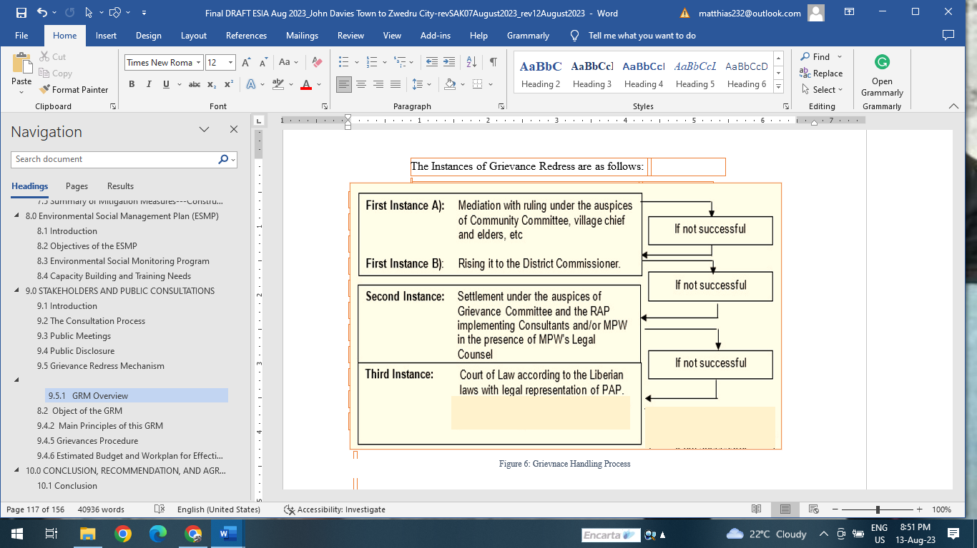

Figure 6: Grievnace Handling Process

9.6 Object of the GRM

The prime objective of establishing the GRM is to resolve problems in an efficient, timely, and cost-effective manner in a cordial environment with the participation of all stakeholders including affected parties. Under the GRM, it shall describe the options available to the project for grievance redress. Any environmental or social impacts (other than issues of valuation and compensation) that would be adversely affecting the general public in the project area should be resolved by the GRC. The GRM is also part and parcel of the machinery of any project. No project can claim to be accountable, responsive, and user-friendly unless it has established an efficient and effective grievance redress mechanism. The grievance redress mechanism of this project (John Davies Town to Zwedru (48.5 km) Road) is an instrument to measure its efficiency and effectiveness as it provides important feedback on the working of the project.
The John Davies Town to Zwedru (48.5Km) Road project is a category “A” Project hence, required the Grievance Redress Mechanism (GRM) to address issues raised by the public about the project implementation since a GRM provides a predictable, transparent, and credible process to all parties, resulting in outcomes that are seen as fair, effective, and lasting. Subsequently, the Grievance Redress Committees (GRC) is been set up to handle all matters arising from the project. The social structure of the project implementing area is to some extent affected by the project. This caused several adverse social and cultural impacts on the community. As a result, it could be identified that several psychosocial issues have taken place. On these grounds, more attention must be paid to the community for the successful implementation and sustainability of the project. Also, the implementation of the GRM is required to follow the gender policy of the GOL and the African Development Bank (AfDB). Accordingly, there should be equal opportunities for men and women to be given at any stage of the GRM and to encourage women’s participation in the decision-making process in development activities.

9.6.1 Main Principles of this GRM

- A Grievance Redress Mechanism (GRM) is proposed to address any complaints and grievances arising during the project. Members of the public may perceive risks to themselves or their property or have concerns about the environmental performance of the project. Any concerns or grievances should be addressed quickly and transparently, and without reprisal to the affected person (AP) or Complainant;
- The primary principles are that all complaints and grievances are resolved as quickly as possible. It, therefore, follows that the resolution of complaints and grievances should be at the lowest possible level for resolution;
- All minor land or property-related complaints that can be resolved, should be resolved immediately on the site. The focus of the GRM is to resolve issues in a customarily appropriate fashion at the community level and record details of the complaint, the complainant, and the resolution;
- All grievances from the public should be considered with equal relevance to avoid conflict of interest. Any complaints from institutions within the project area should also be treated equally as individual complaints passing through the same system and treated equally;
- Decisions that will be taken earlier are reiterated without subjecting the cases to independent examination. There is inertia to review decisions taken by down-the-line functionaries. In many cases, the CLO justifies the delay if any, and continues with the inability to take decisions by putting the onus on another petitioner. Many times, the actual cause of grievance lay in the internal inefficiency of the system and failure to identify simple systemic solutions;
- There is no doubt that grievances will continue to arise because of a high systemic tolerance for delay, work quality, and non-accountability in the daily performance of functions. Failure to review archaic, redundant, and incongruous rules, policies, and procedures and to initiate simple, workable systemic changes is another cause for grievance generation. However, the committee set at the local level and the Offices of the CLO will work with policies and procedures on a day-to-day basis, developing the ability to continually look 'within' and identify deficiencies.

9.6.2 Grievances Procedure

The grievance resolution process includes four key stages – (i) Receive; (ii) Investigate/Enquire; (iii) Respond and Resolve; and (iv) Follow up/Close Out.
The intention is to resolve a complaint as quickly and at as low a level as possible to avoid a minor issue becoming a significant grievance. Unresolved complaints may be treated as grievances only if, in the opinion of the GRC Chairman that they fall within the definition of grievance under the project.
Irrespective of the stage of the process, a complainant can pursue the grievance through the court as is his or her legal right. Table 16 shows the process through which a grievance can be resolved, while Figure 7 displays the escalation matrix.

Table 16: Grievance Resolution Process
Allotted Timeframe Stage
Within 1 day | • | Grievance reported to Contractor through nominated person either CLO by Complainant or community representative.
 | • | A contractor with the support of a Supervision Consultant prepares Grievance Report Form providing full details of the alleged grievance.
Within 2 days | • | CLO investigates and confirms details of the grievance and ensures that details are entered into the Grievance Report Form.
 | • | CLO confirms subject of the complaint is still relevant and contacts management.
 | • | CLO sends Grievance Report Form to management.
 | • | The CLO will log the grievance into the GRM register.
Within 7 days | • | CLO informs GRC Chairman and confirms who will have delegated authority to resolve the grievance.
 | • | GRC delegate and CLO or PIU representative meet with relevant parties, village leaders, etc.
 | • | Depending on the nature or severity of the grievance GR delegate and PIU representative attempt to identify acceptable resolutions.
 | • | Confirm resolution with Affected Party (  representative) and seek their approval or confirmation that the grievance is resolved.
 | • | Grievance closed out by the GRC Chairman in writing informed management.
30 days | • | If unresolved then the Grievance including an update of actions to date is referred to management for further action.
 | • | Database updated by CLO.
As soon thereafter as possible | • • | Management undertakes further action.  If the grievance remains unresolved the grievance can b closed out by management on behalf of the project, and if there exists no way out, Complainant may initiate a leg process through the courts
 | • | Database updated by CLO.

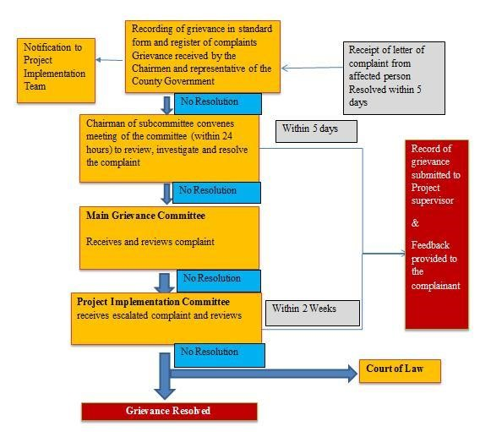
Figure 7: GRM escalation matrix

9.6.3 Estimated Budget and Workplan for Effective GRM Implementation

The budget (Table 17 and Table 18) will allow the GRMC to implement the activities set out in this work plan. Depending on the complaints and reconsideration requests received (which are unpredictable), the budget may need to be supplemented during the year. Both the work plan and budget assume that the project will continue at varying levels during its implementation.

9.6.4 Work Plan for the Implementation of the GRM

Table 17: Grievance Implementation Work Plan
No | Items | Activities | Schedule
1 | Disclosure of the GRM | Gathering of all community dwellers and local authority to disclose the GRM and properly explain the complaint procedure to them | Priod to the commencement of works and throughout the construction period
2 | Establishment of the GMC | The PIU to create awareness and bring communities together by mapping out communities’ leaders to form part of each committee | Prior to the commencement of work
3 | Implementation of the GRM | The PIU Social Safeguard Officer to make regular follow up and resolve all RAP related grievance | Throughout the project cycle
4 | Monthly field visits to the project | The Social Safeguard Office should Visit all communities along the project to follow up with complaints and have them resolve | Monthly
5 | Special Sitting with committee member | The Social Safeguard Officer of the PIU should organize emergency sitting for some committee members and with the involvement of local authority from the county or district level to solve some complicated cases | When required

Table 18: Estimated Budget and Work Plan for GRM Implementation
GRM Implementation Cost
 | Work Plan | Duration | Cost | Source
 | Communication and awareness raising on the GRM | Throughout project implementation | $20,000.00 | GoL/MPW
 | Cost-associated establishment of the various GRM bodies |  | $10,000.00
 | Transport and communication costs associated with GRM  operation |  | $20,000.00
 | Training of the Grievance  Redress Committee  members |  | $15,000.00
 | Cost for purchasing and operating equipment for GRM implementation |  | $5,000.00
 | GRM monitoring and  reporting |  | $10,000.00
 | GRM committees Sitting (this includes local level sitting) |  | $10,000.00
 | Professional Services including Case Management System including Travel associated with complaints/requests |  | $10,000.00
Total |  |  | $100,000.00

10.0 CONCLUSION, RECOMMENDATION, AND AGREED ACTIONS

10.1 Conclusion

The findings of the environmental and social impact assessment (ESIA) conclude that the impact of upgrading to bitumen standards on the Zwedru – Harper Road, specifically Lot 3 – John Davies Town to Zwedru (48.5Km) corridor - is positive overall on the socio-economic environment of the area. However, the impact of the project on the bio-physical environment is potentially slightly to moderately negative both in the construction phase and over the life of the road (operation phase), if appropriate mitigation and support measures are not employed. The social impacts of land take and Resettlement have been addressed during the RAP studies.

The environmental and social management measures proposed are generally straightforward. Most of the measures relate directly to sound operating practices both during the construction phase and subsequently over the operational life of the road.

Provided the road is upgraded with due attention to the mitigation and management measures outlined, the project will have a positive impact on both the bio-physical and socioeconomic environment of the project area. It is recommended that this road project be implemented and that the proposed mitigation and monitoring measures are enforced.

10.2 Recommendations/Agreed Actions

Based on the findings of the study, the following recommendation to the EPA and agreed actions to be carried out by contractors and the MPW/PIU are underscored:

- The road project should be granted an environmental permit/license to commence;
- That the contractor prepares and submits to the PIU/MPW all necessary required E&S documentation including plans e.g., health and safety management plan, traffic control management plan, risk assessment and emergency response plan, contractor’s environmental and social management plan; erosion and sediment control management plan, etc.

- A monitoring program will be adhered to by the supervising Engineers and PIU/MPW during the operation of the road.

- PIU/MPW will liaise with other entities/organizations having utilities on the road to ensure that they only use the edges of the road reserve to avoid future costs of relocation of service and inconvenience.

- PIU/MPW will survey and put beacons on the road reserves to stop encroachment and ease the maintenance of roads.

11.0 REFERENCES
Table 19: References
African Development Bank |  | Environmental and Social Assessment Procedures – For African Development Bank’s Public Sector Operations; © June 2001.
African Development Bank |  | Group Policy on the Environment; 2004.
African Development Bank |  | Policy Guideline Checklist for ES Safeguards
EPA of Liberia  Geographic Maps of Liberia |  | Revised Environmental Social Impact Assessment Procedural Guidelines/Strategic Environmental Assessment (ESIA/SEA) Procedural Guidelines (March 30, 2022)
Liberia Institute of |  | Republic of Liberia – 2008 National Population
Statistics & Geo-Information Services (LISGIS |  | & Housing Census Final Results Monrovia, Liberia; May 2009
Ministry of Public Works |  | Socio-economic Survey Report of Lot 2 of the Zwedru – Harper Road Project (May – June 2013).
Ministry of Foreign Affairs |  | An Act to Adopt the Environmental Protection and Management Law of the Republic of Liberia (2002)
Ministry of Foreign Affairs |  | National Environmental Policy of the Republic of Liberia (2002).
Ministry of Planning & |  | Lift Liberia Poverty Reduction Strategy -
Economic Affairs |  | Final Report: A Results-Focused Assessment
 |  | (June 2008 – December 2011);
Ministry of Planning & |  | Liberia Rising, 2030

12.0 ANNEXURES
Table 20: Annexure
ANNEX “A” | Chance Finds Procedure
ANNEX “B” | Minutes of Public Consultation Meetings in Grand Gedeh
ANNEX “C” | Public Consultation Meeting Attendance
ANNEX “D” | Terms of Reference of the ESIA are attached as a stand-alone document
ANNEX “E” | Ministry of Agriculture (as Annex ‘E-1) and the Ministry of Public Works (Ax E-2)’s Evaluation Price Listings
Annex “F” | Photography

- APPENDIX “A”: Chance Finds Procedure

The chance find procedure is a project-specific procedure that outlines actions required if previously unknown heritage resources, particularly archaeological resources, are encountered during project construction or operation. A Chance Find Procedure is a process that prevents chance finds from being disturbed until an assessment by a competent specialist is made and actions consistent with the requirements are implemented. Scope of the chance find procedure This procedure applies to all activities conducted by the personnel, including contractors, that have the potential to uncover a heritage item/site. The procedure details the actions to be taken when a previously unidentified and potential heritage item/site is found during construction activities. The procedure outlines the roles and responsibilities and the response times required from both project staff, and any relevant heritage authority. Induction/Training All personnel, especially those working on earth movements and excavations, are to be inducted on the identification of potential heritage items/sites and the relevant actions for them with regards to this procedure during the Project induction and regular toolbox talks. Chance finds procedure If any person discovers a physical cultural resource, such as (but not limited to) archaeological sites, historical sites remains and objects, or a cemetery and/or individual graves during excavation or construction, the following steps shall be taken:
Stop all works in the vicinity of the find, until a solution is found for the preservation of these artifacts, or advice from the relevant authorities is obtained;
Immediately notify a foreman. The foreman will then notify the Construction Manager and the Environment Officer (EO)/Environmental Manager (EM);
Record details in the Incident Report and take photos of the find;
Delineate the discovered site or area; secure the site to prevent any damage or loss of removable objects. In cases of removable antiquities or sensitive remains, a night guard shall be arranged until the responsible local authorities take over;
Preliminary evaluation of the findings by archaeologists. The archaeologist must make a rapid assessment of the site or find to determine its importance. Based on this assessment the appropriate strategy can be implemented. The significance and importance of the findings should be assessed according to the various criteria relevant to cultural heritage such as aesthetic, historic, scientific or research, social and economic values of the find;
Sites of minor significance (such as isolated or unclear features, and isolated finds) should be recorded immediately by the archaeologist, thus causing a minimum disruption to the work.
- schedule of the Contractor. The results of all archaeological work must be reported to the Ministry/Agency, once completed.
- In case of a significant find the MPW, Ministry of Internal Affairs, EPA or Ministry of Information, Culture, and Tourism (hereinafter referred to as Heritage team) should be informed immediately and in writing within 7 days from the find;
- The onsite archaeologist provides the Heritage team with photos, and other information relevant for the identification and assessment of the significance of heritage items. The Ministry must investigate the fact within 2 weeks from the date of notification and respond in writing.
- Decisions on how to handle the finding shall be taken by the responsible authorities. This could include changes in the layout (such as when finding an irremovable remain of cultural or archaeological importance) conservation, preservation, restoration, and salvage;
- Construction works could resume only after permission is granted from the responsible authorities.
- In case no response is received within the 2 weeks mentioned above, this is considered as authorization to proceed with suspended construction works. One of the main requirements of the procedure is record keeping. All finds must be registered. Photolog, copies of communication with decision-making authorities, conclusions and recommendations/guidance, implementation reports – kept.

Additional information Management options for Archaeological Site

Site avoidance: If the boundaries of the site have been delineated attempt must be made to redesign the proposed development to avoid the site. (The fastest and most cost-effective management option)
Mitigation: If it is not feasible to avoid the site through redesign, it will be necessary to sample it using a data collection program prior to its loss. This could include surface collection and/or excavation. (The most expensive and time-consuming management option.)
Site Protection: It may be possible to protect the site through the installation of barriers during the time of the development and/or possibly for a longer term. This could include the erection of high-visibility fencing around the site or covering the site area with a geotextile and then capping it with fill. The exact prescription would be site-specific. Management of replicable and non-replicable heritage Different approaches for the finds apply to replicable and nonreplicable heritage. Replicable heritage Where tangible cultural heritage that is replicable and not critical is encountered, mitigation measures will be applied. The mitigation hierarchy is as follows:

Avoidance:
Minimization of adverse impacts and implementation of restoration measures, in situ;
Restoration of the functionality of the cultural heritage, in a different location;
Permanent removal of historical and archaeological artifacts and structures;
Compensation of loss where minimization of adverse impacts and restoration is not feasible. Non-replicable heritage Most cultural heritage is best protected by in situ preservation since removal is likely to result in irreparable damage or even destruction of the cultural heritage. Replicable cultural heritage is defined as tangible forms of cultural heritage that can themselves be moved to another location or that can be replaced by a similar structure or natural features to which the cultural values can be transferred by appropriate measures. Archaeological or historical sites may be considered replicable where the particular eras and cultural values they represent are well represented by other sites and/or structures;
The overall benefits of the project conclusively outweigh the anticipated cultural heritage loss from removal, and Any removal of cultural heritage must be conducted using the best available technique advised by the relevant authority and supervised by an archaeologist or the PIU EO. Human Remains Management Options The handling of human remains believed to be archaeological requires communication according to the same procedure described above. There are two possible courses of action:
Avoid: The development project is redesigned to completely avoid the found remains. An assessment should be made as to whether the remains may be affected by residual or accumulative impacts associated with the development, and properly addressed by a comprehensive management plan, and
Exhumation: Exhumation of the remains in a manner considered appropriate by decision-makers. This will involve the predetermination of a site suitable for the reburial of the remains. Certain ceremonies or procedures may need to be followed before development activities can recommence in the area of the discovery.

- ANNEX “B”: Minutes of Public Consultation Meetings in Grand Gedeh

Table 21: Public Consultation Meetings ‘Minutes in John Davies Town, Karlorwleh Town, Gbargbo Town and Zwedru, Grand Gedeh County
Date | Location Meeting | of | Number of  Participants | Matters discussed, questions and answers
May 29, 2023 | John Davies Town |  | 29 | - Introduction of the team;  - Introduction of the Project;  - Emphasized the essence of the ESIA and RAP process.  - Provided a detailed explanation of the new design.  - Encouraging the Participants to be open and feel free in expressing their opinions.  - Presentation of the road project (including brief history and overview of the formalities leading to the proposed construction of the 52.7Km road, John Davies Town to Zwedru)  - Short presentation on the EPML and AfDB’s Policy.  - Summary of the impacts that might occur Question and answer session:  - The main issues were access to the road, loss of property,  - change in route design between the preparation of RAP,  - compensation aspects (graves, land, crops)
May 30, 2023 | Karlorwleh Town |  | 27 | - Introduction of the team;  - Introduction of the Project;  - Emphasized the essence of the ESIA and RAP process.  - Provided a detailed explanation of the new design.  - Encouraging the Participants to be open and feel free in expressing their opinions.  - Presentation of the road project (including brief history and overview of the formalities leading to the proposed construction of the 52.7Km road, John Davies Town to Zwedru)  - Short presentation on the EPML and AfDB’s Policy.  - Summary of the impacts that might occur  - Commented on the role of Royal Environmental Group Consultant  as well as provided detailed information on RE-GROUP’s involvement with the project.  - Distributed and provided a detailed understanding of the Stakeholder Engagement Brochure, Grievance Redress Mechanism, and Assets Evaluation Forms to the locals.  - Posted the Assets Evaluation Form at strategic locations in the project area.  - Established the cut-of-date of all affected properties (June 30, 2023).  - Exemplified how the asset evaluation exercise will be carried out.  Questions and answers session:  - Job opportunities,  - compensation aspects (graves, land, crops),  - Women's participation in the project
Women Focus Group Discussion

Date | Location of Meeting |  | Number of  Participants | Matters discussed, questions and answers
May 31, 2023 | Gbargbo Town |  | 24 | What do the women know about the project and if they are participating in decision-making?  Do you have access to the legal title of the land?  What are the livelihood activities and expected changes?  Are there specific needs for women?  What are the existing skills among women?  What are the common diseases and the current state of health facilities?  What are the expected social impacts related to displacement?  What needs to be considered related to resettlement?  What are the challenges in the area of women in terms of marketing local produce?  What is the perceived percentage of educated women in the area and what can be done to improve the condition?  Question and answer session:  Job opportunities,  Compensation aspects (is there the possibility of land for land and house for house compensation instead of cash)
Further Focus Group Discussions
- What is the integrity of the existing water distribution network?
- Is the water supply capacity adequate to provide the additional water demand to meet the expanded system and the expectations of the consumers?
- How sustainable is the supply in the long run? • Is there a monitoring procedure and components for the water distributed and supplied to track losses and the value of water supplied?
- What is the level of ability and willingness of consumers to pay for water as a justification for the construction of the pipeline?
- What are the implications to the physical environment (drainage, sanitation hygiene) in the project area following the proposed works?
Household Questionnaire
Date | Location Meeting | of | Number of  Participants | Matters discussed, questions and answers
June 1, 2023 | Zwedru City |  | 38 | - Introduction of the team;  - Introduction of the Project;  - Emphasized the essence of the ESIA and RAP process.  - Provided a detailed explanation of the new design.  - What is the expected value of the project?  - What is the current source of water for the PAPs?  - Willingness to pay for the project.  - Expected disadvantages of the project  - Major concerns and impacts expected on the communities  - Road conditions  - Land use and land productivity  - Involvement of the local community in the construction  - Expected social impacts and suggestions to reduce impacts  - Environmental concerns

Table 22: Questions and Answers from Consultation Meetings
Issues | Comments
A. Value of the project in the area
What is the main source of water for general domestic use? | Residents said that they obtained water from the following sources:  Hand pumps, wells, and the main creeks since most hand pumps are not functioning.
Whether their main source of water is the same during the dry and wet seasons | Most of them said no.  According to them, the quality of the waters is sometimes clean and sometimes dirty and they experience difficulties in getting water during dry season months, and during this tense stage of the dry season, most of the water is undrinkable.
Whether they find the project construction of the road useful, and its benefits after upgrading it to the proposed standard ac road | All of them agreed that the project will be useful in terms of:  - Increase productivity, market, farming, etc.;  - Increased wealth creation owing to the influx of investors coming to exploit the increased business potential due to good road network;  - Savings arising from reduced transportation costs and time spent traveling or commuting;  - Increase in the government revenue generation;  - Creation of employment during the construction and operation phases of the project; and  - Boost in the business of construction materials and consumables, especially during the construction phase.
Whether they are willing to give land for contractor and engineer camps | The people of John Davies Town willingly requested the team for the project to be established in John Davies Town. They are willing to give their land for camps construction;
Disadvantages of the project | - Loss of properties;  - Loss of farmlands;  - Change of socio-cultural setup of the community;  - Water/Air/Noise pollution;  - Discharge of runoff to nearby farms thus destroying crops and soil erosion issues  - Vibration due to quarry rock blasting, and excavation during road work;
Major concerns regarding upgrading the road | - Drainage and erosion concerns  - The road should be constructed to standard so that it can last longer;  - Disruption of services;  - Health and safety standards should be followed;  - Pollution;  - Incidences of accidents may increase;

- Economic growth in the area
- Unlocking the potential of the high-potential areas
How does the road construction impact the community | - Opening up of the place for investments;  - Increased urbanization  - Establishment of institutions e.g. schools, etc.;  - Reduce transportation costs;  - Reduce accident rate;  - Improve health and schooling;  - Employment opportunities to work with the construction company
B. Road condition in the area
Prevalent mode of transport within the two Townships | Pehn-Pehn i.e. motorcycles, private transport and public transport (buses), trucks, etc.
Effects of the road condition on the community | - Delay of the farm produces reaching the market;  - Waste of time and unreliable means of transport;  - Accidents;  - Breakdown of vehicles; hence increase in transport costs;  - Delays in accessing social amenities e.g. hospitals and schools;  - Hinders communication; and  - Slowed down the economic growth of the area.
C. Impacts on Land Use and Land Productivity
Centers that are of major  economic value along the road | - Putu Waterside (where Putu Iron Ore Mining Company is located);  - John Davies Town/CVI Junction (high mining activities, market center,  etc.)  - Duo Town (high mining activities), market center;
Major economic activities in the two Townships | • Agricultural crops, Mining, livestock production; • Transport; and Trade, etc.
Constraints encountered in the named economic activities | - Access to markets;  - Exploitation by brokers; • No access to credit facilities;  - Poor infrastructure.
How the new road construction will affect land use and land productivity in the area | - Change in landscape and land use; • Land value will go up;  - High land utility.
D. 52.7Km Road Construction and Workforce
Ways in which the local community can be involved in the road construction | - Involve the locals in unskilled labor with a priority on  skilled locals;  - Recruitment should be done in liaison with provincial administration; and  - Use locally available raw materials supplied by locals.  - Involve women in road work;
Locations recommended for the workforce | • John Davis Town, Karlorwleh Town, Duo Town, Putu Waterside Town, Sayon Town, Gbargbo Town, Pellezon, Zwedru, etc.
Services to be provided by the local community during  construction | - Security;  - Catering services;  - Skilled and unskilled labor;  - Accommodation;  - Drivers;  - Flaggers  - Grass planting on roadsides to avoid erosion;  - Culvert construction;  - Other engineering works
E. Social Impacts
Impacts that the non-local workers will have on the locals | - Increased income;  - Disharmony with the local communities;  - Pressure on local resources;  - Insecurity;  - Change of socio-cultural setup;  - Integration, peace building and friendship; • Education/exchange of knowledge/ideas;  - Disease outbreak.
Suggestions to reduce the resultant negative impacts | - Give the locals jobs;  - Involve local leaders in integrating local and non-local workers;  - Community policing;  - HIV/AIDS awareness and malaria control programs.  - Sensitization and mobilization of the community;  - Increase security patrols;  - No grazing along the road to avert accidents; and,  - Advertise recruitment to the local community.
F. Environmental Concern
Changes in Physical Features | Due to the felling of trees along the proposed road corridor (50 km Putuken to John Davis Town), the community felt that this will negatively affect the physical appearance of the area.
Degradation of Water Courses | The communities believed the value of the wetlands and water courses will be degraded.
Dust, Noise, and Vibration | The communities expressed fears of possible increases in dust, noise, and vibration especially during the construction phase e.g., quarry rock blasting, crusher plant, etc.

- ANNEX “C”: Public Consultation Meeting Attendance

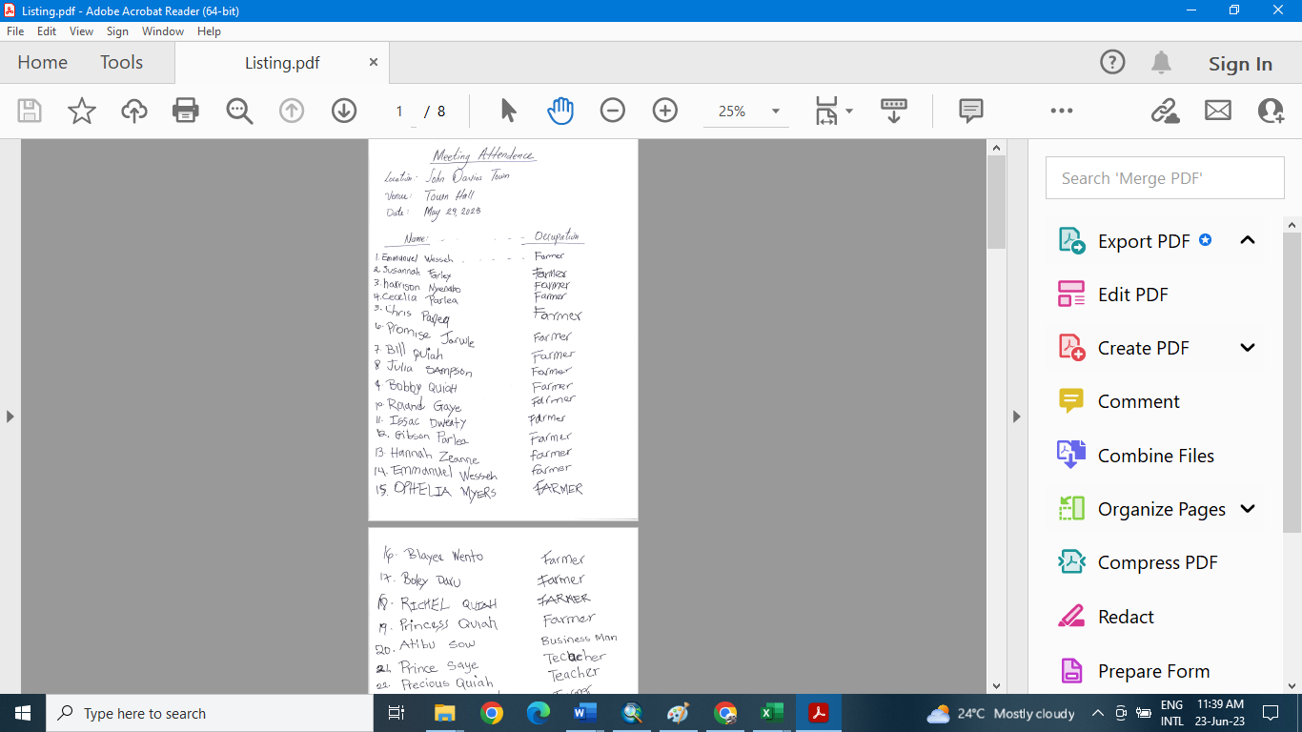

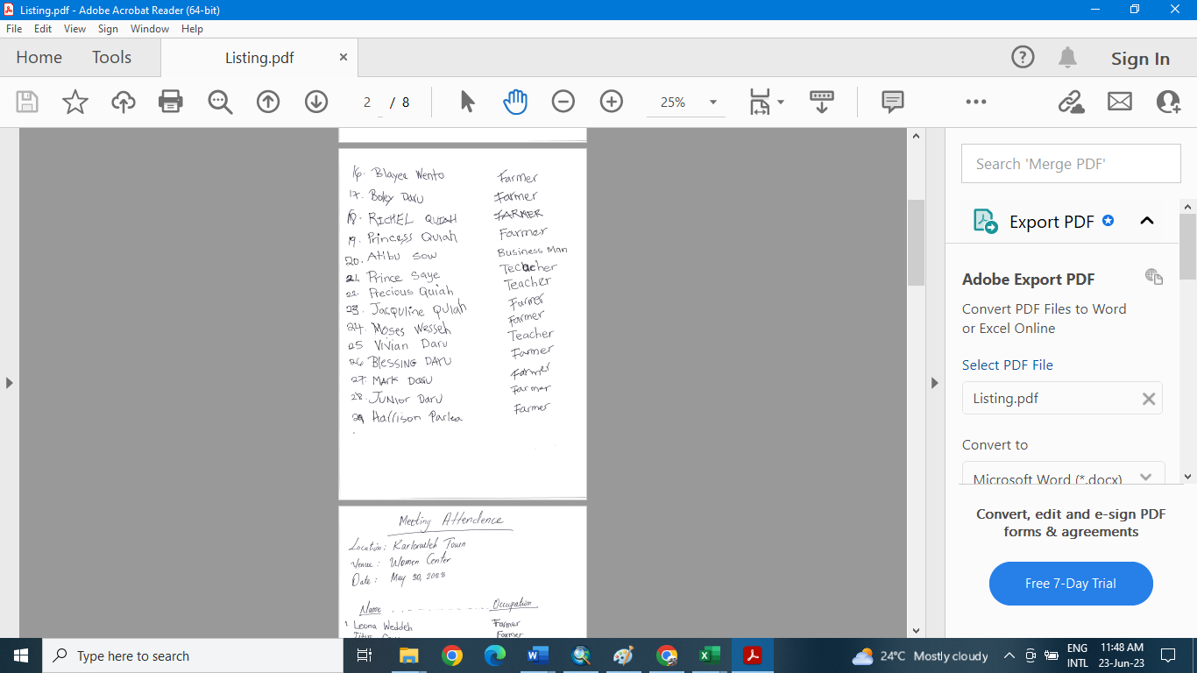

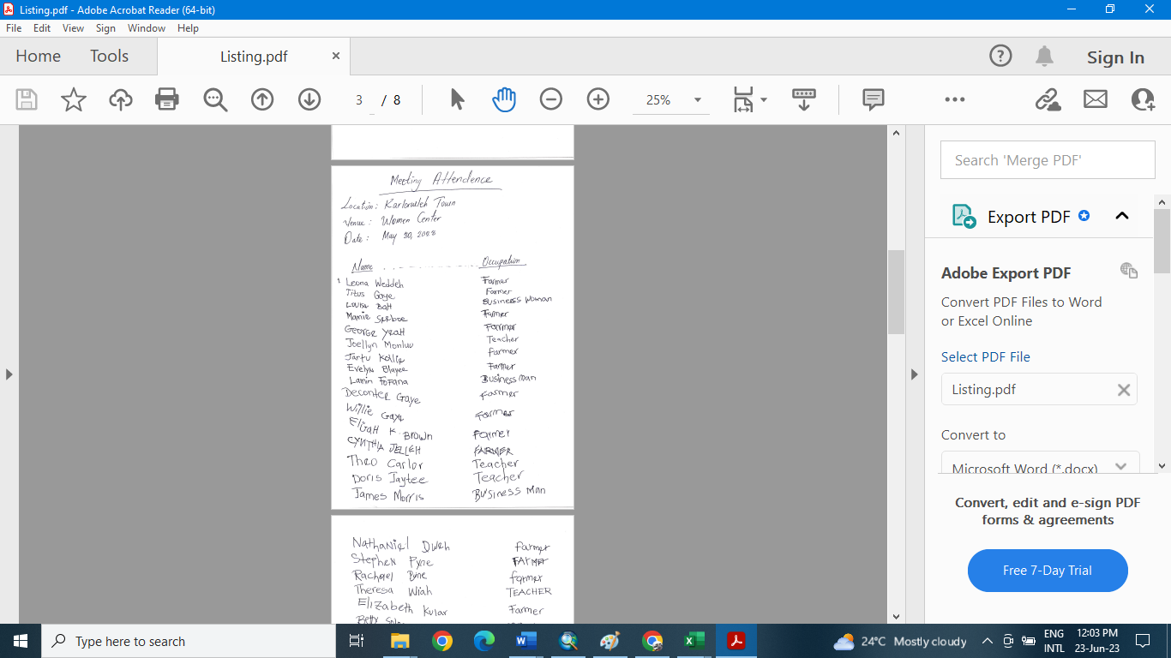

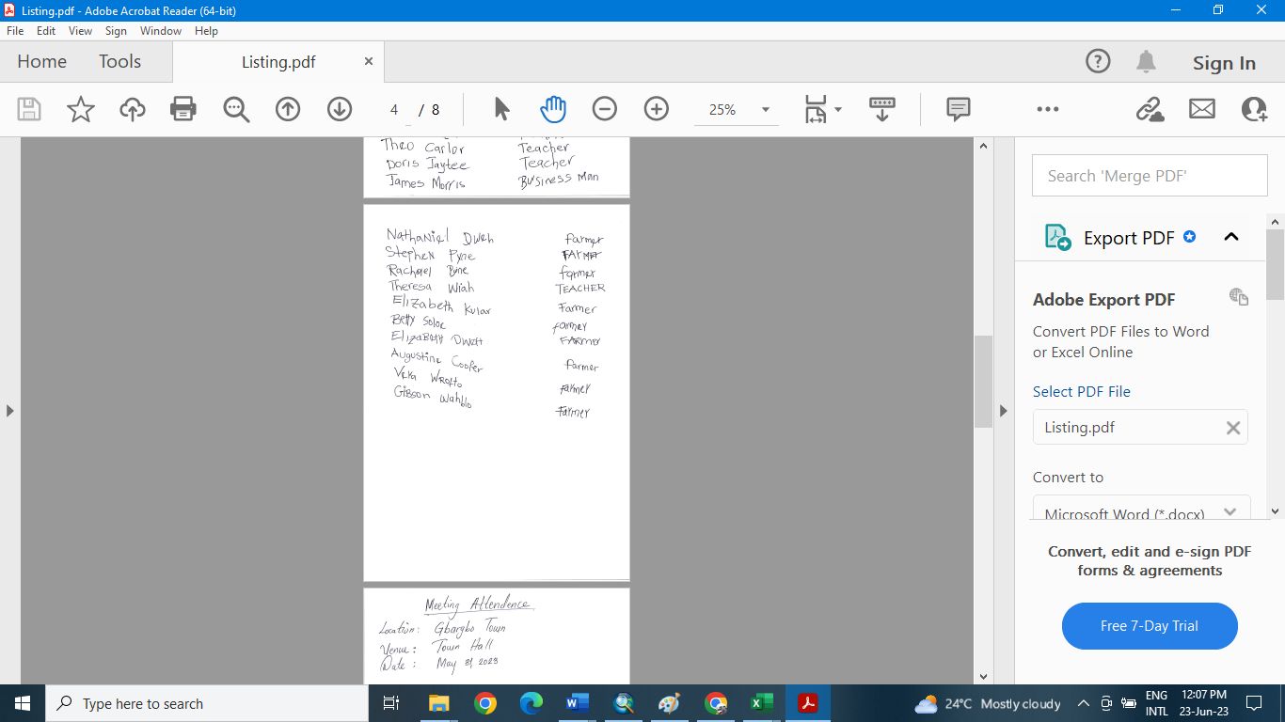

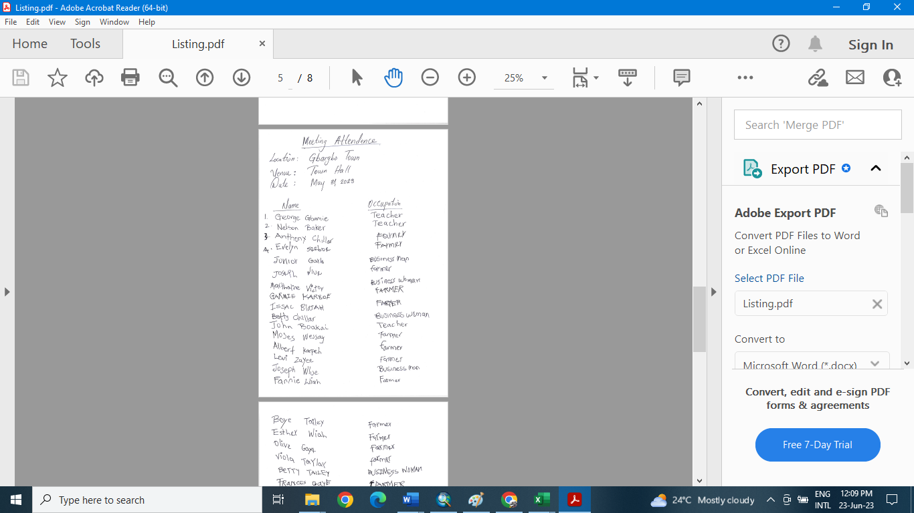

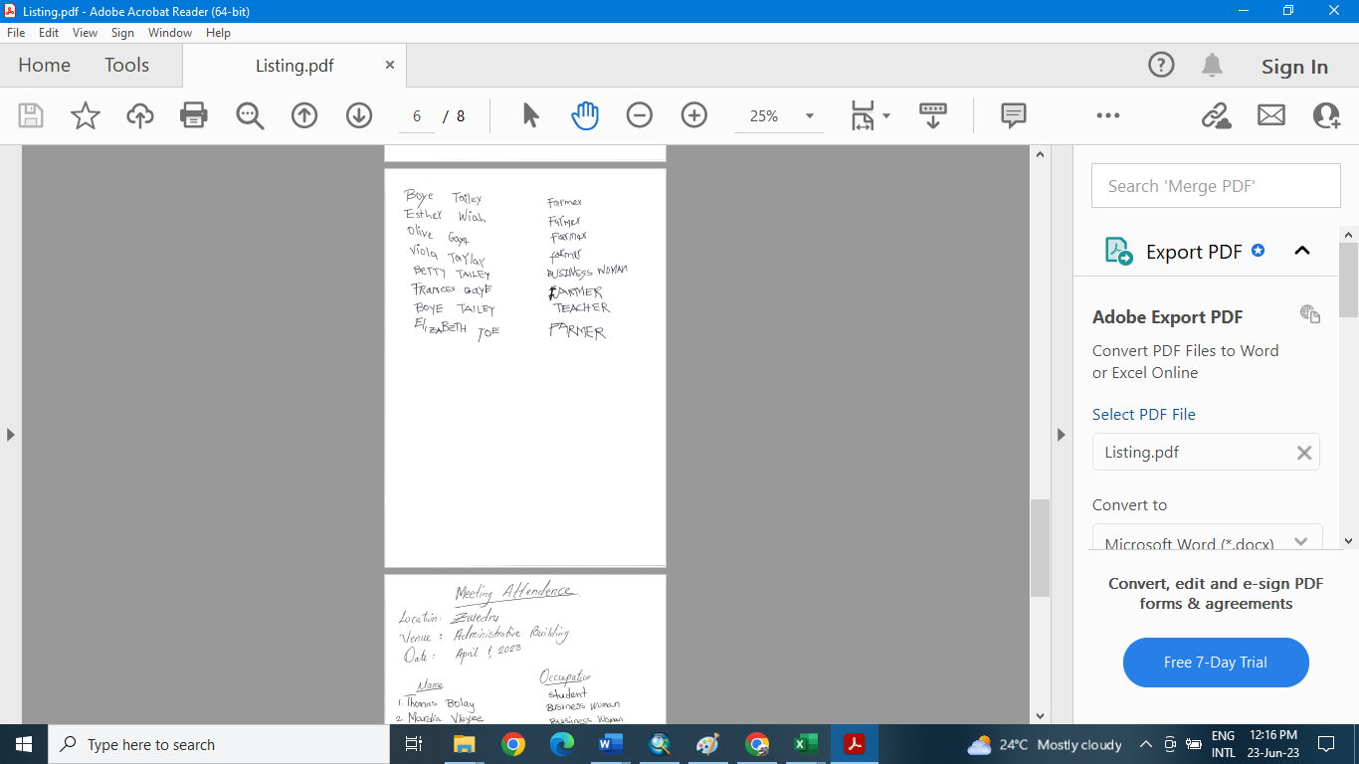

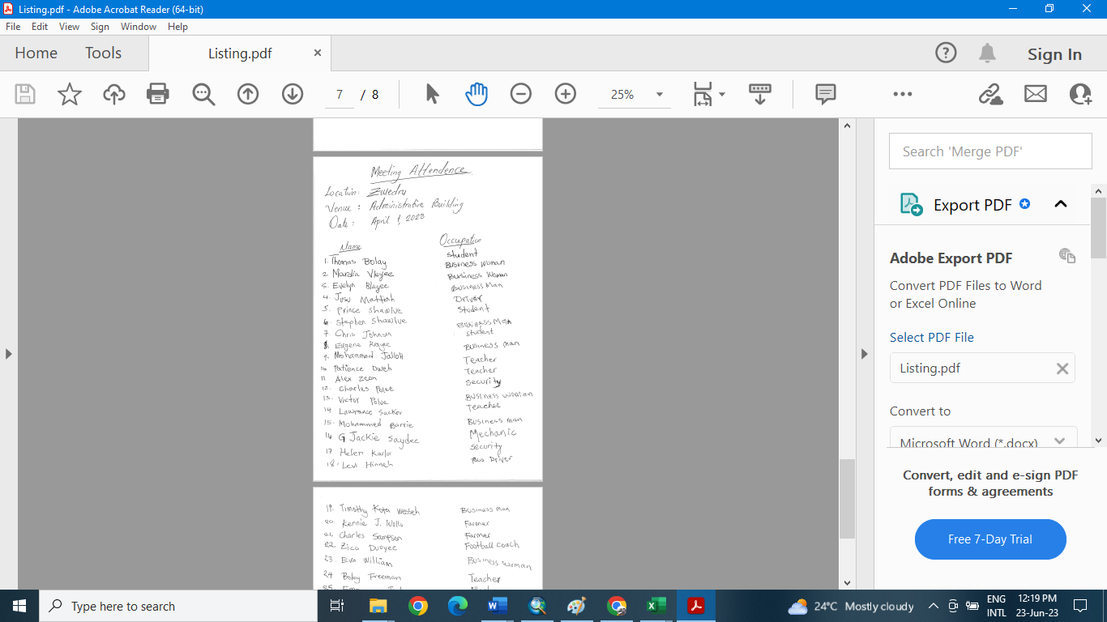

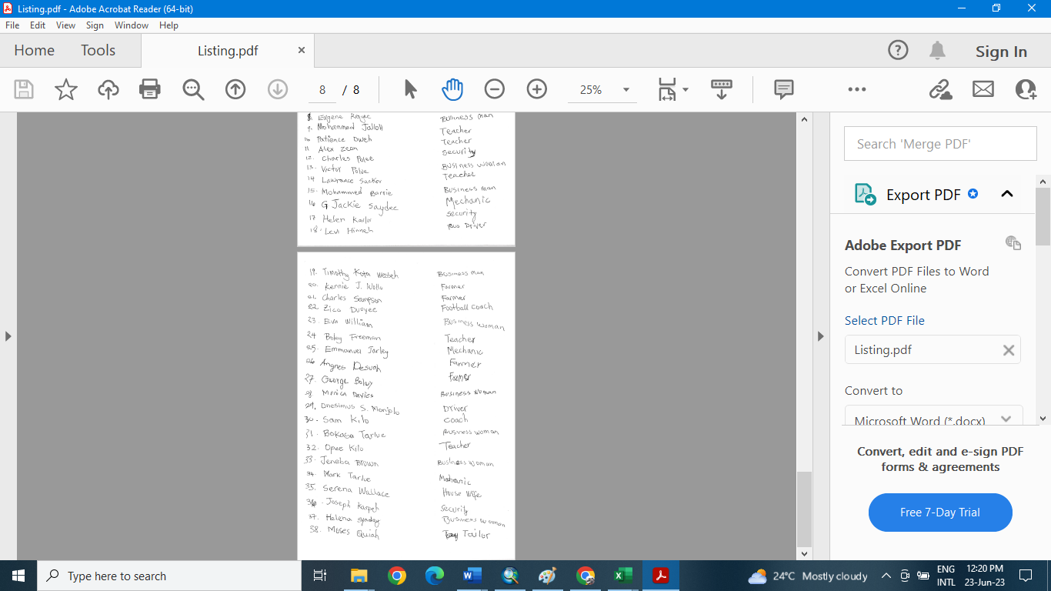

- ANNEX “D”: Environmental Protection Agency (EPA) Liberia’s ESIA Procedural Guidelines (Revised 2022)’s Terms of Reference
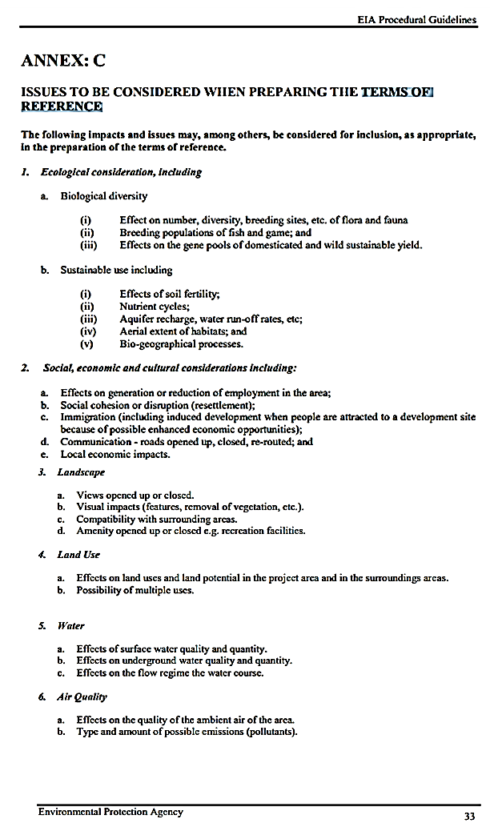

- ANNEX “E”: Ministry of Agriculture (as Annex ‘E-1) and the Ministry of Public Works (Ax E-2)’s Evaluation Price Listings
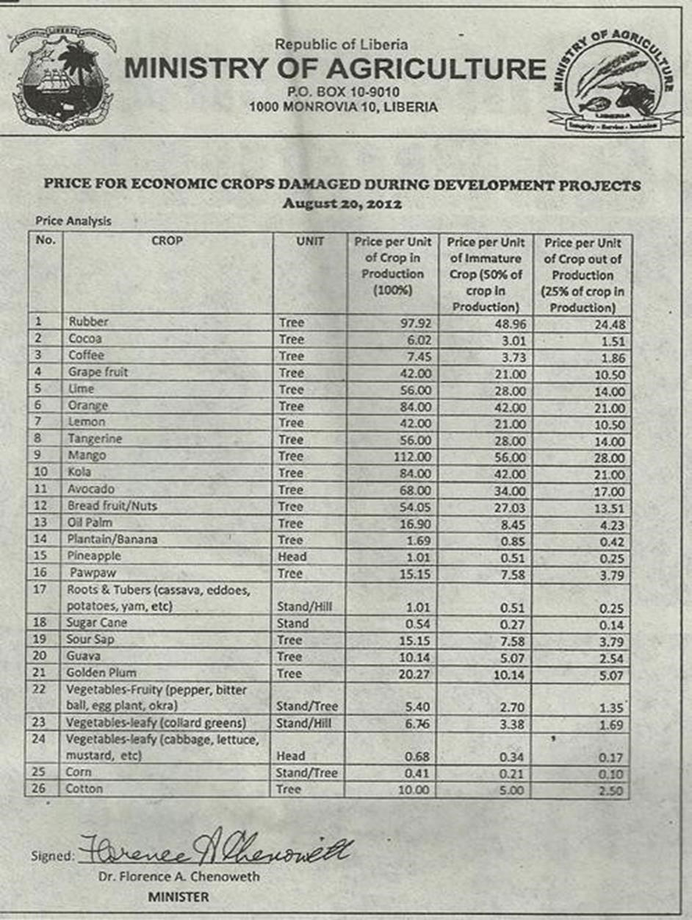

Table 23: Annex “E-2”: MPW Valuation Rates for Structures
ID No | Structure Type | Main  Outer  Wall | Main Roofing Material | Main Window  Material | Main Floor Material | Ceiling Type | Door  Type
1 | Residential/ Commercial | Concrete Wall | Decra/Onduline/ Aluminum/ 28-guage channeled zinc/ concrete | Aluminum Framed/glass | Ceramic  Tiles/ Marble | plywood | panel/ steel | $  35.00
2 | Residential/ Commercial | Concrete Wall | Decra/Onduline/ Aluminum/ 28-guage channeled zinc/ concrete | Aluminum Framed/glass | Terrazo/  Vinyl Tiles | plywood | panel/ steel | $  34.00
3 | Residential/ Commercial | Concrete Wall | Metal Sheet/zinc | Jalousie  Window/ Wood/  Decorative  Blocks | Concrete/  Terrazo/ vinyl  Tiles | plywood/ mat | plywood/ Panel | $  29.00
4 | Residential/ Commercial | Concrete Wall | Metal Sheet/zinc | Jalousie  Window/ Wood/  Decorative  Blocks | Ceramic  Tiles/ marbles | plywood | plywood/ Panel | $  30.00
5 | Residential/ Commercial | Wood | Metal Sheet/zinc | Jalousie  Window/ Wood/  Decorative  Blocks | Ceramic  Tiles/  Marbles | mat/ plywood | plywood/ Panel | $  21.75
6 | Residential/ Commercial | Wood | Metal Sheet/zinc | Jalousie  Window/ Wood/  Decorative  Blocks | Concrete/  Terrazo/  Vinyl Tiles/  Wood | mat/ plywood | plywood/ Panel | $  20.76
7 | Residential/ Commercial | Dirt Brick  &  Concrete | Metal Sheet/zinc | Jalousie  Window/ Wood/  Decorative  Blocks | Concrete/  Terrazo /  Vinyl Tiles | plywood/ mat | Wood/ plywood | $  16.77
8 | Residential/ Commercial | Dirt Brick | Metal Sheet/zinc | Wood/  Decorative  Blocks | Concrete/ Vinyl Tiles | plywood/ mat | Wood/ plywood | $  9.87
9 | Residential/ Commercial | Dirt Brick | Metal Sheet/zinc | Wood/ Zinc | Plastic Vinyl/ Concrete | mat/none | Wood/ plywood | $  9.44
10 | Residential/ Commercial | Dubbed Mud | Metal Sheet/zinc | Wood/ Zinc | Mud/Concrete | None/mat | Wood/ plywood | $  6.50
11 | Residential/ Commercial | Dubbed Mud | Thatch | Wood/ Zinc | Mud/Concrete | None/mat | Wood/ plywood | $  5.00
12 | Residential/ Commercial | Zinc |  |  |  |  |  | $  11.15
13 | Shed | Channeled zinc roof, Ceramic Tile floor with sides close to concrete block |  |  |  |  |  | $  17.00
14 |  | Channeled zinc roof, concrete floor with sides close to concrete block |  |  |  |  |  | $  15.00
15 |  | Channeled zinc roof, concrete floor with sides close to wood |  |  |  |  |  | $  10.00

ID No | Structure Type | Main  Outer  Wall | Main Roofing Material | Main Window  Material | Main Floor Material | Ceiling Type | Door  Type
16 |  | Channeled zinc roof, concrete or laterite floor with open sides |  |  |  |  |  | $  3.50
17 |  | Thatch roof, concrete or laterite floor with open sides |  |  |  |  |  | $  2.00
18 | Warehouse | Reinforced concrete framed structure, usually with cast roof and concrete floor |  |  |  |  |  | $  25.00
19 |  | Concrete blocks structure with zinc roof and concrete floor |  |  |  |  |  | $  20.00
20 |  | Dirt Brick and concrete and concrete |  |  |  |  |  | $  17.00
21 |  | Concrete foundation with prefab structures and roof or zinc. |  |  |  |  |  | $  10.00
22 | Foundation |  |  |  |  |  |  | $  15.00
23 | Concrete  Block Fence |  | Less than 5 Rows (Courses) | Plastered |  |  |  | $  70.00
24 | Concrete  Block Fence |  | Less than 5 Rows (Courses) | Not Plastered |  |  |  | $  55.00
25 | Concrete  Block Fence |  | 5 to 10 Rows  (courses) | Plastered |  |  |  | $  85.00
26 | Concrete  Block Fence |  | 6 to 10 Rows  (courses) | Not Plastered |  |  |  | $  70.00
27 | Concrete  Block Fence |  | More than 10 Courses | Plastered |  |  |  | $  100.00
28 | Concrete  Block Fence |  | More than 10 Courses | Not Plastered |  |  |  | $  85.00
29 | Wooden  Fence |  |  |  |  |  |  | $  30.00
30 | Zinc Fence |  |  |  |  |  |  | $  15.00
31 | Handpump |  |  |  |  |  |  | $  3,600.00
32 | Well |  |  |  |  |  |  | $  2,000.00
33 | Grave/ Concrete |  |  |  |  |  |  | $  800.00
34 | Grave/ Earth |  |  |  |  |  |  | $  500.00
35 | Grave/ Tiles |  |  |  |  |  |  | $  1,200.00
ID No | Structure Type | Main  Outer  Wall | Main Roofing Material | Main Window  Material | Main Floor Material | Ceiling Type | Door  Type
36 | Monument no engravement |  |  |  |  |  |  | $  250.00
37 | Monument engravement |  |  |  |  |  |  | $  500.00
38 | Monument |  |  |  |  |  |  | $  350.00

- ANNEX “F”: Photography
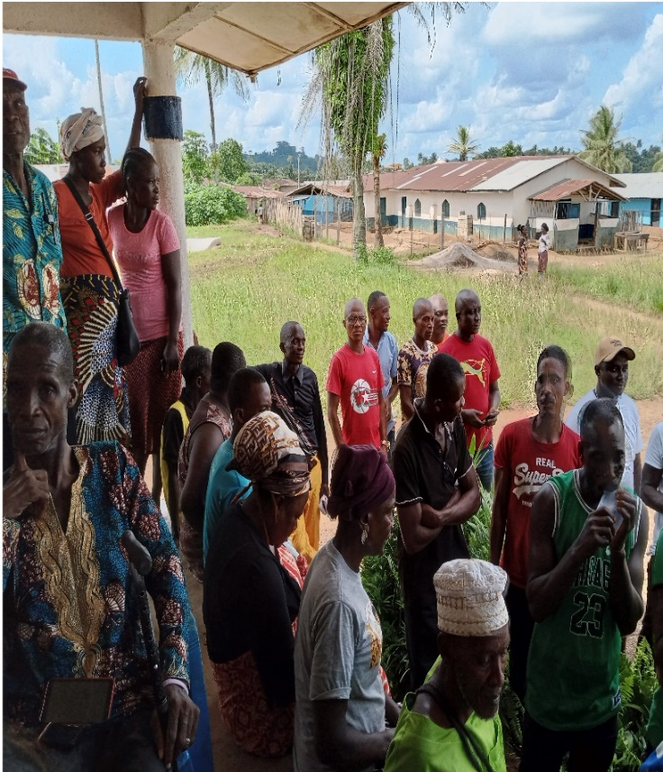
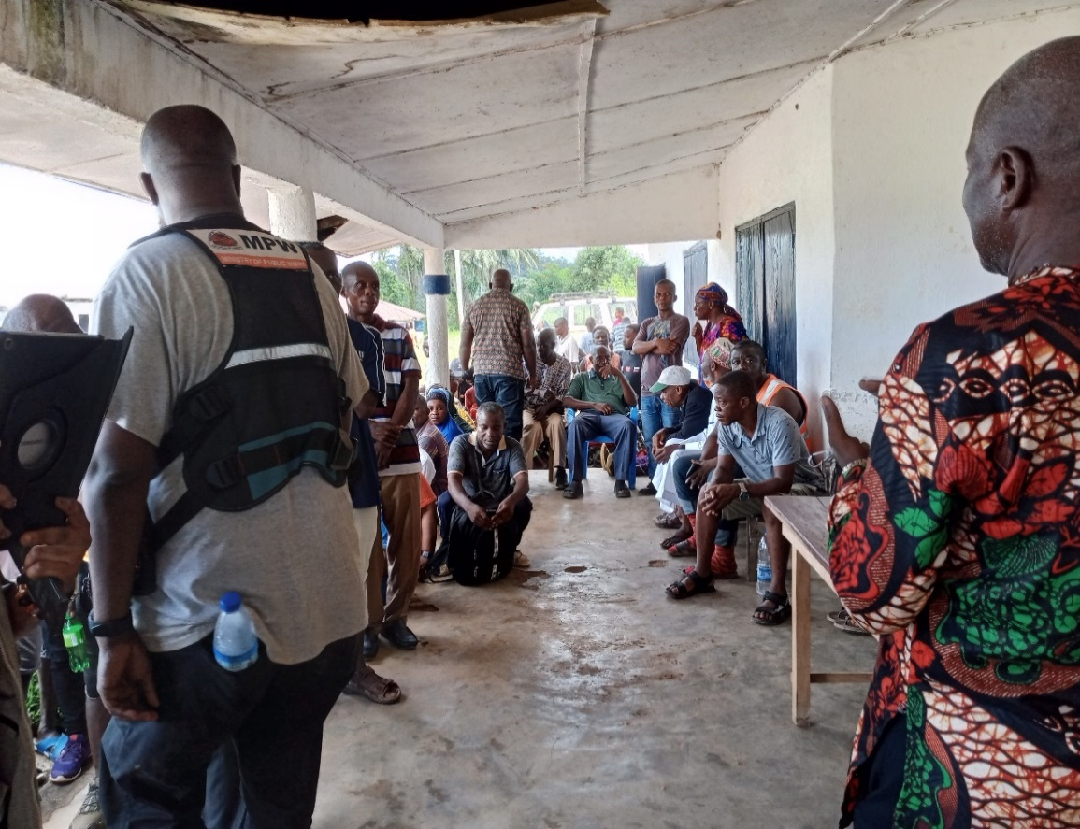
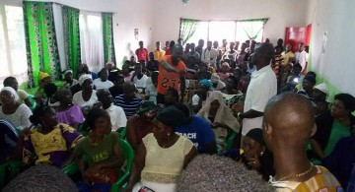
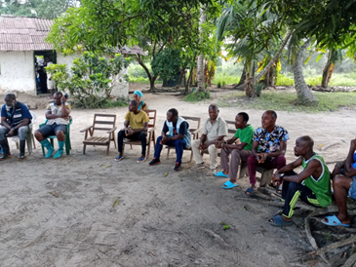
Consultation Meetings

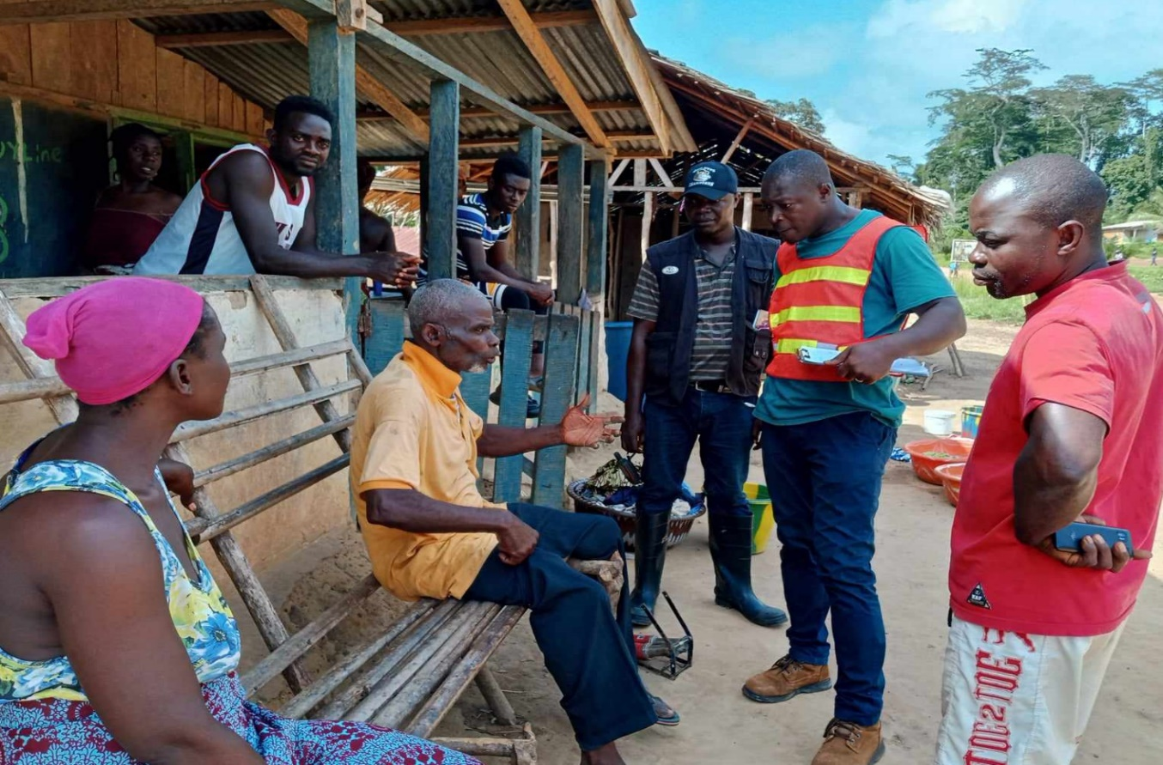
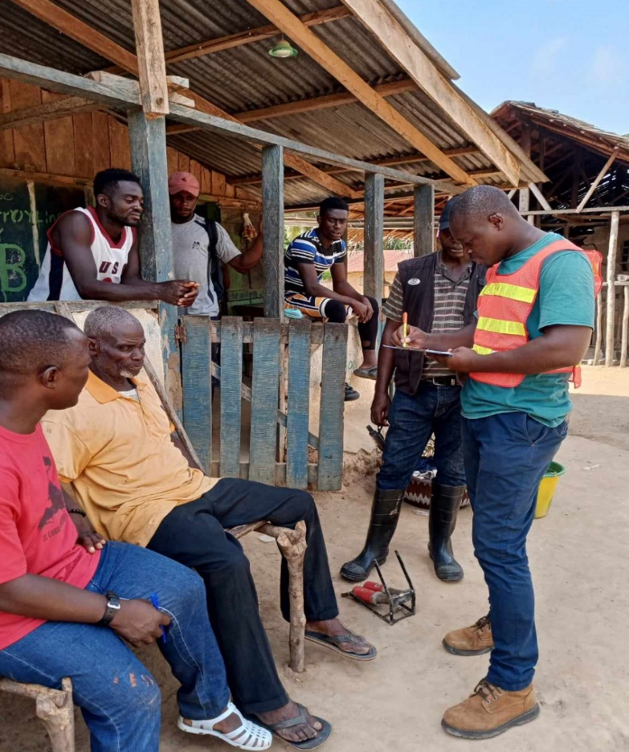
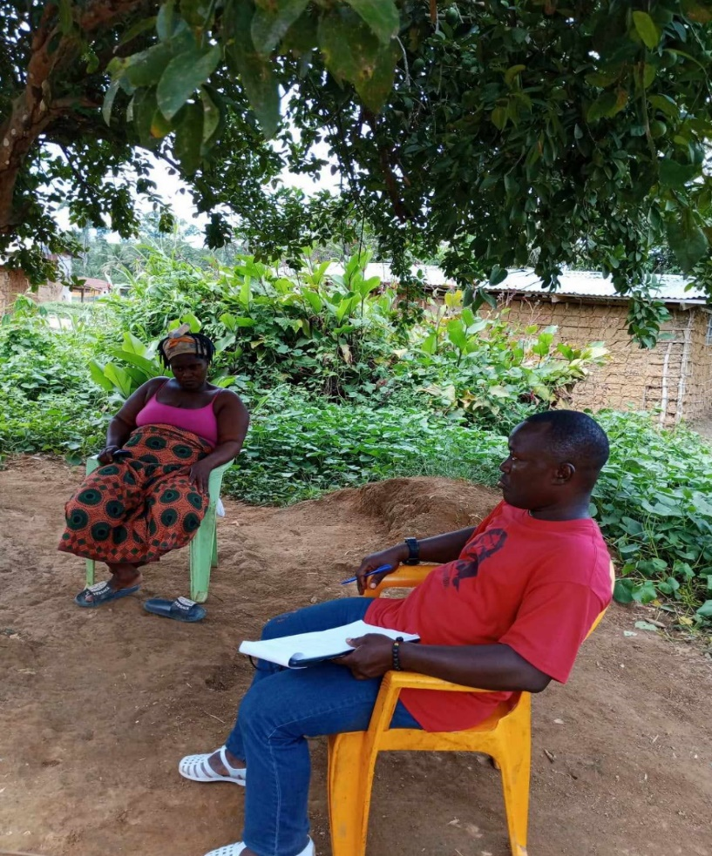
Some meetings held along the project corridor using FGD (Focus Group Discussion) method to help collect data

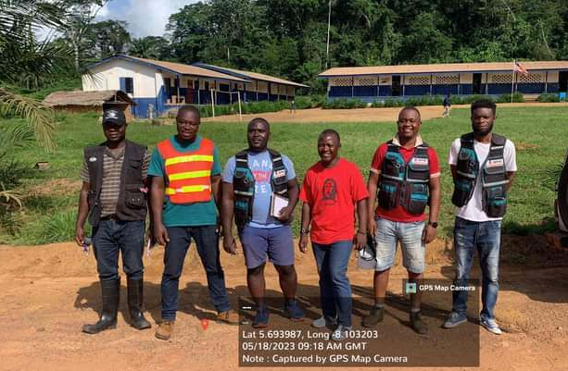
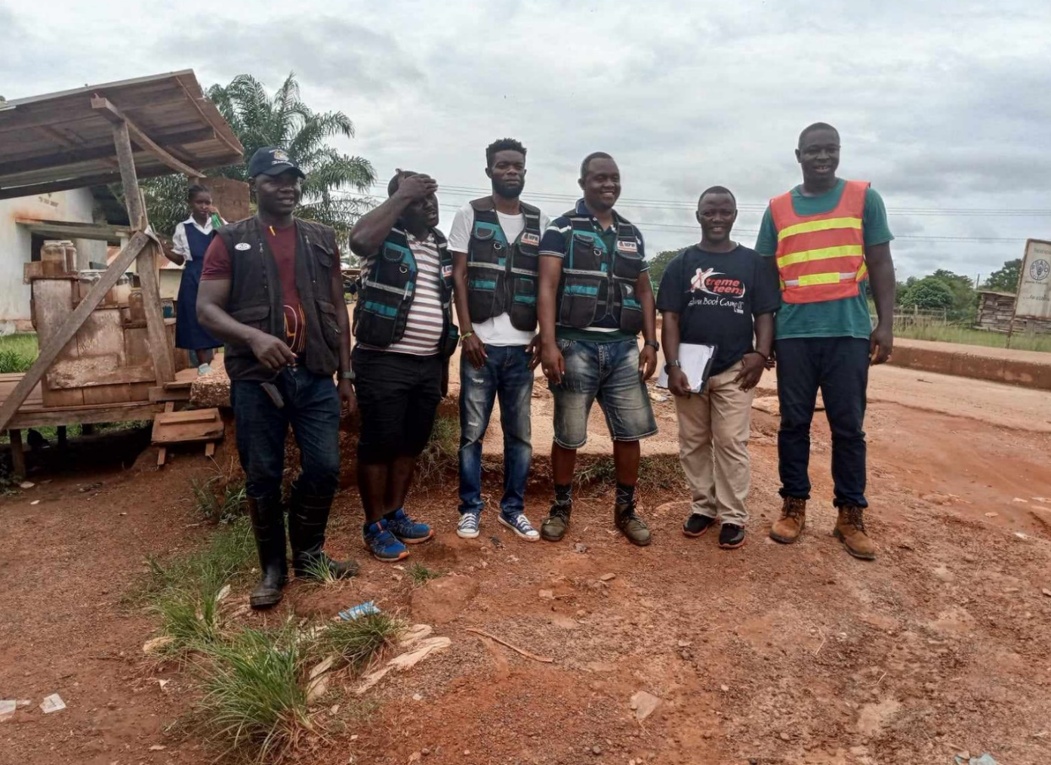
The beginning of the proposed Project Corridor, John Davies Town @ Km 0+000
End of proposed Project Corridor, Zwedru @ Km 52.7

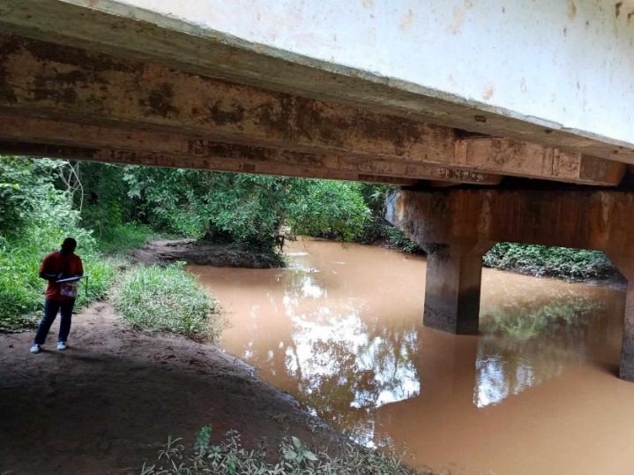
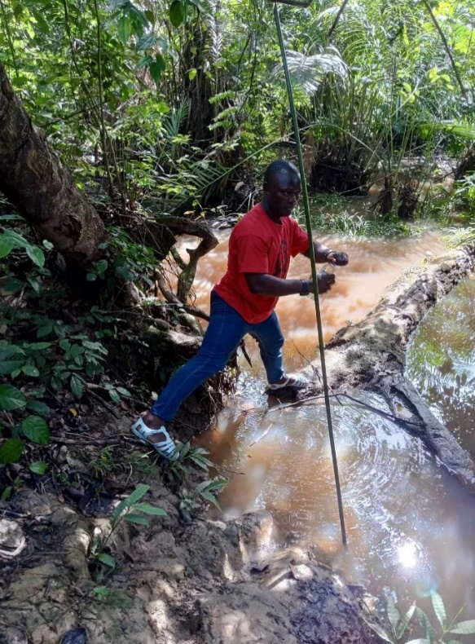
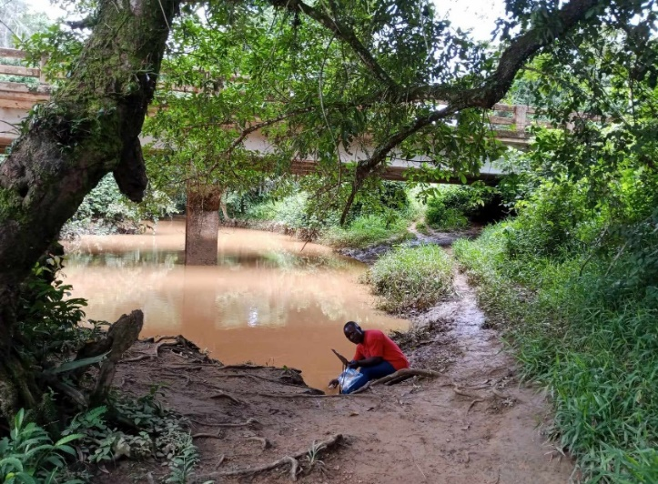
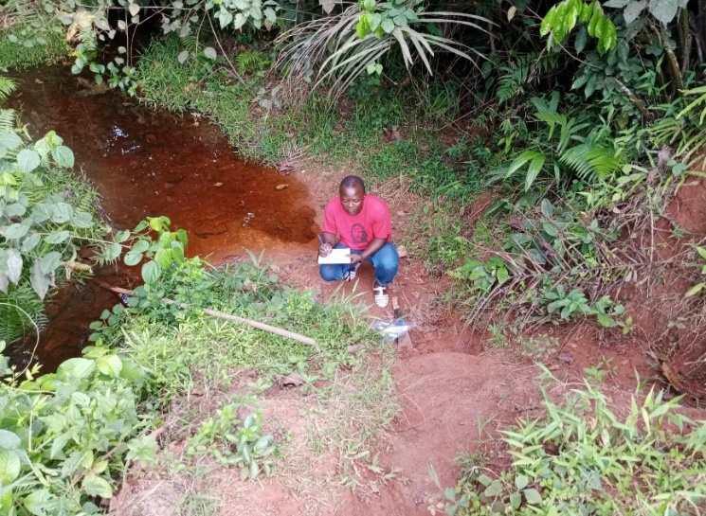
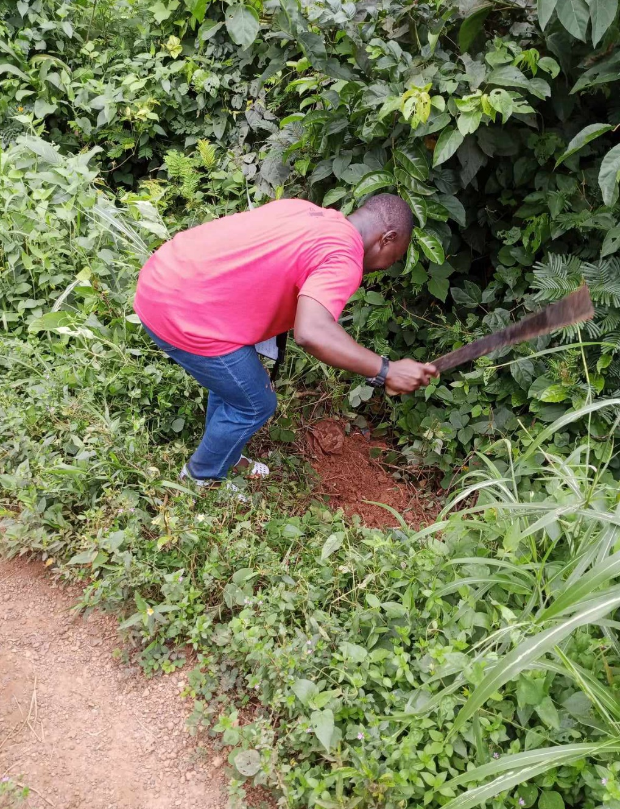
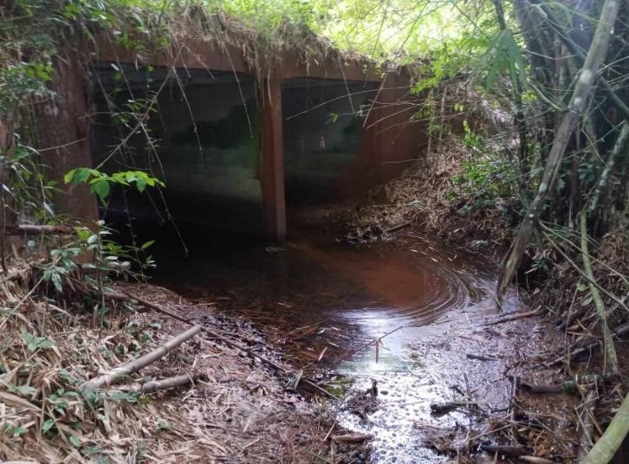
Soil and Water Samples collection along the proposed project corridor

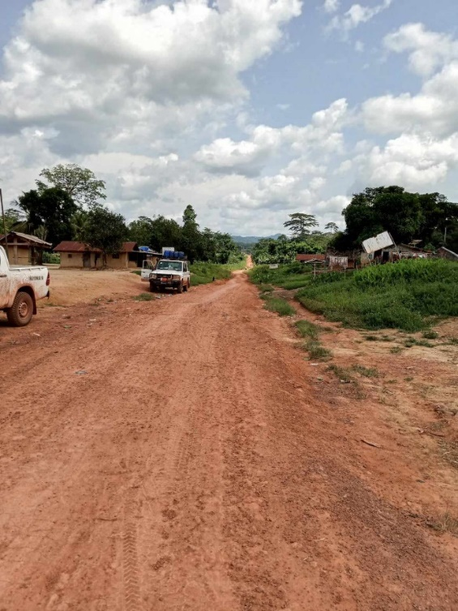
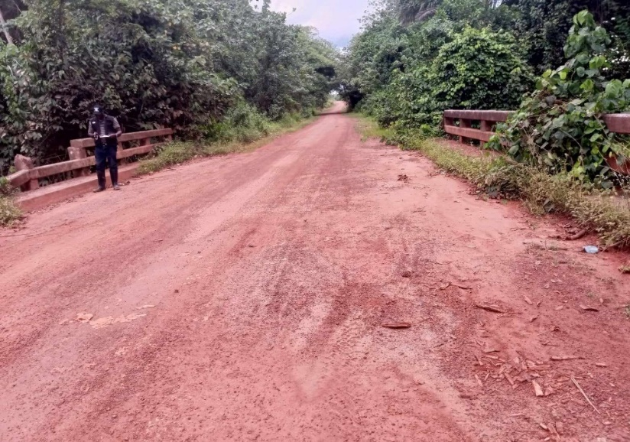
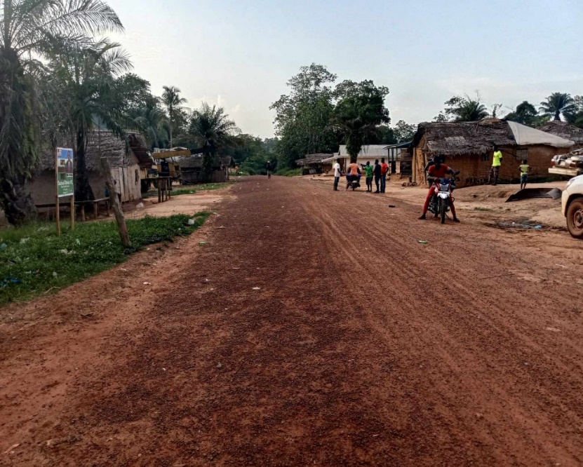
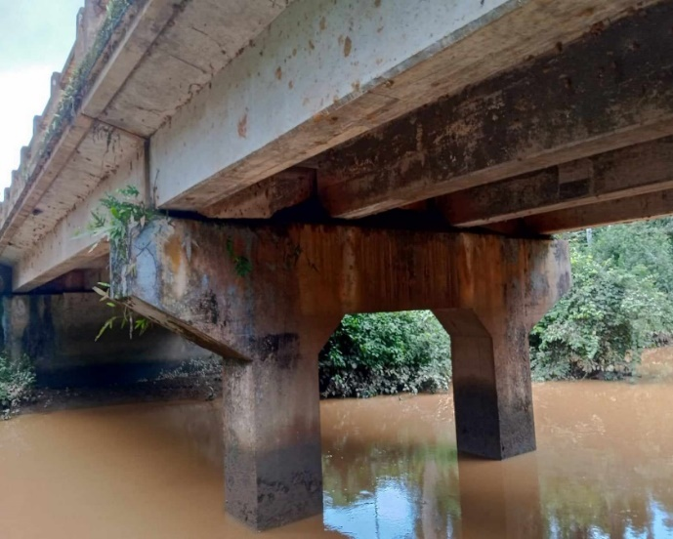
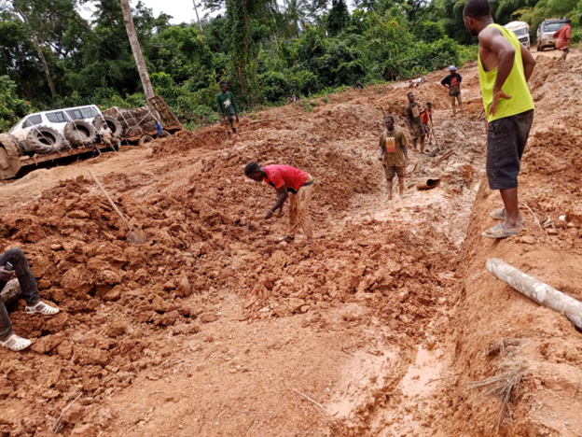
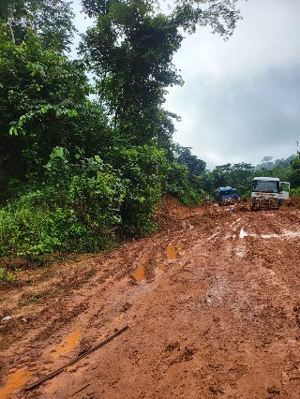
Dugbeh River Bridge
The proposed Project Road

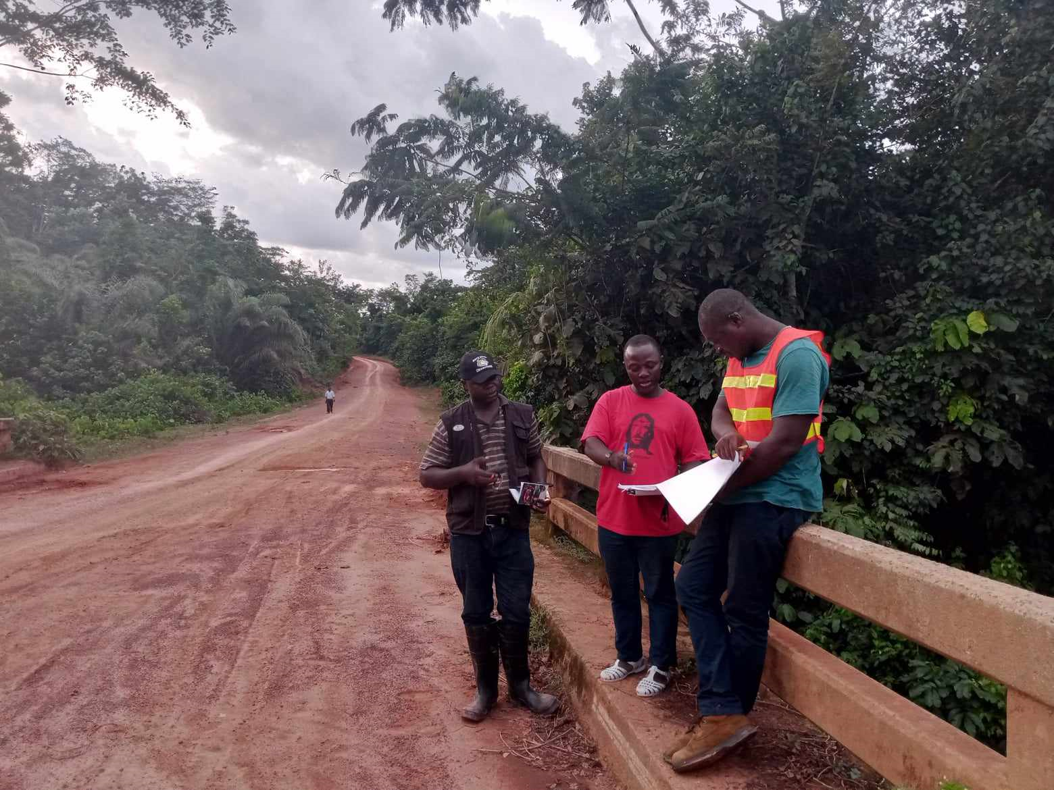
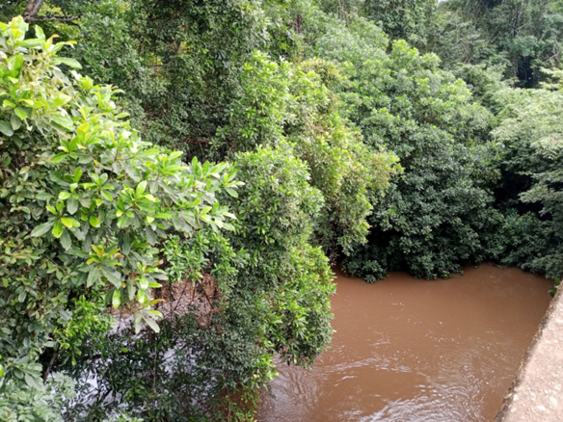
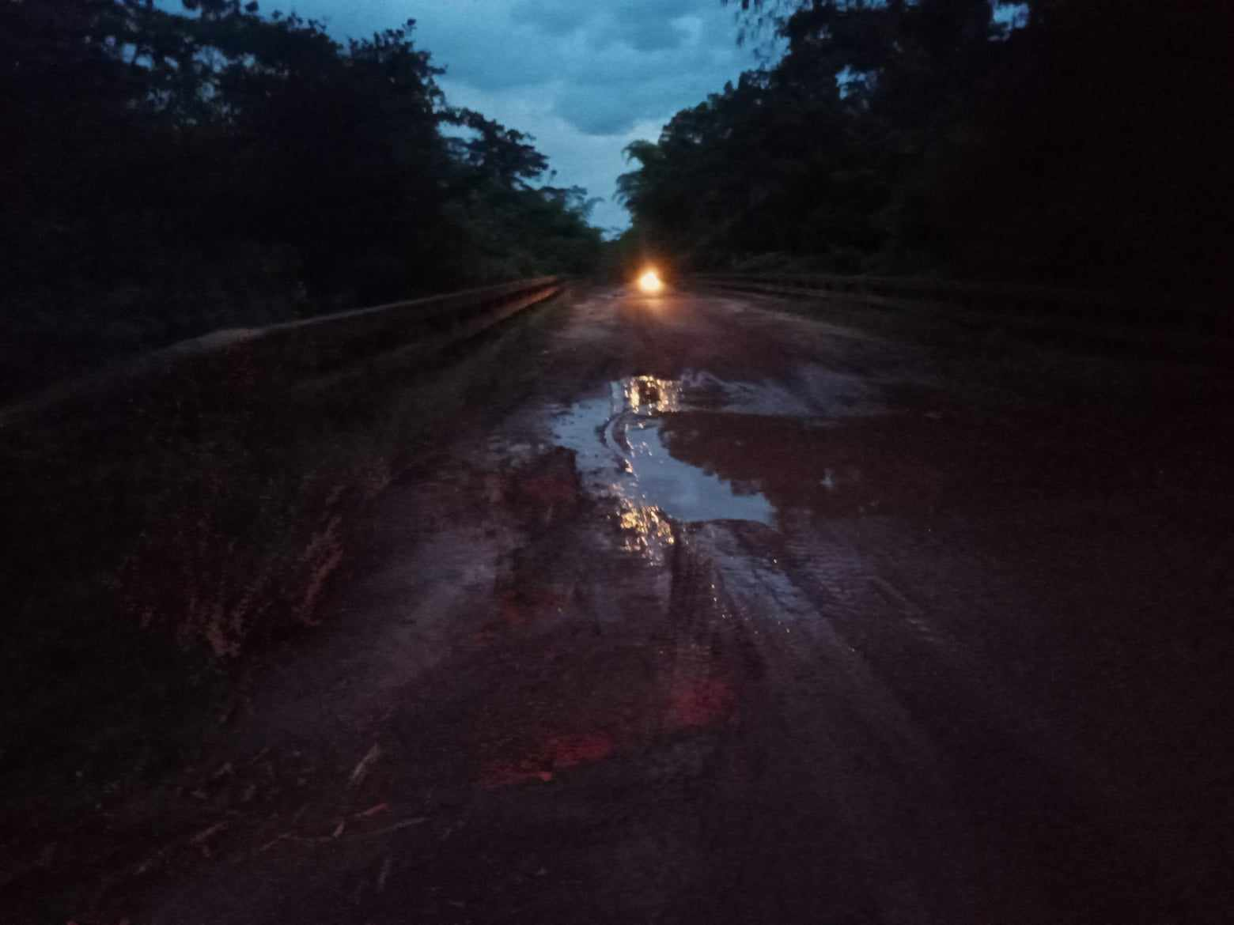
Brainstorming on realignment areas of the proposed project road
The Dugbeh River

